Majális 2022: Arburg Hungary opens its doors

- Tradition: After two years, Arburg Hungária Kft. in Budapest goes "live" again with an open house
- Two days of high-tech: Digitalisation, Gestica control system, packaging and medical technology
- Two days of networking: Industry get-together in Budapest

Lossburg, 18/3/2022
Majális 2022 will open its doors for specialist visitors on 5 and 6 May. The open house could not take place in 2020 and 2021 because of the Corona pandemic. Now, however, the team at Arburg Hungária Kft. in Budapest are looking forward to this important personal get-together and to networking again with all the customers and other interested parties in the country. Two high-end exhibits, the Allrounders 520 H and 470 A, will be on show with innovative applications for medical technology, and the packaging and food industries. Further highlights include the Gestica control system, digitalisation with arburgXworld, and the arburgGREENworld sustainability programme.

László Csizmadi, Managing Director of the Arburg Hungary is optimistic about the event: "Our two exhibits perfectly reflect market trends. Medical technology and packaging are the industries that are currently booming in Hungary. With the arburgXworld products and services, we will also focus on the topic of digitalisation, so that you can simplify work at an injection moulding plant, while making it more efficient too." The Gestica control system with its numerous assistants also makes complex production processes easy to master. "If you want to produce sustainably as well as economically, you will find the right approaches for this in our arburgGREENworld programme," László Csizmadi continues. "Here it is made clear how working with us can present you with an all-round carefree package for smooth plastic processing. Proof will be provided at Majális."

Hybrid high performance for medical technology
What does medical technology production require in order to be permanently successful? Short cycle times and thus high throughput rates in serial production, for example. In this way, the first of two exhibits, a hybrid Allrounder 520 H with a clamping force of 1,500 kN, precisely meets the requirements of medical technology. It is fast, precise, and high-performing with a throughput of around 19,200 moulded parts per hour. During Majális 2022, this system will demonstrate the production-efficient, high quality manufacture of pipette tips from PP in a cycle time of around six seconds. The exhibit is equipped with a 32-cavity mould from Zahoransky, a long-standing Arburg partner, and is prepared for use in clean rooms.

High-performing: Gestica – control system of the future
The second exhibit, an electric Allrounder 470 A with 1,000 kN clamping force and size 290 injection unit is equipped with a 4-cavity mould from Slezák, the Hungarian mould constructor and long-standing Arburg customer. A "shot glass" will be injected as a demonstration part in a cycle time of 20 seconds. This application focuses on the performance of the Gestica control system: it shows how its comprehensive features can be used simply, safely and intuitively for trouble-free production. The ease of use and efficiency of the Gestica is increased further through its extensive assistants. These “pilots” help to easily implement smooth, highly autonomous and monitored production.

Digitalisation with arburgXworld
At the Majális, Arburg will let you try a demo version of the arburgXworld customer portal live to see how simple, easy-to-use and quick-to-understand digitalisation can be achieved practically in modern injection moulding companies. The customer portal is available in 18 languages. On top of the free introduction with core apps, e.g., the ServiceCenter and the Shop, there are additional fee-based extensions that offer all users considerable added value. These include intuitive setting and simple control of complex production operations, targeted optimisation through direct information exchange when planning orders, quality assurance, mould management and maintenance, as well as the extensive digitalisation of services and business processes.

Arburg: More reliable pre- and after-sales service
Since its foundation in 1998, the Hungarian subsidiary Arburg Hungária Kft. has been known as a partner of the country's plastics processors with a high level of know-how and experience in sales, service and after-sales. "Also interesting for our customers," says László Csizmadi, "are the seemingly, small, but really important advantages such as the availability of our digital products in the local language or our training courses at the subsidiary or directly at the customer's site in Hungarian, English or German." This makes all the difference in how the company is perceived. Arburg has been active on the market for many years and is highly esteemed as a reliable and competent partner. We will accompany you from the first consultation to after-sales service. The Majális also serves as an important component in regional customer cooperation.

Photos

113983
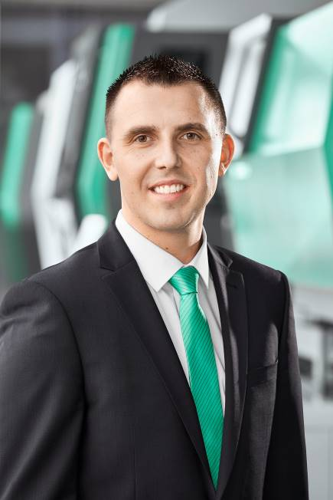
László Csizmadi, Managing Director Arburg Hungária Kft. is looking forward to Majális.

176284
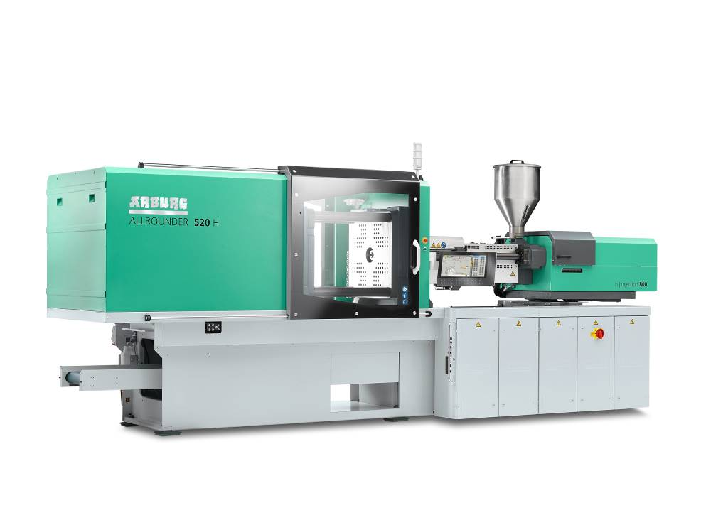
High-performance for medical technology: At the Majális an Allrounder 520 H will produce around 19,200 pipette tips per hour.

176977
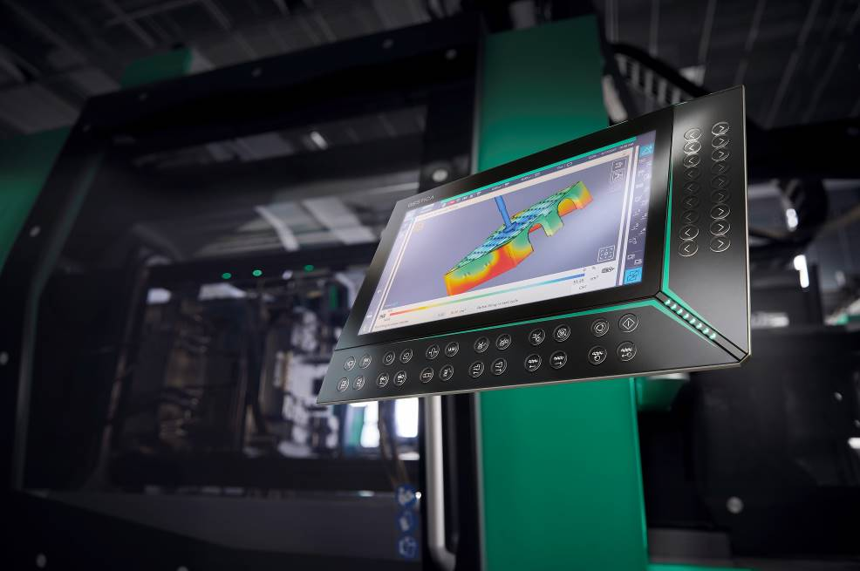
Control system of the future: The Gestica offers a wide range of assistants, including the "aXw Control FillAssist" that enables filling simulations directly on the screen of the control system.

Photo: Arburg

Download Photos:
https://media.arburg.com/portals/downloadcollection/DBA78DCB1B6DB21483DAB2E7BE29690C

Press release
File: input.doc
Characters: 4.741
Words: 722

This and other press releases are available for download from our website at www.arburg.com/de/presse/ (www.arburg.com/en/press/)

Contact
ARBURG GmbH + Co KG
Press office
Susanne Palm
Dr Bettina Keck
Postfach 1109
72286 Lossburg
Tel.: +49 (0)7446 33-3463
Tel.: +49 (0)7446 33-3259
presse_service@arburg.com

About Arburg
German family-owned company Arburg is one of the world's leading manufacturers of plastic processing machines. Its product portfolio encompasses Allrounder injection moulding machines with clamping forces of between 125 and 6,500 kN, the Freeformer for industrial additive manufacturing and robotic systems, customer and industry-specific turnkey solutions and further peripheral equipment.
Arburg is a pioneer in the plastics industry when it comes to production efficiency, digitalisation, and sustainability. The “arburgXworld” program comprises all digital products and services and is also the name of the customer portal. The company’s strategies regarding the efficient use of resources and circular economy, as well as all related aspects and activities, are outlined in the “arburgGREENworld” program.
Arburg’s central aim is for customers to be able to produce their plastic products, from one-off parts to large-volume batches, in optimum quality at minimum unit costs. The target groups include, for example, the automotive and packaging industries, communication and entertainment electronics, medical technology and the white goods sector.
An international sales and service network ensures first-class customer support at a local level: Arburg has its own organisations at 35 locations in 26 different countries and, together with its trading partners, is represented in more than 100 countries. Its machines are produced exclusively at the company's German headquarters in Lossburg. Of a total of roughly 3,400 employees, around 2,850 work in Germany. About 550 further employees work in Arburg's organisations around the world. Arburg has triple certification, in accordance with ISO 9001 (quality), ISO 14001 (environment) and ISO 50001 (energy).
Further information about Arburg can be found at www.arburg.com

