Arburg at Formnext 2023
Additive processing of high-temperature plastic, carbon fibres and liquid silicone

- Freeformer 750-3X: High-temperature version for components made of certified Ultem original granules
- TiQ: Compact 3D printers produce robotic grippers from reinforced filament
- LiQ: Reliable processing of liquid silicone

Lossburg, 21/09/2023
At Formnext 2023 in Frankfurt, Germany, ARBURGadditive will be presenting its complete range of products for industrial additive manufacturing based on granulates, filaments and liquid silicone (LSR) at Stand D79 in Hall 12.1. One highlight will be the new 750-3X high-temperature Freeformer from ARBURGadditive, which produces resilient air distributors from certified Ultem original granulate.
TiQ and LiQ series 3D printers from innovatiQ will be demonstrating the processing of fibre-reinforced filaments and certified LSR. There will also be many sample components on display, including brand-new APF components made of short-fibre reinforced thermoplastics.

"Formnext is undisputedly the world's leading trade fair for additive manufacturing technology and 3D printing and one of the most important trade fairs of all for us and our markets," says Dr Victor Roman, Managing Director of ARBURGadditive. "This is a chance for us not only to showcase our technical achievements, but also to observe further developments in this highly dynamic market of the future."

Freeformers for high temperature and soft materials

With the freeformers, fully functional components and small series based on original plastic granulates can be industrially additively manufactured using Arburg Plastic Freeforming (APF), even from very soft materials (up to hardness 28 Shore A) or in hard/soft combinations. The machines are generally suitable for sophisticated applications in medical technology, the automotive industry and aerospace.

At Formnext 2023, the new Freeformer 750-3X in high-temperature version will be producing geometrically sophisticated air distributors from original Ultem 9085. The high-end machine has three discharge units and, from the outside, is indistinguishable from the Freeformer 300-3X. However, at around 750 square centimetres, the part carrier is around 2.5 times larger. In addition, data processing and the Gestica controller, which is developed and manufactured by Arburg in-house, have been optimised in terms of process stability and component quality, and build time has been significantly shortened. The result is significantly reduced costs per component and lower material usage. The temperature of the build chamber can be raised to 200 degrees Celsius, and the granules are plasticised at up to 450 degrees Celsius.

A second Freeformer 750-3X will be producing orthopaedic insoles up to shoe size 50. Thanks to the APF process, certain parts of the insole can be individually reinforced and others specifically designed to be soft – either through a multi-material combination of e.g. hard PP and soft TPE or by adjusting the filling density. This sample part is also used to show how build time can be significantly reduced through enhanced software features, for example, and lattice-shaped support structures. The third APF exhibit, a Freeformer 200-3X, is specially designed for processing soft materials.

Short-fibre reinforced components and small series

"We are experiencing high demand for additively manufactured components made from short-fibre reinforced thermoplastics," says Simon Leitl, Director Development at ARBURGadditive. "At Formnext, we will be happy to demonstrate our current progress in the APF process with the Freeformer using the first sample components for various industries. This includes the development of a modified discharge system, for example.

The suitability of the APF process for efficiently producing small batches will also be demonstrated using a platform, closely fitted with 3D-printed holders made of PA, as an example. Arburg's experts will also be happy to share their experience with interested parties from the fields of injection moulding and additive manufacturing.

TiQ series for fibre-reinforced filaments
The compact 3D printers in the TiQ series have a CNC control system and process filaments using the fused filament fabrication (FFF) process. The TiQ 2 is particularly economical and also ideal as an entry-level additive manufacturing solution thanks to its open material system. Loadable suction pads and mechanical grippers made of fibre-reinforced PA and PP with individualised fingers for picking up components, mounted on robot arms, will be on show in Frankfurt.
Another exhibit, a TiQ 5 "pro", has integrated material drying and active build chamber temperature control. One component highlight is a “High-speed Water Scooter Board”, 3D-printed from fibre-reinforced filament using this high-performance printer. Its individual parts are laminated to form a functional prototype.

3D printing of automation components from LSR
All 3D printers from innovatiQ are operated using the intuitive industrial controller GestiQ-Pro. The optional SmartMonitoring system allows several printers to be monitored simultaneously during production. LAM (liquid additive manufacturing) technology can be used to print items such as bellows, soft grippers and end-of-arm tooling (EoAT) for automation, as well as industrial seals and nozzle closures in various Shore hardnesses – all with high process reliability.
Formnext 2023 will see the first demonstration of the processing of Shin-Etsu's extensively medical and FDA-certified standard LSR KEG-2003H-30A/B. This can be used to manufacture implants and products for the food sector, for example. The 3D-printed components have virtually the same flame-retardant, UV and temperature-resistant properties as injection-moulded parts.

ProcessLog
Two PC workstations will also be used to demonstrate how the "ProcessLog" customer portal app can be used to seamlessly document and trace every single APF component. This allows a wide range of process and build job data to be displayed in clear graphical form and documented – which in turn ensures transparency, high part quality and can significantly reduce rejects and error rates.

Photos

180187

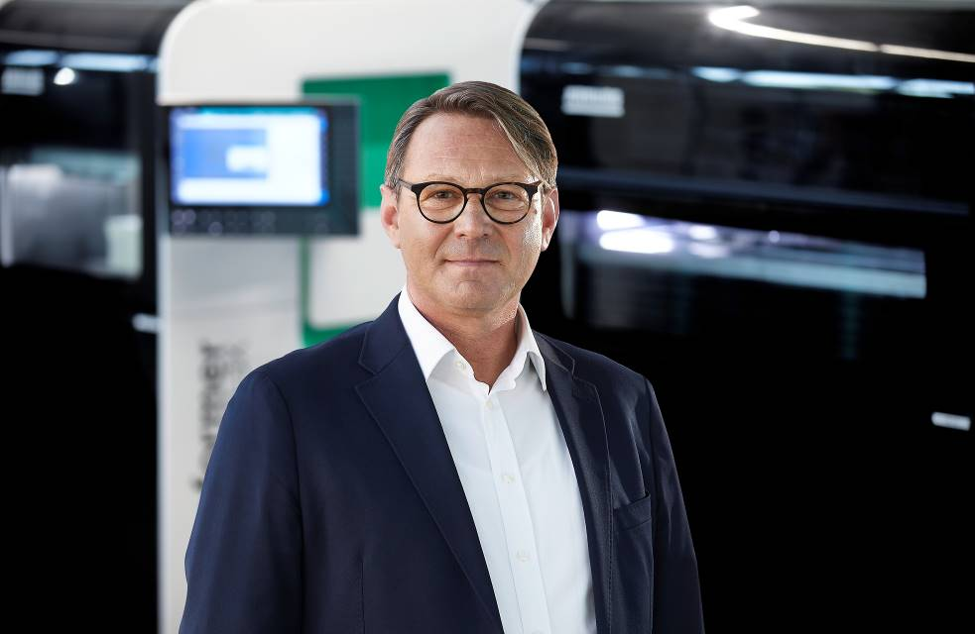

Dr Victor Roman, Managing Director of ARBURGadditive.

Photo: ARBURG

183833

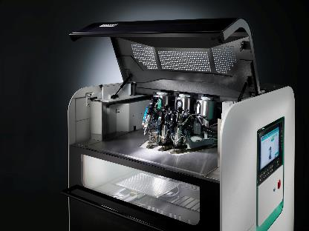

In the high-temperature Freeformer 750-3X with three discharge units, the temperature of the build chamber can be raised to 200 degrees Celsius, and the original granulate is plasticised at up to 450 degrees Celsius.

Photo: ARBURG

194691

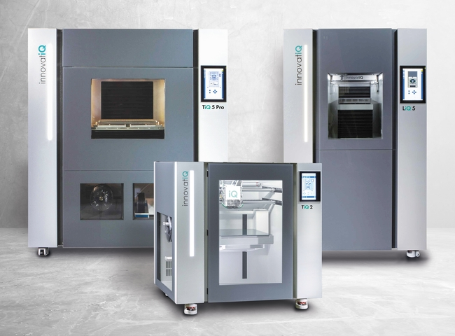

The TiQ and LiQ series 3D printers from InnovatiQ are ideal for processing fibre-reinforced filaments and standard silicones.

Photo: innovatiQ

195640

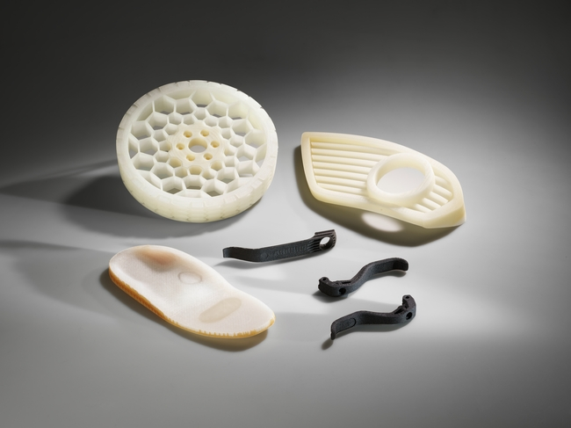

At Formnext 2023, ARBURGadditive will also be presenting a wide range of additively manufactured sample components as hands-on exhibits.

Photo: ARBURG

Photo download:
https://media.arburg.com/portals/downloadcollection/C38D5B7C764E77F32FD180AB5B595674

Press release
File: ARBURG Press preview Formnext 2023_en_GB.docx
Characters: 5,855
Words: 853

This and other press releases are available for download from our website at www.arburg.com/de/presse/ (www.arburg.com/en/press/)

Contact
ARBURG GmbH + Co KG
Press office
Susanne Palm
Dr Bettina Keck
Postfach 1109
72286 Lossburg
Tel.: +49 (0)7446 33-3463
Tel.: +49 (0)7446 33-3259
presse_service@arburg.com

About Arburg
German family-owned company Arburg is one of the world's leading manufacturers of plastic processing machines. Its product portfolio encompasses Allrounder injection moulding machines with clamping forces of between 125 and 6,500 kN, the freeformer for industrial additive manufacturing and robotic systems, customer and industry-specific turnkey solutions and further peripheral equipment.
Arburg is a pioneer in the plastics industry when it comes to energy and production efficiency, digitalisation and sustainability. The "arburgXworld" program comprises all digital products and services and is also the name of the customer portal. The company’s strategies regarding the efficient use of resources and circular economy, as well as all related aspects and activities, are outlined in the 'arburgGREENworld' program.
Arburg's main aim is to enable its customers to manufacture their plastic products, from one-off parts to large-volume batches, to optimum quality standards and in a way that conserves resources, is sustainable and minimises unit costs. Target groups include the automotive and packaging industries, communication and entertainment electronics, medical technology and the white goods sector.
First-class customer support on-site is guaranteed by the international sales and service network: Arburg has own organisations in 25 countries at 35 locations and is represented in over 100 countries together with trade partners. Its machines are produced at the company's German headquarters in Lossburg. Of a total of roughly 3,600 employees, around 3,000 work in Germany, with another 600 employees based in Arburg's organisations around the world. Arburg is certified to ISO 9001 (quality), ISO 14001 (environment), ISO 27001 (information security), ISO 29993 (training) and ISO 50001 (energy).
Further information about Arburg can be found at www.arburg.com

