Arburg exhibit at Fakuma 2023
Premiere: New hybrid Allrounder 520 H

- Expansion: Size 520 expands the range of hybrid Allrounders with new machine technology
- Hybrid alternative: energy-saving, efficient, lower costs and carbon footprint
- Performance variants: Comfort, Premium and Ultimate - a suitable solution for all requirements

Lossburg, 17/10/2023
One machine highlight at Fakuma 2023 is the premiere of the Allrounder 520 H. The new machine in the hybrid Hidrive series with innovative machine technology is particularly good at saving energy and conserving resources, as well as being production-efficient, user-friendly and reliable.

The machine technology of the Hidrive series has been significantly enhanced, with the new hybrid machines featuring an optimised energy footprint and reduced cycle times. Following the launch of the 470 H milestone machine in the spring to mark "100 years of the Hehl family company", the next step has now been taken with the size 520 and 570 machines.

New size 520 with 1,500 kN clamping force
The size 520 with a clamping force of 1,500 kN is on show for the first time at Fakuma 2023. The exhibit, an Allrounder 520 H "Premium", uses a 1+1+1-cavity mould to produce three different moulded parts from ABS in a cycle time of around 50 seconds: a machine base, a feed hopper, and a controller. These three components are subsequently separated from each other in a cutting station and round off a set of 15 parts for a model Allrounder on a scale of 1:18.
In this application, the Moldlife Sense computer system enables sensor-controlled mould monitoring over the complete life cycle. The recorded data is passed via an OPC-UA interface directly to the Gestica control system, which displays corresponding malfunctions as well as performance-dependent maintenance intervals, thereby enabling predictive maintenance.
The new Multilift Select 8 linear robotic system with an eight kilograms load removes the moulded parts and places them in a box. A box changer ensures an autonomy of about two hours.

Cost- and resource-saving alternative
The Hidrive series combines an electric energy-efficient and precise clamping unit with a powerful and dynamic hydraulic injection unit. Compared to all-electric and hydraulic machines, it is characterised by significantly reduced acquisition and operating costs as well as a better energy and carbon footprint.
A novelty in the new hybrid Allrounder "Premium" machines is flow splitting as standard, with cutting-edge Varan valve technology used to split the main pump's available flow volume when required. This enables simultaneous movements of hydraulic auxiliary axes with programmable control such as the ejector and core pull – without technology stages or multi-pump technology. This saves energy, costs and space on the machine and increases production efficiency.
Compared to corresponding hydraulic machines, the energy footprint of the new Allrounder H is up to 50 per cent better. In addition, the carbon footprint can be significantly reduced. Thanks to a new oil management concept, the new Allrounder machines require up to 35 per cent less oil. The required cooling water capacity can be reduced by up to 70 per cent. The dry cycle time is also reduced by around 40 per cent.

Three performance variants
Thanks to its many options, the Allrounder 520 H can be adapted precisely to individual customer requirements. Like the size 470 H machine, it is available in three performance variants: "Comfort", "Premium" and "Ultimate". The first two variants feature the Arburg servo hydraulic system (ASH) as standard, with the speed-controlled, water-cooled servo motor adapting continuously to the actual power requirement, thus enabling particularly energy-efficient and low-emission operation. At the same time, however, the machine's cooling requirements and noise level are also significantly reduced.

Easy to operate and maintain
User-friendliness and reliability are also important criteria for the new machine in order to save time and money on service and maintenance. Predictive maintenance is an important keyword: for example, the machine automatically reports when the oil filter is due to be changed soon. Oil filters and connections are more accessible and the mounting locations for the central lubrication system, pneumatic system and interfaces have also been optimised.

Photo

194798

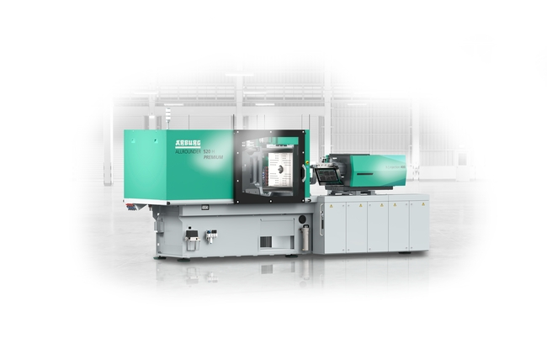

Following the launch of the new hybrid machine technology with the Allrounder 470 H milestone machine in the spring, the Allrounder 520 H is now celebrating its premiere in the "Premium" performance variant at Fakuma 2023.

Photo: ARBURG

Photo download – updated with motifs from the trade fair:
https://media.arburg.com/portals/downloadcollection/94C3E3E5A34C121936701806098C7844

Press release
File: ARBURG Press release Allrounder 520 H Premiere Fakuma 2023_en_GB.docx
Characters: 4,163
Words: 645

This and other press releases are available for download from our website at www.arburg.com/de/presse/ (www.arburg.com/en/press/)

Contact
ARBURG GmbH + Co KG
Press office
Susanne Palm
Dr Bettina Keck
Postfach 1109
72286 Lossburg
Tel.: +49 (0)7446 33-3463
Tel.: +49 (0)7446 33-3259
presse_service@arburg.com

About Arburg
German family-owned company Arburg is one of the world's leading manufacturers of plastic processing machines. Its product portfolio encompasses Allrounder injection moulding machines with clamping forces of between 125 and 6,500 kN, the Freeformer for industrial additive manufacturing and robotic systems, customer and industry-specific turnkey solutions and further peripheral equipment.
Arburg is a pioneer in the plastics industry when it comes to production efficiency, digitalisation and sustainability. The “arburgXworld” program comprises all digital products and services and is also the name of the customer portal. The company’s strategies regarding the efficient use of resources and circular economy, as well as all related aspects and activities, are outlined in the 'arburgGREENworld' program.
Arburg's main aim is to enable its customers to manufacture their plastic products, from one-off parts to large-volume batches, to optimum quality standards and in a way that conserves resources, is sustainable and minimises unit costs. Target groups include the automotive and packaging industries, communication and entertainment electronics, medical technology and the white goods sector.
First-class customer support on-site is guaranteed by the international sales and service network: Arburg has own organisations in 26 countries at 36 locations and is represented in over 100 countries together with trade partners. Its machines are produced at the company's German headquarters in Lossburg. Of a total of roughly 3,800 employees, around 3,200 work in Germany, with another 600 employees based in Arburg's organisations around the world. Arburg is certified to ISO 9001 (quality), ISO 14001 (environment), ISO 27001 (information security), ISO 29993 (training) and ISO 50001 (energy).
Further information about Arburg can be found at www.arburg.com

