ARBURG at the NPE 2024
First world premiere of a new Arburg machine in the USA

- Important: US market and Golden Electric series of great strategic importance for Arburg
- "More than a machine": Innovations, concentrated expertise and comprehensive support
- 13 exhibits and digitalisation: Comprehensive Arburg portfolio for efficient plastics processing

Lossburg, 31/01/2024
Arburg will celebrate a double premiere at the NPE from 6 to 10 May 2024 in Orlando, Florida, USA: For the first time in the company's history, a world debut will be presented outside Germany with a new "golden" electric machine: The Allrounder 720 E Golden Electric will be the highlight at booth 3743 (West Hall). Moreover, arburgSOLUTIONworld provides the answers to customers' meta-topics. The company is not only an innovative machine manufacturer, but also offers its customers comprehensive advice and support, for example in the areas of automation, additive manufacturing, digitalisation and after-sales service. In Orlando, a total of 13 exhibits at the company's own stand and those of its partners will demonstrate the broad product range across a wide variety of processes and all industries - from 3D printing to injection moulding of packaging items in large volume batches.

"The fact that we are presenting the world premiere of the new Golden Electric series at NPE 2024 reflects the great importance of the American market for Arburg, our leading position in the USA and the expansion of our international business, says Gerhard Böhm, Managing Director Sales and Aftersales from the company's German headquarters in Lossburg. The NPE is the most important plastics trade fair in America; we will be represented there with a strong team from the Arburg locations in the USA and the German company headquarters." Martin Baumann, President of Arburg Inc. in Rocky Hill, USA, is also certain: "Thanks to its standardised equipment and unbeatable price/performance ratio, the new Allrounder 720 E Golden Electric is highly interesting for the US market and many of our customers, especially because of increasing cost pressure. With our automation and turnkey expertise, digital products such as the Arburg host computer system and comprehensive support and advice at arburgSOLUTIONworld, we have an economical and efficient solution for everyone."

World premiere: Slim in design and price
The Allrounder 720 E Golden Electric with a clamping force of 2,800 kN stands out for its electrical precision and process stability and offers excellent part quality combined with low investment costs and prompt availability. Its design has been optimised so that it has a significantly smaller footprint compared to other machines in its class. This means that more machines can be accommodated in the same injection moulding production area, which in turn results in an increased output per square metre. The new machine is suitable for a wide range of plastic parts and cycle times of around 15 seconds or more. Typical areas of application include medical technology, mobility and technical injection moulding. The "golden" electric all-rounder can be automated with all Arburg robotic systems – including six-axis robots. The exhibit at NPE 2024 uses a 24-cavity mould to produce razor covers. A Multilift V 30 linear robot system performs the handling tasks here.

13 machine exhibits demonstrate a wide range of services
The wide range of applications possible with Arburg machine technology will be demonstrated by 13 exhibits at the NPE, seven of which will be on the company's own stand. In addition to the new Allrounder 720 E Golden Electric, these are:
- A new precise IML process designed specifically for medical technology can be seen on a production cell based around an electric Allrounder 520 A in cleanroom design using the example of labelled centrifuge tubes.
- For the first time in the USA, an Allrounder Cube 1800 machine will be presented, which uses an integrated six-axis robot to produce two-component medical closures fully automatically.
- As an energy-efficient, resource-saving alternative to thermoforming, an Allrounder 720 A "Ultimate" electric packaging machine produces IML round cups with a wall thickness of 0.37 millimetres using injection compression moulding at an injection pressure of just 1,600 bar.
- An equally interesting exhibit is an Allrounder More 2000 two-component all-rounder equipped with an integrated six-axis robot, which produces a pair of glasses made of thermoplastic and optical LSR as an example. With this application, Arburg Inc. highlights its turnkey expertise in the USA.
- An Allrounder 520 H "Premium" featuring new hybrid machine technology processes 100 per cent ABS recyclate into components for a 1:18 scale Allrounder model. For this purpose, the machine is equipped with the recyclate package.
- The give-away – a toolbox in the Arburg design – which is coveted by trade fair visitors worldwide, is produced on a turnkey system centred around a hybrid Allrounder 920 S.
- Last but not least, a 750-3X high-temperature Freeformer will be demonstrating industrial additive manufacturing. The 3D printer is particularly suitable for processing certified original material into components for medical technology and aerospace.

Advantages of digitalisation and expert presentation on OPC UA
Digitalisation can help you hold your own in the market because it can significantly increase the energy and production efficiency of machines and systems. For example, Arburg offers the ALS host computer system and the "arburgXworld" customer portal with extensive digital features. The Gestica control system also offers intelligent assistance functions that actively support the set-up and operation of machines and systems.
At the trade fair, all Allrounders are networked with the Arburg ALS host computer system via OPC UA interfaces. With this central MES, the entire plastic parts production process can be digitally planned and controlled and all relevant information can be tracked. Digitalisation expert Jürgen Peters, Head of Software Development, will give a presentation on the advantages of integrating peripherals via OPC UA on Tuesday 7 May at the "Innovation Stage" at NPE 2024.
Photo

195815 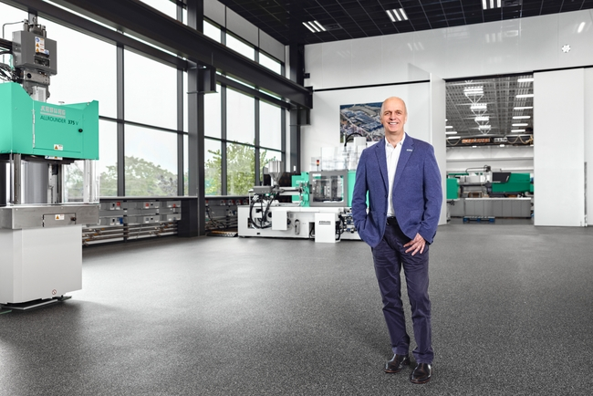
Martin Baumann, President of Arburg Inc., the US headquarters in Rocky Hill, Connecticut.
Photo: Arburg
Photo download:
https://media.arburg.com/portals/downloadcollection/F189D71A05EFB30A5D057DB30C1CE536

Press release
File: input.doc
Characters: 5.845
Words: 902

This and other press releases are available for download from our website at www.arburg.com/de/presse/ (www.arburg.com/en/press/)

Contact
Arburg GmbH + Co KG
Press office
Susanne Palm
Dr Bettina Keck
Postfach 1109
72286 Lossburg
Tel.: +49 (0)7446 33-3463
Tel.: +49 (0)7446 33-3259
presse_service@arburg.com

About Arburg
German family-owned company Arburg is one of the world's leading manufacturers of plastic processing machines. Its product portfolio encompasses Allrounder injection moulding machines with clamping forces of between 125 and 6,500 kN, the freeformer for industrial additive manufacturing and robotic systems, customer and industry-specific turnkey solutions and further peripheral equipment.
Arburg is a pioneer in the plastics industry when it comes to energy and production efficiency, digitalisation and sustainability. The "arburgXworld" program comprises all digital products and services and is also the name of the customer portal. The company’s strategies regarding the efficient use of resources and circular economy, as well as all related aspects and activities, are outlined in the 'arburgGREENworld' program.
Arburg's main aim is to enable its customers to manufacture their plastic products, from one-off parts to large-volume batches, to optimum quality standards and in a way that conserves resources, is sustainable and minimises unit costs. Target groups include the automotive and packaging industries, communication and entertainment electronics, medical technology and the white goods sector.
First-class customer support on-site is guaranteed by the international sales and service network: Arburg has own organisations in 25 countries at 35 locations and is represented in over 100 countries together with trade partners. Its machines are produced at the company's German headquarters in Lossburg. Of a total of roughly 3,800 employees, around 3,200 work in Germany, with another 600 employees based in Arburg's organisations around the world. Arburg is certified to ISO 9001 (quality), ISO 14001 (environment), ISO 27001 (information security), ISO 29993 (training) and ISO 50001 (energy).
Further information about Arburg can be found at www.arburg.com

