Arburg at Plastpol 2024
European premiere: Arburg’s new “treasure”, the Allrounder 720 E Golden Electric

- Gold standard: Poland will be the first in Europe to showcase the Allrounder 720 E Golden Electric
- Cheers: A beer mug in less than 37 seconds
- 3D printer: TiQ 2 from ARBURGadditive portfolio completes the range of exhibits

Lossburg, 22/03/2024
For four days, it is the Polish place to be if you have anything to do with plastics. Kielce, located roughly halfway between Warsaw and Krakow, is hosting the 28th Plastpol from 21 to 24 May 2024. Arburg will be taking part again in 2024 – and how! For the first time in Europe, the company will be presenting its latest “treasure” to trade visitors, the Allrounder 720 E Golden Electric, just a few days after its world premiere at NPE in Orlando, Florida.

“This is the first time in Arburg’s history that a brand new machine will be celebrating its European premiere here in Poland,” says Konrad Szymczak, Managing Director of Arburg Polska Sp. z o o. “We will also be showcasing the hybrid Allrounder 470 H with automation specially designed by us in Poland. This includes what are known as ‘cobots’, i.e. robots that work directly with humans. In addition, there will be the TiQ 2 3D printer from the ARBURGadditive portfolio.”

Allrounder Golden Electric in a new design
The centrepiece will, of course, be the Allrounder 720 E Golden Electric with a clamping force of 2,800 kN. The new electric injection moulding machine extends the product range of the eponymous series upwards. Its main advantages in a nutshell? A slimmed down design with a price to match. The Allrounder 720 E Golden Electric combines electrical precision and process stability with a smaller installation area. It offers high component quality with low investment costs and short delivery times.
The space-optimised Allrounder fits into existing production grids and lines. The new design means that more machines can be used in injection moulding production, resulting in an increased output per square metre. The Golden Electric series is particularly suitable for technical injection moulding. Typical areas of application include dimensionally accurate housings for electromobility, thick-walled closures for household goods, delicate components for medical technology and the construction and leisure industries. The new machine can be combined and automated with any of Arburg’s robotic systems. At Plastpol, the machine will be used to produce medical 0.5 ml syringe plungers made of PP. The 64-cavity mould from Ruhla produces the parts with a moulded part weight of 0.34 grams in a cycle time of just nine seconds.

“Freshly tapped” – a beer mug ready to go
But that’s not the only highlight from Arburg at Plastpol 2024. The hybrid Allrounder 470 H Comfort with 1,000 kN clamping force and linear robotic system Multilift Select 8 is also likely to attract particular attention, as it will be producing a give-away that is sure to be very popular: a 0.5-litre beer mug. In Kielce, visitors will be able to see for themselves how a mug like this is produced from PC in a cycle time of 31 seconds.
The hybrid Allrounder Hidrive machines are impressive thanks to their modular, customisable drive systems that allow users to harness the benefits of both electric and hydraulic technology – namely speed and precision paired with power and dynamics. The finely graduated hybrid machine technology from Arburg is comparable to all-electric machines in terms of dry cycle times and injection speeds. This makes the new Allrounder Hidrive (H) machines an energy-saving alternative to hydraulic machines and an economical alternative to electric machines, unlike anything previously available on the market. They are currently available in sizes 470, 520 and 570 and in the “Comfort”, “Premium” and “Ultimate” performance variants.

Cost-effective introduction to 3D printing
The TiQ 2 3D printer is particularly economical and also ideal as an entry-level additive manufacturing solution thanks to its open material system. It processes filaments using FFF (fused filament fabrication) technology. Injection moulding plants will be interested in the option of using it to produce end-of-arm tooling (EAOT), including resilient suction pads and mechanical grippers made of fibre-reinforced PA and PP, for example, with customised fingers for picking up components.

All in all, Plastpol offers a wide range of products for the key topics in the industry. Konrad Szymczak comments: “The most important trends and topics are probably energy efficiency, recycling and the further automation of the injection moulding process in order to fill the existing gaps in qualified personnel.” Arburg is therefore well equipped for a successful and exciting Plastpol 2024 in Kielce.

Photos

177629
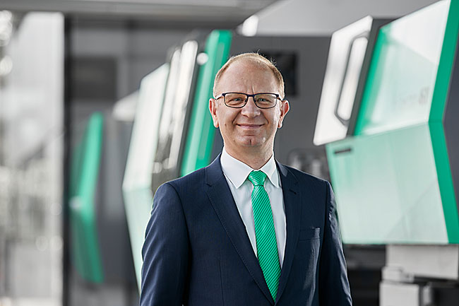

Konrad Szymczak, Managing Director of Arburg Polska Sp. z o o.

197271

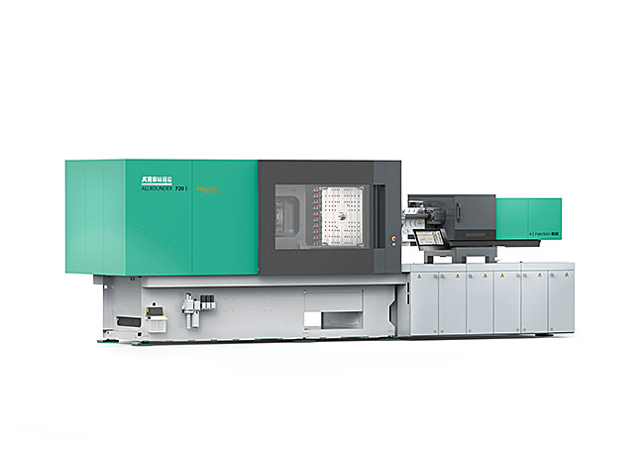

European premiere at Plastpol 2024: Thanks to its new design and standardised equipment, the new electric Allrounder 720 E Golden Electric has a particularly compact installation area and a price to match.

186060
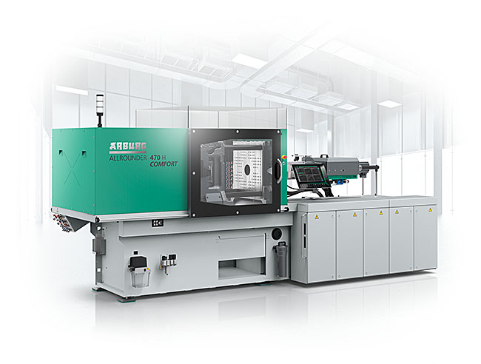

An Allrounder 470 H Comfort with new hybrid machine technology produces beer mugs as an example at Plastpol 2024.

Photos: ARBURG
Photo download:
https://media.arburg.com/web/4e44ee7c5fc82311/plastpol-2024-arburg-press-preview/

Press release
File: ARBURG press preview Plastpol 2024_en_GB.docx
Characters: 4,438
Words: 706

This and other press releases are available for download from our website at www.arburg.com/de/presse/ (www.arburg.com/en/presse/)

Contact(s)
ARBURG GmbH + Co KG
Press office
Susanne Palm
Dr Bettina Keck
Postfach 1109
72286 Lossburg, Germany
Tel.: +49 (0)7446 33 3463
Tel.: +49 (0)7446 33 3259
presse_service@arburg.com

About Arburg
Founded in 1923, the German family-owned company is one of the world’s leading manufacturers of plastic processing machines. The ARBURG family also includes AMKmotion and ARBURGadditive, including innovatiQ.
The portfolio includes injection moulding machines, 3D printers for industrial additive manufacturing, robotic systems and customer- and industry-specific turnkey solutions. It also includes digital products and services.
ARBURG is a pioneer in the plastics industry when it comes to energy and production efficiency, digitalisation and sustainability. ARBURG machines are used to manufacture plastic products for industries such as mobility, packaging, electronics, medicine, construction and equipment engineering, and leisure.
The company headquarters are located in Lossburg, Germany. In addition, ARBURG has its own organisations at 36 locations in 26 countries and, together with trading partners, is represented in over 100 countries. Of a total of around 3,700 employees, some 3,100 work in Germany while around 600 are based in ARBURG organisations around the world.
ARBURG is certified in accordance with ISO 9001 (quality), ISO 14001 (environment), ISO 27001 (information security), ISO 29993 (training) and ISO 50001 (energy).
Further information: www.arburg.com, www.amk-motion.com and www.arburg.com/arburgadditive.

