Arburg at the rapid+tct 2024
Freeformer: Reliable 3D printing of components for aerospace and medical

- Open system: Freeformer 750-3X processes plastic pellets reliably and cost-efficiently
- High performance applications: Medical & aerospace components, including multi-material combinations
- ARBURGadditive: Broad portfolio of Freeformers and 3D printers

Lossburg, 18/04/2024
At rapid+tct in Los Angeles, California (USA) from 25 to 27 June 2024, ARBURGadditive's broad portfolio for reliable high value 3D printing will be on display at stand no. 2001. A high temperature Freeformer 750-3X will be processing plastic pellets of Ultem 9085. This high-temperature material is widely used in the Aerospace industry. The highly interesting Arburg customer portal app "ProcessLog" will also be on show, which can be used to reliably track process quality.

"The rapid+tct is one of the important trade fairs in the USA, bringing together decision-makers from industry and technology in one place," emphasises Dr Victor Roman, Managing Director of ARBURGadditive. "We will be focusing on the additive production of genuine functional components that are in no way inferior to injection moulding, the processing of certified virgin plastics to create complex and individualised components in small quantities and, of course, our Freeformer 750-3X, which can reliably and reproducibly perform such demanding tasks."

Processing of high-temperature plastics
The Freeformer 750-3X can process virgin plastic pellets and certified materials in Arburg Plastic Freeforming (AKF), including hard/soft combinations and high-temperature materials. For this purpose, the build chamber can be heated up to 200 degrees Celsius; the plasticising takes place at up to 450 degrees Celsius. A typical application is the production of geometrically demanding ventilation ducts for the aerospace industry from virgin Ultem 9085 pellets.
The 750 square centimetre build plate can be used to produce larger functional components or additively manufacture small series on an industrial scale. A compact mass pressure generator equipped with servo motors from AMKmotion (a member of the Arburg family), delivers tiny droplets at a rate up to 400 hertz to print parts that are similar in density to injection moulded parts.

Shoe insole example: reduction of construction time and costs
The Gestica control system is also optimised for additive manufacturing in terms of process stability, part quality and build time. Based on the slicing data, the exact amount of material required to build each individual layer is calculated. The variable dispensing behaviour helps to reduce the dwell time. The example of customised orthopaedic insoles up to shoe size 50 (EU) shows how the construction time and costs per component can be significantly reduced, e.g. by optimising software features and grid-shaped support structures. The footbed can be individually reinforced or made soft, depending on the wearers needs – either through a multi-material combination, e.g. of hard PP and flexible TPE, or by adjusting the filling density. Thanks to an adapted discharge strategy and layer thickness, the construction time was reduced by 72 percent.

ProcessLog: seamless component documentation
A reproducible and reliable AM process is an indispensable prerequisite for the use of additively manufactured functional components in safety-relevant areas. For patient-specific implants or ventilation ducts in aeroplanes it is essential that parameters to produce each individual component can be fully documented and traced. To this end, Arburg offers the "ProcessLog" customer portal app, which clearly visualises and documents a wide range of process and build order data. This significantly reduce rejects and error rates.

"More than a machine"
Arburg offers its customers in the USA far more than just machine technology. The Arburg Prototyping Center at the headquarters in Rocky Hill, CT also offers machine installation and training. Moreover, the Center is capable of testing materials and the production of benchmark components, including the setup of print profiles. The AM team in the USA also helps customers with troubleshooting and provides tips and guidance on how to optimise the operation of installed machines. Project enquiries are welcomed, particularly in the medical, aerospace and industrial applications sectors.

Photos

180187

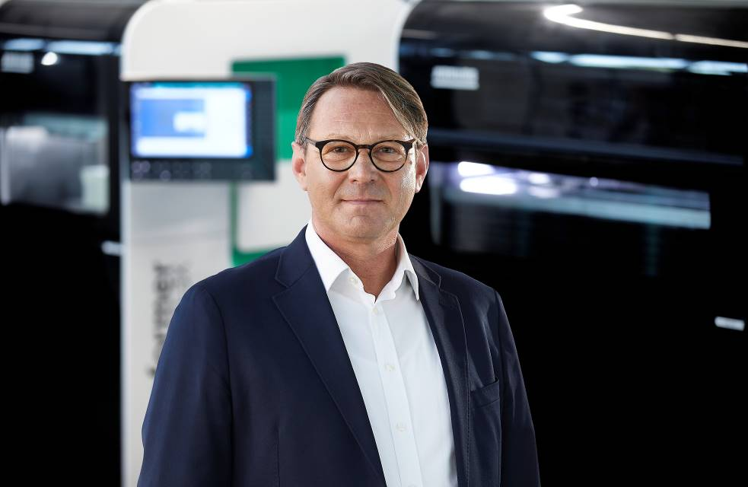

Dr. Victor Roman, Managing Director ARBURGadditive.

183833

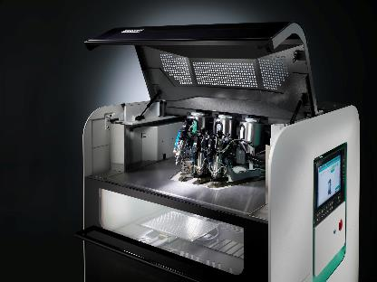

The Freeformer 750-3X has three discharge units and produces functional components that can be additively loaded, also in hard/soft combinations and from original plastic granulate.

178069
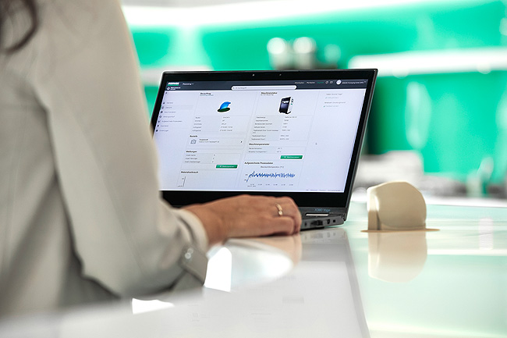

With the "ProcessLog" app developed specifically for the Freeformer, a wide range of process and construction order data can be clearly displayed for each construction order. This enables seamless part-specific monitoring.

Photos: ARBURG

Photo download:
https://media.arburg.com/web/dc7253c7ac02bf22/rapid---tct-2024-arburg-press-preview/

Press release
File: ARBURG press preview rapid+tct 2024_en_GB.docx
Characters: 4,067
Words: 610

This and other press releases are available for download from our website at www.arburg.com/de/presse/ (www.arburg.com/en/press/)

Contact
ARBURG GmbH + Co KG
Press office
Susanne Palm
Dr Bettina Keck
Postfach 1109
72286 Lossburg
Tel.: +49 (0)7446 33-3463
Tel.: +49 (0)7446 33-3259
presse_service@arburg.com

About Arburg
Founded in 1923, the German family-owned company is one of the world's leading manufacturers of plastic processing machines. The ARBURG family also comprises AMKmotion and ARBURGadditive, including innovatiQ.
Its portfolio includes injection moulding machines, 3D printers for industrial additive manufacturing, robotic systems and customer- and industry-specific turnkey solutions. It also includes digital products and services.
ARBURG is a pioneer in the plastics industry when it comes to energy and production efficiency, digitalisation and sustainability. ARBURG machines are used to manufacture plastic products for industries such as mobility, packaging, electronics, medicine, construction and equipment engineering, and leisure.
The company headquarters are located in Lossburg, Germany. In addition, ARBURG has its own organisations at 36 locations in 26 countries and, together with trading partners, is represented in over 100 countries. Of a total of around 3,700 employees, some 3,100 work in Germany while around 600 are based in ARBURG organisations around the world.
ARBURG is certified in accordance with ISO 9001 (quality), ISO 14001 (environment), ISO 27001 (information security), ISO 29993 (training) and ISO 50001 (energy).
Further information can be found at: www.arburg.com, www.amk-motion.com and www.arburg.com/arburgadditive.

