Cooperation between Arburg and AIMPLAS
Development of new materials for additive manufacturing

- Together: Arburg and AIMPLAS research new materials for 3D printing
- Targeted: New materials for applications e.g. in medical technology
- Sponsored: Arburg provides Freeformer 200-3X for research purposes

Lossburg, 29/10/2024
The renowned Technological Institute of Plastics AIMPLAS in Valencia, Spain, and Arburg have been cooperating in materials research for industrial additive manufacturing since July 2024. The Freeformer 200-3X provided is being used at AIMPLAS to carry out tests to qualify new materials for additive manufacturing. The research team was trained by Arburg experts in September. The common goal is to develop new applications that fulfil the requirements of demanding industries such as medicine.

AIMPLAST relies on Arburg Plastic Freeforming (APF) with the Freeformer. A Freeformer 200-3X has now been installed at the Plastics Institute. This can process a wide range of commercially available plastic granulates, including medically approved original materials (FDA).

Freeformer additively processes materials for medical technology
The materials being tested include modified original materials, medical polylactides, biopolymers and combinations of these. The plastics experts are working on optimising the materials in terms of properties such as tensile strength, elongation at break, compression set, solubility and water resistance. They will then be used to additively manufacture 3D-printed components for orthoses, resorbable implants and the treatment of bone fractures, for example.

Open 3D printing system for optimised material processing
A major advantage of the Freeformer and the APF process is that the process parameters can be flexibly varied in order to change the component properties in a targeted manner. The program created for the Freeformer allows small series to be additively manufactured in a reproducible manner and the option to further optimise the process individually if required is retained.

Cooperation with rental machine
The cooperation between Arburg and AIMPLAS provides for the Freeformer 200-3X to be loaned for an initial period of one year so that the researchers at the technology centre in Valencia can further develop their tests and experiments. The focus is on medical technology and personalised components. The APF experts from Arburg provided the AIMPLAS team with customised training for this task in September 2024.

Picture

acuerdo AIMPLAST 2024-09-05

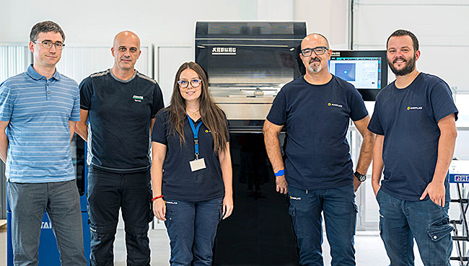

The Technological Institute for Plastics AIMPLAST, Spain, uses a Freeformer 200-3X for research into 3D printing materials. The cooperation team (from left): Dr Michael Salinas and José Francisco García from Arburg as well as Paula Maestro García, Galileo Roig and Vicente González Giménez from AIMPLAST.

Photo: Arburg

Photo Download:
https://media.arburg.com/web/20a754ef0d19ed5b/cooperation-aimplas-2024/

Press Release
File: Press release AIMPLAS 2024_en.docx
Character: 2.163
Words: 318

You can also download this and other press releases from our website at www.arburg.com/de/presse/ (www.arburg.com/en/presse/)

Contact us
ARBURG S.A.
Margarita Mahringer
Avenida de Madrid, 25 nave 9A
28500 Arganda del Rey (Madrid)
Tel. 91 870 29 29 / 629 71 73 03
margarita_mahringer@arburg.com

About Arburg
Founded in 1923, the German family-owned company is one of the world's leading machine manufacturers for plastics processing. The ARBURG family also includes AMKmotion and ARBURGadditive including innovatiQ.
The portfolio includes injection moulding machines, 3D printers for industrial additive manufacturing, robotic systems and customer- and industry-specific turnkey solutions. It also includes digital products and services.
ARBURG is a pioneer in the plastics industry when it comes to energy and production efficiency, digitalisation and sustainability. ARBURG machines are used to manufacture plastic products for the mobility, packaging, electronics, medical, construction and apparatus engineering and leisure sectors, for example.
The company headquarters are located in Lossburg, Germany. In addition, ARBURG has its own organisations in 27 countries at 37 locations and is represented in over 100 countries together with trading partners. Of the total workforce of around 3,700, around 3,100 are employed in Germany and around 600 in the ARBURG organisations worldwide.
ARBURG is certified in accordance with ISO 9001 (quality), ISO 14001 (environment), ISO 27001 (information security), ISO 29993 (training) and ISO 50001 (energy).
Further information: www.arburg.com, www.amk-motion.com and www.arburg.com/arburgadditive.

