Arburg at Fakuma 2024
Digitalisation and automation hand in hand: efficient, traceable part production

- Fully automated: a turnkey system with a hanging-mounted six-axis robot
- Compact: vertical Allrounder overmoulds inserts
- Seamless: ATCM for 100 percent traceable part quality and R-Cycle information

Lossburg, 19/09/2024
At Fakuma 2024, Arburg (Halle A3, Stand 3101) will be demonstrating how digitalisation and automation work hand in hand to produce plastic parts efficiently and with 100 percent traceability and recyclability, using a turnkey system centred around a vertical Allrounder 375 V. Vacuum housings are manufactured and installed in Multilift robotic systems. The accompanying six-axis robot is suspended and therefore requires very little space. The SCADA system Arburg Turnkey Control Module (ATCM) makes it possible to link material and process data. The fully automated application is also an application example of the R-Cycle initiative.

The compact turnkey system for the automated overmoulding of inserts and traceable part production is a sophisticated manufacturing solution with high autonomy. The consistent use of digitalisation solutions allows the individual process steps to be linked via a continuous data and information chain, enabling seamless tracking of part quality and output.

Space-saving automation
A vertical Allrounder 375 V with a clamping force of 500 kN is at the centre of the production cell, equipped with a single-cavity mould from Arburg. The hanging-mounted automation does require not any additional space. The six-axis robot first transfers two metal bushings, which are provided via vibratory conveyors, to the mould where they are overmoulded with glass-fibre-reinforced polyamide PA6 (GF30). The "aXw Control ReferencePilot" ensures homogeneous material preparation and consistently high product quality. This pilot function in the control system precisely regulates the pressure profile in the mould and compensates for fluctuations in viscosity. The cycle time is around 30 seconds, and the weight of the moulded part is 58.5 grams. After removal from the mould, the injection moulded parts are marked with two QR codes by a laser station for part-specific traceability and for reading R-Cycle information. The housings are finally discharged from the production cell via a conveyor belt.

100 percent traceable
The SCADA system ATCM is the key technology for linking and tracing material and process data. At the exhibit at Fakuma, the part-specific data from the injection moulding process and the automation will be collected and linked with the results of the visual inspection of the insert. The component ID ensures that each individual product is clearly identified and that the part quality is seamlessly documented.
On the other hand, the application is a practical example of R-Cycle and digital product passports: the ATCM passes on data relevant to processing and recycling over a defined production period during the manufacturing phase. This is done using a so-called GS1 barcode standard (in accordance with the German guideline "Circular Plastics Traceability"). R-Cycle enables standardised data exchange across company boundaries. The data is stored in digital product passports. In this way, information relevant to recycling can be viewed and utilised across the entire value chain, e.g. by subsequent processors, end users and recycling companies. This forms the basis for recyclable processes and the best possible reuse.

Photo

194730
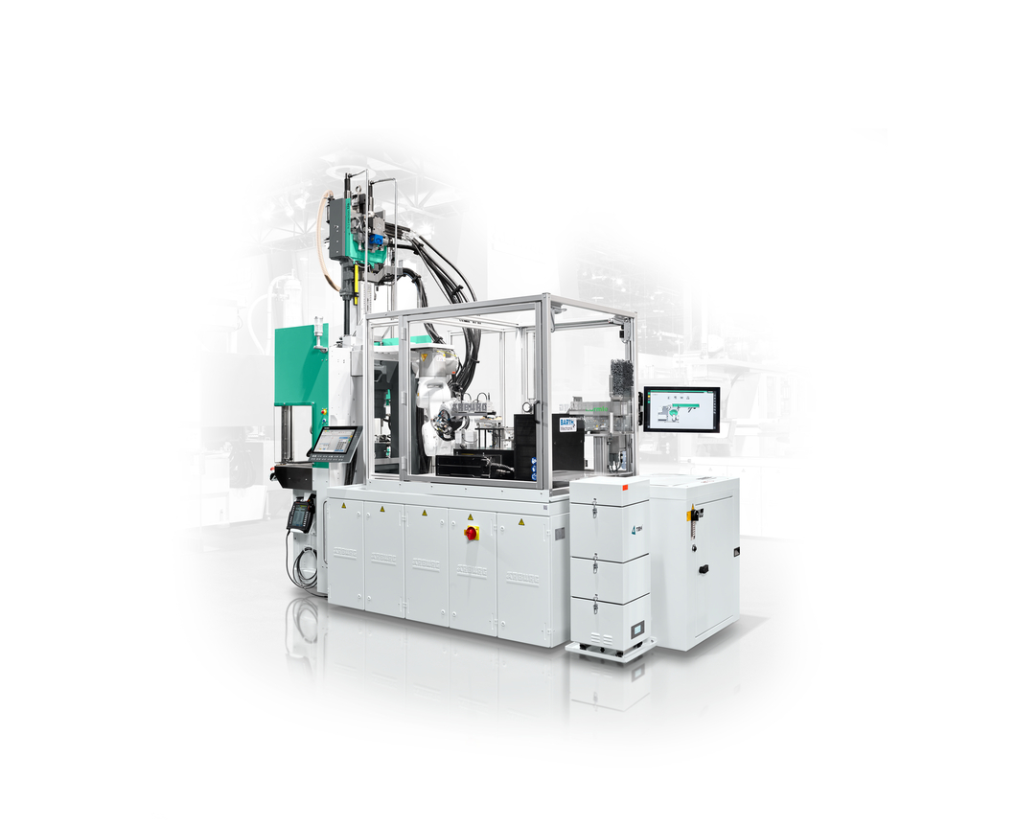

Compact: a turnkey system centred around an Allrounder 375 V with a hanging-mounted six-axis robot and Arburg Turnkey Control Module (ATCM) will be producing vacuum housings for Multilift robotic systems at Fakuma 2024.

Photo: Arburg
Photo download:
https://media.arburg.com/web/fdf1709acdea7908/allrounder-375v-fakuma-2024

Press release
File: Pressemitteilung Allrounder 375V Fakuma 2024_en_GB.docx
Characters: 3,178
Words: 477

This and other press releases are available for download from our website at www.arburg.com/de/presse/ (www.arburg.com/en/press/)

Contact
Arburg GmbH + Co KG
Press office
Susanne Palm
Dr Bettina Keck
Postfach 1109
72286 Lossburg
Tel.: +49 (0)7446 33-3463
Tel.: +49 (0)7446 33-3259
presse_service@arburg.com

About Arburg
Founded in 1923, the German family-owned company is one of the world's leading manufacturers of plastic processing machines. The ARBURG family also comprises AMKmotion and ARBURGadditive, including innovatiQ.
Its portfolio includes injection moulding machines, 3D printers for industrial additive manufacturing, robotic systems and customer- and industry-specific turnkey solutions. It also includes digital products and services.
ARBURG is a pioneer in the plastics industry when it comes to energy and production efficiency, digitalisation and sustainability. ARBURG machines are used to manufacture plastic products for industries such as mobility, packaging, electronics, medicine, construction and equipment engineering, and leisure.
The company headquarters are located in Lossburg, Germany. In addition, Arburg has its own organisations at 37 locations in 27 countries and, together with trading partners, is represented in over 100 countries. Of a total of around 3,700 employees, some 3,100 work in Germany while around 600 are based in ARBURG organisations around the world.
ARBURG is certified in accordance with ISO 9001 (quality), ISO 14001 (environment), ISO 27001 (information security), ISO 29993 (training) and ISO 50001 (energy).
Further information can be found at: www.arburg.com, www.amk-motion.com and www.arburg.com/arburgadditive.

