Arburg at Fakuma 2024
Allrounder 570 H "Ultimate": 64 medical syringe plungers in just six seconds

- High speed: Allrounder 570 H with new hybrid machine technology
- Sustainable: Innovative product design reduces material usage by 20 per cent
- Competent: Arburg offers complete solutions for medical technology

Lossburg, 17/09/2024
At Fakuma 2024, Arburg (Hall A3, Stand 3101) will be presenting a high-speed application for medical technology in the form of a hybrid Allrounder 570 H: 64 syringe plungers with a product design specifically optimised for reduced material usage will be produced in a cycle time of around just six seconds. The application demonstrates the advantages of combining hybrid machine technology with a high-performance mould and innovative product design.

The Hidrive series is particularly suitable for the production of typical mass-produced medical products. The exhibit features Arburg's hybrid machine technology, which combines an energy-efficient and precise electric clamping unit with a powerful and dynamic hydraulic injection unit.

High-speed medical application
At Fakuma 2024, Arburg will be presenting a concept for a high-speed medical application that can be used to produce from a grey room into a clean room. A clean room version of a hybrid Allrounder 570 H "Ultimate" with a clamping force of 2,000 kN will be on show, with special options including a clean-air module, light grey medical colour scheme and a conveyor belt with tunnel cover.
The exhibit will be equipped with a 64-cavity mould from Ruhla, and will process a medical PP from partner firm Borealis (Bormed HG820MO). The hot runner technology from Ewikon enables sprue-free direct lateral injection moulding. To monitor the temperatures in the mould, the injection moulding machine communicates with the hot runner controller via the Gestica control system and OPC UA. The speed of the ejector and mould opening are synchronised. A spring assembly in the mould transfers the components from the nozzle side to the ejector side before demoulding. In a cycle time of around just six seconds, the high-performance machine produces 64 free-falling syringe plungers, each weighing 0.34 grams, for 0.5 millilitre disposable syringes. This corresponds to an output of around 38,400 pieces per hour.
The innovative product design with three-blade geometry reduces the amount of material used in this application by around 20 per cent compared to a four-blade version. A predetermined breaking point ensures that the plunger snaps when it is pulled out again, meaning that the syringe can only be used once, which contributes to patient safety.

Hybrid machine technology reduces costs and cycle time
Launched on the market in 2023, the Allrounder Hidrive machines with new hybrid machine technology are particularly energy saving, economical with resources, production efficient, reliable and user friendly. Particularly impressive features include reduced purchase and operating costs, optimised energy footprint and reduced cycle times. They come in sizes 470, 520 and 570 with clamping forces of 1,000, 1,500 and 2,000 kN and in "Comfort", "Premium" and "Ultimate" performance variants. Thanks to a wide range of options, the machines can be customised precisely to the respective requirements. "Ultimate", the highest performance variant, is specially designed for high-speed and sophisticated processes. It has an electric direct drive that allows every position to be approached extremely quickly and precisely – even over a long service life and when the machine is running at full load. The "Arburg electro-mechanical dosage" (AED) function and hydraulic accumulator technology are included as part of the standard equipment.

Gestica control system: Pilot functions increase part quality
"Smart" pilot functions in the Gestica control system have the ability to significantly increase part quality. With the syringe plunger application, for example, the "aXw control PressurePilot" ensures bionically optimised pressure regulation. In turn, the "aXw Control ScrewPilot" compensates for errors in the filling process and keeps the mould filling stable. This makes it possible to achieve injection precision on a par with an electric injection unit. Arburg also offers functions such as "Stability Monitoring" for reduced scrap and "Precision Dosing" for precise screw control.

Arburg: Competent partner for medical technology
From docked machines to Allrounders completely in the clean room and complex turnkey systems, Arburg offers customised concepts for medical technology. The company's service expertise covers the entire process chain – from the project idea to the SAT (Site Acceptance Test) at the customer's premises. Added to this is support with services such as regular recalibration. At Fakuma 2024, ARBURG's experts will also be on hand to answer questions about qualification and validation as well as machine design, turnkey projects, risk analysis, particle measurement and clean-room concepts.

Photos

570H_DSC5738

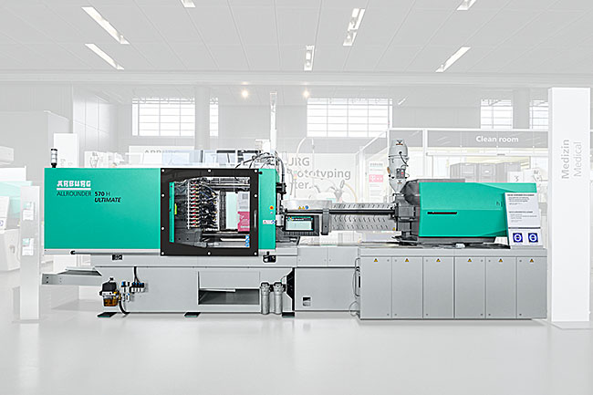
The Allrounder 570 H "Ultimate" with new hybrid machine technology will be on show for the first time at Fakuma 2024 in a light grey clean room version. The exhibit can produce 64 syringe plungers from PP in a cycle time of just six seconds.

197393
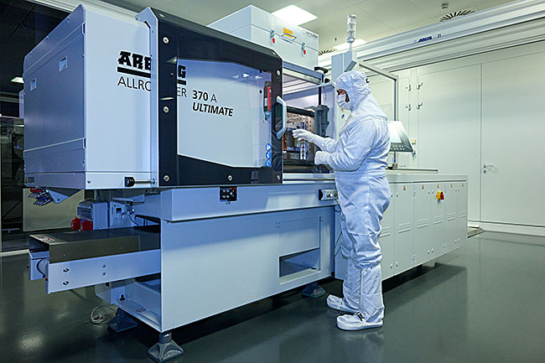
Arburg offers customised concepts for medical technology – from docked machines and Allrounders completely in the clean room to complex turnkey systems. A clean room version of the hybrid Allrounder 570 H "Ultimate" will be on show at Fakuma 2024.

570H syringe plunge_J0A5870
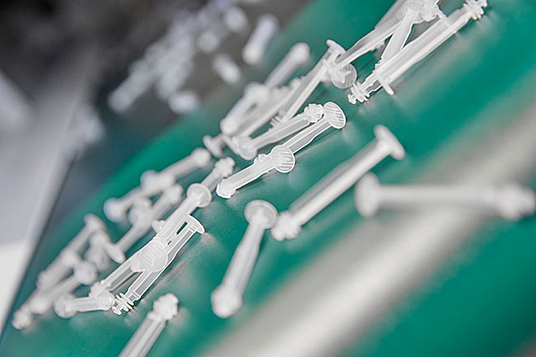
The three-blade design of the self-destructing syringe plungers reduces the amount of material used by around 20 per cent.

Photos: ARBURG

Photo download:
https://media.arburg.com/web/f9d98f41ace16e18/allrounder-570h-medical-fakuma-2024

Press release
File: Pressemitteilung Allrounder 570H Medical Fakuma 2024_en_GB.docx
Characters: 4,625
Words: 692

This and other press releases are available for download from our website at www.arburg.com/de/presse/ (www.arburg.com/en/press/)

Contact
ARBURG GmbH + Co KG
Press office
Susanne Palm
Dr Bettina Keck
Postfach 1109
72286 Lossburg
Tel.: +49 (0)7446 33-3463
Tel.: +49 (0)7446 33-3259
presse_service@arburg.com

About Arburg
Founded in 1923, the German family-owned company is one of the world's leading manufacturers of plastic processing machines. The ARBURG family also comprises AMKmotion and ARBURGadditive, including innovatiQ.
Its portfolio includes injection moulding machines, 3D printers for industrial additive manufacturing, robotic systems and customer- and industry-specific turnkey solutions. It also includes digital products and services.
ARBURG is a pioneer in the plastics industry when it comes to energy and production efficiency, digitalisation and sustainability. ARBURG machines are used to manufacture plastic products for industries such as mobility, packaging, electronics, medicine, construction and equipment engineering, and leisure.
The company headquarters are located in Lossburg, Germany. In addition, Arburg has its own organisations at 37 locations in 27 countries and, together with trading partners, is represented in over 100 countries. Of a total of around 3,700 employees, some 3,100 work in Germany while around 600 are based in ARBURG organisations around the world.
ARBURG is certified in accordance with ISO 9001 (quality), ISO 14001 (environment), ISO 27001 (information security), ISO 29993 (training) and ISO 50001 (energy).
Further information can be found at: www.arburg.com, www.amk-motion.com and www.arburg.com/arburgadditive.

