New electric machine for Asia
Local to local: Allrounder Golden Electric Evo

- New: Entry-level electric machines for the Asian market
- Focus: "Made by Arburg" – cost effective and
quickly available
- Premiere: On view for the first time at Chinaplas

Lossburg/Shanghai 22/04/2024
The Allrounder Golden Electric Evo series, which is celebrating its premiere at Chinaplas 2024, is fully tailored to Asia. The electric machines combine the "Made by Arburg" quality seal known throughout the global market with unbeatable value for money and short delivery times, making the purchase of an Arburg machine easy, quick and cost effective for Asian customers. In action at the trade fair in Shanghai will be an Allrounder 470 E Golden Electric Evo, demonstrating a sophisticated LSR application automated with a Flexlift 10 linear robotic system, also specially designed for Asia.

Arburg set the initial course for its "local-to-local" activities back in 2020, with the opening of the Arburg Technology Factory (ATF) in Pinghu. Initially, activities focused on adapting Allrounder machines to customer-specific requirements and implementing turnkey systems in cooperation with local suppliers of moulds and peripheral equipment. This was followed in 2023 by the Flexlift linear robotic system and now the Allrounder Golden Electric Evo. Both product series are specifically tailored to the requirements of customers in Asia, and are also exclusively available there.
Assembly in the ATF ensures quick availability of the entry-level electric machines. The portfolio includes the sizes 370, 470, 520 and 570, which cover clamping forces ranging from 600 to 2,000 kN. The injection units range from size 100 to size 800, for shot weights of up to around 430 grams of PS.

Precision, speed and energy efficiency
The Allrounder Golden Electric Evo is extremely precise, thanks to its high-quality injection units. The servo-electric drives for "inject", "dose" and "open and close mould" deliver fast acceleration, high speeds, and simultaneous movements, all of which add up to short cycle times. Compared to standard hydraulic machines, the dry cycle times are up to two seconds shorter. What's more, the energy requirement can be reduced by up to 50 per cent with the toggle-type clamping unit, the high efficiency of the servo-electric drive and recovery of braking energy.

Just for Asia: The Flexlift robotic system
Another product designed for the Asian market is the Flexlift, a reliable, quick and precise robotic system that offers excellent value for money. Its minimal height and telescopic design also make it suitable for confined spaces. Powerful servo motors ensure highly dynamic and precise performance of the vertical mould-entry axes. This enables fast removal, accurate and vibration-free movements and short cycle times.
In addition, the automation and application experts in the ATF in Pinghu develop turnkey and tailored complete solutions in cooperation with local partners. An example is the Chinaplas exhibit for LSR processing.

Heat- and media-resistant LSR components
An electric Allrounder 470 E Golden Electric Evo with 1,000 kN of clamping force, LSR cylinder and vacuum equipment will produce valves made of liquid silicone rubber for use in cars. The material Elastosil (Shore hardness 50 A) from Wacker is resistant to heat and media, and also offers good resilience and a consistently high performance. Using an 8-cavity mould from Chinese partner Gaoyuan, eight LSR components, each weighing 0.8 grams, are produced in a cycle time of around 55 seconds. Injection is sprueless and performed directly via a pneumatic cold runner system. The LSR dosing unit is supplied by Arburg's partner 2KM. A Flexlift 10 linear robotic system gently removes the moulded parts from the mould and places them on a conveyor belt.

Images

Allrounder 470E Golden Electric Evo perspective

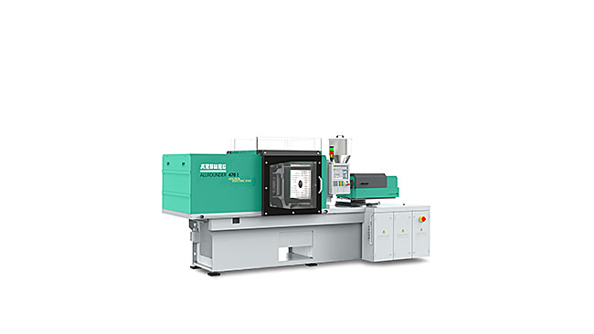

At Chinaplas 2024, an electric Allrounder 470 E Golden Electric Evo will be producing LSR valves using an 8-cavity mould . Part handling will be performed by a Flexlift 10 linear robotic system.

185627 / 185625
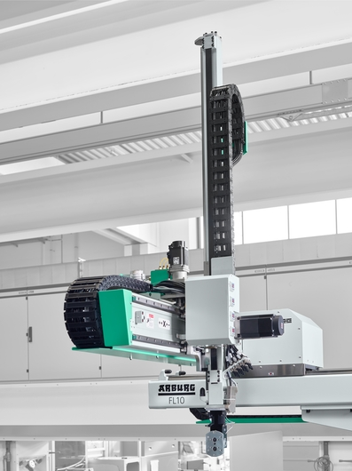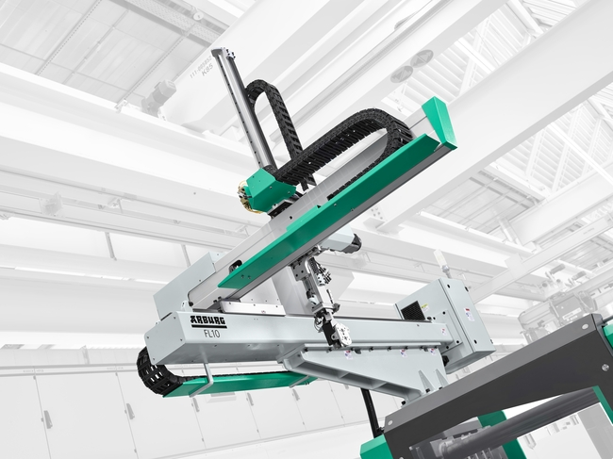

Arburg has designed the Flexlift specially for the Asian market. The linear robotic system is available with load weights of 5, 10 and 15 kg, and in each case optionally with one or two vertical axes.

Photos: Arburg
Photo download:
https://media.arburg.com/web/a84ed6c974ae109c/allrounder-470e-golden-electric-evo-chinaplas-2024/

Press release
File: 01 ARBURG press release Allrounder Golden Electric Evo_en_GB.docx
Characters: 3.549
Words: 553

This and other press releases are available for download from our website at www.arburg.com/de/presse/ (www.arburg.com/en/press/)

Contact
Arburg GmbH + Co KG
Press office
Susanne Palm
Dr. Bettina Keck
Postfach 1109
72286 Lossburg, Germany
Tel.: +49 7446 33-3463
Tel.: +49 7446 33-3259
presse_service@arburg.com

About Arburg
Founded in 1923, the German family-owned company is one of the world's leading manufacturers of plastic processing machines. The ARBURG family also includes AMKmotion and ARBURGadditive, including innovatiQ.
The portfolio includes injection moulding machines, 3D printers for industrial additive manufacturing, robotic systems and customer- and industry-specific turnkey solutions. It also includes digital products and services.
ARBURG is a pioneer in the plastics industry when it comes to energy and production efficiency, digitalisation and sustainability. ARBURG machines are used to manufacture plastic products for industries such as mobility, packaging, electronics, medicine, construction and equipment engineering, and leisure.
The company headquarters are located in Lossburg, Germany. In addition, ARBURG has its own organisations at 36 locations in 26 countries and, together with trading partners, is represented in over 100 countries. Of a total of around 3,700 employees, some 3,100 work in Germany while around 600 are based in ARBURG organisations around the world.
ARBURG is certified in accordance with ISO 9001 (quality), ISO 14001 (environment), ISO 27001 (information security), ISO 29993 (training) and ISO 50001 (energy).
Further information: www.arburg.com, www.amk-motion.com and www.arburg.com/arburgadditive.

