2024 training cohort
75th year of training – 75 new trainees and DHBW students join Arburg

- Growth: Managing Director Steffen Kroner welcomes 56 new trainees and 19 DHBW students
- Foresight: at Arburg, training is one of the keys to a successful future
- Success: Arburg has been offering training excellence for 75 years

Lossburg, 05/09/2024
On 2 September 2024, a total of 75 trainees and students from the Baden-Wuerttemberg Cooperative State University (DHBW) began their professional careers at Arburg. They were welcomed by Steffen Kroner, the new Managing Director Finance, Controlling, IT and HR Management, and by Training Manager Michael Vieth, whose first working day at Arburg was exactly 40 years ago.

"On behalf of Arburg management, the shareholder families, and all employees - especially the training team - I am delighted to welcome you to the Arburg family this morning," said Steffen Kroner, emphasising: "Providing young people with a solid foundation for their careers is extremely important to us. Training is one of the keys to a successful future at Arburg. And it has been for 75 years. To succeed together, we need your commitment, your flexibility and your willingness to learn for life!"

Varied introduction
The 2,000 square metre Vocational Training Center is the central contact point. To make starting out on a career path easier and to get to know the "Arburg family" better, Training Manager Michael Vieth and his 20-member team have developed a comprehensive programme. During an introductory week, the newcomers are given the opportunity to discover the company and get to know their trainee colleagues and cohort supervisors, who are on hand to give them advice and support. Other activities include a tour of the company and a presentation of the product range and corporate philosophy. In addition, a team-building event and joint barbecue are planned.

Triple training certification
This year, the Lossburg-based family company can reflect on 75 years of successful training. Since 1949, Arburg has laid the foundations for the successful careers of almost 2,300 young people. In order to continuously expand the high level of its training, Arburg works closely with vocational schools and the cooperative state universities and is the first company in Baden-Wuerttemberg to be awarded triple certification since 2018: ISO 29993 for quality management in training, the LQW award (learner-oriented quality testing in further education) and the seal of approval of the Chamber of Industry and Commerce (IHK). As one of the largest apprenticeship employers in the Northern Black Forest region, Arburg is one of the select few among 1,300 companies to receive the "1A Ausgezeichneter Ausbildungsbetrieb" (Excellence in Training) award again in 2024.

Apply now for 2025
Arburg consistently offers demand-driven training across more than 15 different professions. There is a diverse range of training and DHBW degree programmes to choose from. Including commercial and technical professions such as industrial mechanic, technical product designer, plastics and rubber technologist, warehouse logistics specialist or industrial clerk. Courses include industrial engineering, computer science, mechatronics, electrical engineering and mechanical engineering. Anyone interested in a traineeship or the Cooperative State University programme at Arburg can find all the information they need about careers and applications on the trainee homepage at www.ausbildung.arburg.com or in the applicant portal at www.arburg.com/info/ausbildung.

Photo

Trainees 2024_DSC1636

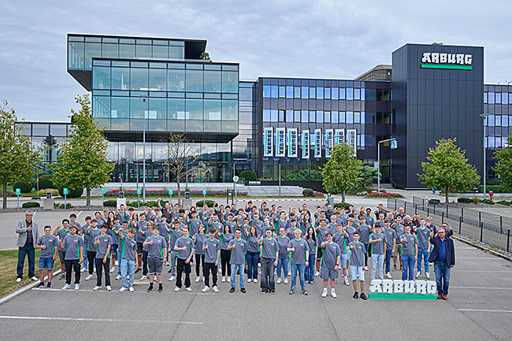
Looking forward to a successful start to their careers: 75 apprentices and DHBW students joined Arburg in Lossburg on 2 September 2024.

Photo download:
https://media.arburg.com/web/194c17b0eae93fb9/trainees-2024-press-release

Press release
File: Pressemitteilung Ausbildungsjahrgang 2024_en_GB.docx
Characters: 3,216
Words: 481

This and other press releases are available for download from our website at www.arburg.com/de/presse/ (www.arburg.com/en/press/)

Contact
ARBURG GmbH + Co KG
Press office
Susanne Palm
Dr Bettina Keck
Postfach 1109
72286 Lossburg
Tel.: +49 (0)7446 33-3463
Tel.: +49 (0)7446 33-3259
presse_service@arburg.com

About Arburg
Founded in 1923, the German family-owned company is one of the world's leading manufacturers of plastic processing machines. The ARBURG family also comprises AMKmotion and ARBURGadditive, including innovatiQ.
Its portfolio includes injection moulding machines, 3D printers for industrial additive manufacturing, robotic systems and customer- and industry-specific turnkey solutions. It also includes digital products and services.
ARBURG is a pioneer in the plastics industry when it comes to energy and production efficiency, digitalisation and sustainability. ARBURG machines are used to manufacture plastic products for industries such as mobility, packaging, electronics, medicine, construction and equipment engineering, and leisure.
The company headquarters are located in Lossburg, Germany. In addition, Arburg has its own organisations at 37 locations in 27 countries and, together with trading partners, is represented in over 100 countries. Of a total of around 3,700 employees, some 3,100 work in Germany while around 600 are based in ARBURG organisations around the world.
ARBURG is certified in accordance with ISO 9001 (quality), ISO 14001 (environment), ISO 27001 (information security), ISO 29993 (training) and ISO 50001 (energy).
Further information can be found at: www.arburg.com, www.amk-motion.com and www.arburg.com/arburgadditive.

