Arburg training: Event on the company's history
New training cohort immerses itself in Arburg company history

- 75 years of Arburg training: Interactive campaign on the company's history
- "Group experience trip": New trainees and students learn more about the company's history in workshops
- Company archive: Exciting tasks in multimedia format

Lossburg, 12/12/2024
Those who know more about the history of their company are also more emotionally connected to it, and this year Arburg is celebrating 75 years of training. Two good reasons for the machine manufacturer's first "History Week" in Lossburg. From 5 to 11 December 2024, the new trainees and students delved deep into the company archive during workshops and experienced Arburg's history in an active and multimedia way.

Katharina Depner, company archivist at Arburg, has designed a one-hour "group adventure trip" for the 2024 training year. The participants were actively introduced to the company's historical highlights in four exciting workshops.

"Group adventure trip" to the archive
In groups of ten to 20 people each, the new trainees and students familiarised themselves with the company archive and its "treasures" in detail. The prospective cutting machine operators and mechatronics technicians started on 5 December, followed by the industrial and construction mechanics, IT specialists and electronics technicians and finally, on 11 December, the warehouse logistics specialists, industrial clerks and students from the dual universities. Katharina Depner describes the aims of the four workshops as follows: "Trainees and students should be able to engage directly with our company history together and experience it using striking examples."

Topics on company history developed
Each group began their workshop with an introduction to the company archive. The young visitors then split into three teams to work on three set topics. Firstly, the participants had to put the entire Arburg company complex together correctly using a "building puzzle". They then focussed on the differences in training between the past and present and the development of the professions. The trainees and students were given the opportunity to familiarise themselves with the training chronicle and work with it. The third part of the workshop focussed on the world of work. Questions that arose here included how people worked in the office at Arburg back then.
In a feedback round, the trainees described the workshops as very informative and interesting. They particularly liked the many "tangible" historical exhibits, such as an old time clock, as well as a video from 1982, which showed the company's state-of-the-art production technologies at the time. Between all the insights and the newly acquired knowledge, this excursion into the past was a complete success and an appealing format for providing information about the exciting history of Arburg.

Broad knowledge transfer in 75 years of training
In the anniversary year of the Arburg apprenticeship programme, the "History Week" is one of many activities to draw attention to the company's training expertise and broad knowledge transfer. Trainer Marius Singer sees the benefits of the campaign in the company archive primarily in integrating the young employees into the Arburg family right from the start: "We wanted to familiarise our 75 trainees and students with '75 years of training at Arburg' in a special setting. The young people should be able to understand the development of 'their' company. This has a positive influence on the identification between the company, trainees and students right from the start." If the analysis of the workshops produces a positive result, they will be continued in the coming years.
More about "75 years of Arburg training" can also be found on the Instagram channel of the Arburg rookies: https://www.instagram.com/arburg_rookies/?hl=de

Picture

History Week 1486

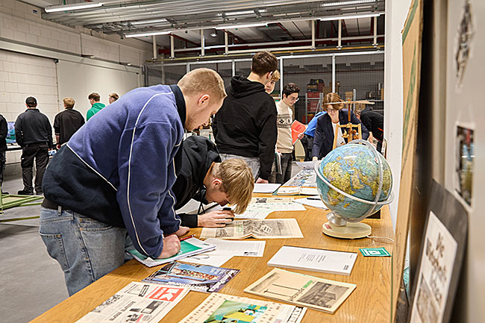

"History Week" at Arburg: As part of four workshops in December 2024, the trainees worked on various topics relating to the company's history in the Arburg archive. Exciting details were closely scrutinised.

Photo: ARBURG
Photo Download:
https://media.arburg.com/web/94bd10e67282727c/history-week-press-release/

Press Release
File: ARBURG press release History Week 2024_en_GB.docx
Characters: 3,479
Words: 543

You can also download this and other press releases from our website at www.arburg.com/de/presse/ (www.arburg.com/en/presse/)

Contact us
ARBURG GmbH + Co KG
Press office
Susanne Palm
Dr Bettina Keck
PO Box 1109
72286 Lossburg
Phone: +49 7446 33-3463
Phone: +49 7446 33-3259
presse_service@arburg.com

About Arburg
Founded in 1923, the German family-owned company is one of the world's leading machine manufacturers for plastics processing. The ARBURG family also includes AMKmotion and ARBURGadditive including innovatiQ.
The portfolio includes injection moulding machines, 3D printers for industrial additive manufacturing, robotic systems and customer- and industry-specific turnkey solutions. It also includes digital products and services.
ARBURG is a pioneer in the plastics industry when it comes to energy and production efficiency, digitalisation and sustainability. ARBURG machines are used to manufacture plastic products for sectors such as mobility, packaging, electronics, medicine, construction, apparatus engineering and leisure.
The company headquarters are located in Lossburg, Germany. In addition, ARBURG has its own organisations in 27 countries at 37 locations and is represented in over 100 countries together with trading partners. Of the total workforce of around 3,700, around 3,100 are employed in Germany and around 600 in the ARBURG organisations worldwide.
ARBURG is certified in accordance with ISO 9001 (quality), ISO 14001 (environment), ISO 27001 (information security), ISO 29993 (training) and ISO 50001 (energy).
Further information: www.arburg.com, www.amk-motion.com and www.arburg.com/arburgadditive.

