"pureelbe" project and swimming event
Arburg once again supports "swimming professor" in passion project

- Sporty: Transnational swimming event over 1,000 kilometres to the Elbe estuary
- Active: Large-scale campaign draws attention to water pollution and microplastics
- Committed: Professor Andreas Fath is also an Arburg brand ambassador

Lossburg, 13/09/2024
On 10 September 2024, Professor Andreas Fath from Furtwangen University, now internationally known as the "swimming professor", once again completed a project close to his heart on the subject of water pollution: after previous swimming events down the Rhine, the Tennessee River and the Danube, he swam the entire length of the Elbe starting on 16 August, also acting as a floating brand ambassador for Arburg.

Drawing attention to pollution in rivers and the major issue of protecting our waterways is a passion project for Professor Dr Andreas Fath, and one in which he is also supported by sponsors such as Arburg.

1,083 kilometre long "swimming pool"
The 1,083-kilometre "swimming pool" stretched from the source of the Elbe, or Smirice in the Czech Giant Mountains, to the mouth of the Elbe in Cuxhaven. Professor Andreas Fath reached his destination after just 25 days and an average of 46 kilometres and eight hours of swimming per day. Along the way, he and his team took daily water samples, which were scientifically analysed for things such as microplastic content. The wetsuit he wore in the water was also particularly interesting as it had a filter membrane attached to it that imitated fish skin and provided additional information on water quality. (More about the project: www.pureelbe.org)

"Swimming professor" highly motivated
Professor Andreas Fath has already swum several thousand kilometres in a number of large transnational rivers. His motivation in a nutshell is "clean water." The goal is ambitious: of the 8.3 billion tonnes of plastic that humans have already produced worldwide to date, only nine percent has been recycled so far. To put it another way: far too much plastic waste and microplastics are still ending up in rivers, lakes and oceans around the world instead of being collected and recycled. This is why large-scale campaigns are important alongside the marathon swim. Along the route, workshops, seminars and lectures are held, press events and clean-ups organised, films about the projects shown and, with Fath's "knowledge workshop", simple and easy-to-understand experiments with water carried out to motivate as many people as possible to take a stand for the protection of this important life source.

"pureelbe": Arburg provides sponsorship again
During the swimming marathon down the Elbe, Professor Dr Andreas Fath's non-profit company H2Org was supported by the Plastic-Free Nature Alliance (Bündnis plastikfreie Natur) as a cooperation partner. The main sponsors were companies Arburg and Hansgrohe as well as Furtwangen University. The project attracted a great deal of attention in major German cities such as Dresden, Leipzig and Hamburg. The reception committee in Hamburg included Managing Director Gerhard Böhm and Vice President Global Marketing Dr Christoph Schumacher, both from Arburg, as well as Hansgrohe CEO Hans-Jürgen Calmbach and Rector Dr Alexandra Bormann from Furtwangen University.
"After "cleandanube", "pureelbe" is now the second successful project in which we have been very happy to support our brand ambassador," says Dr Christoph Schumacher. "Our sponsorship underscores our company's commitment to sustainable production. For many years now, we have been bringing together our activities relating to resource conservation and the circular economy in the "arburgGREENworld" program. We are working hard to reduce the carbon footprint of our machines in production and use by customers and to advance the processing of recycled materials."

Discussion panel and finale in the "Villa Viva"
At the end of the Hamburg leg, the "swimming professor" received support in the water from Leonie Beck, a top German swimmer and multiple open water world champion. Shortly before reaching the harbour, the swimmers were picked up by the "Aldebaran", a German research and sailing ship, and taken to the "Cap San Diego" at Hamburg's Überseebrücke. This ship provided a fitting setting for the reception, which was followed by a discussion panel on the topic of clean water and a Q&A session. The day ended with a joint dinner. Three days later, Professor Andreas Fath completed "pureelbe" in Cuxhaven.

Photos

pureelbe Hamburg 2025-09-07 DE_CS1
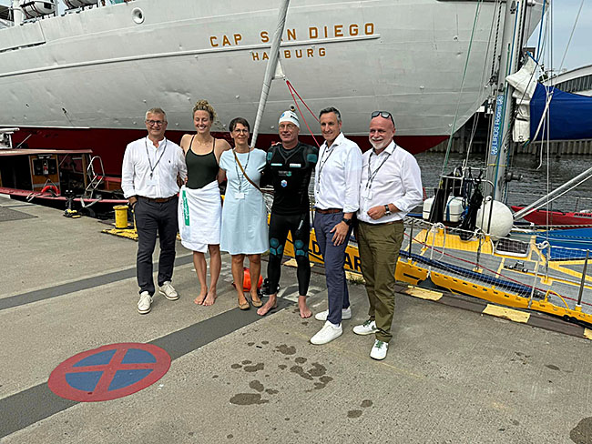
On 7 September 2024, the "swimming professor" Andreas Fath (3rd from right) was welcomed at his final destination in Hamburg by the "pureelbe" sponsors: Gerhard Böhm (left) and Dr Christoph Schumacher (right), both Arburg, Hans-Jürgen Kalmbach (2nd from right), Hansgrohe, and Dr Alexandra Bormann, Rector of Furtwangen University (3rd from left). Swimming champion Leonie Beck (2nd from left) also accompanied him on the last leg of the day's stage.

pureelbe Hamburg 2025-09-07 DE_CS2
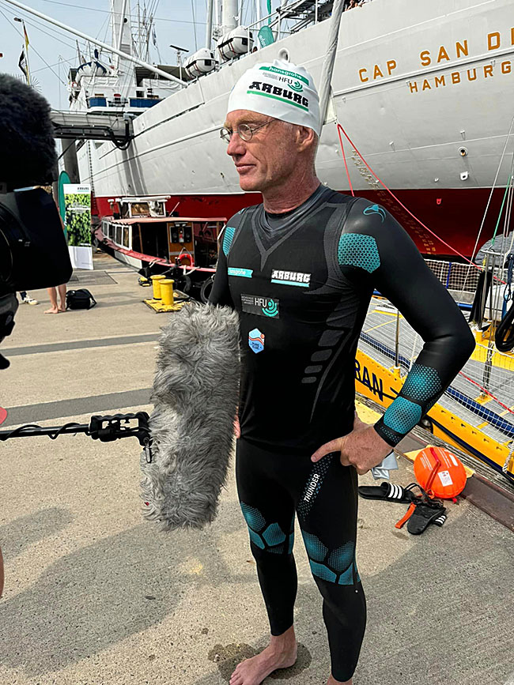
Out of the water and in front of the press: On 7 September 2024, the "swimming professor" and Arburg brand ambassador Professor Andreas Fath arrives in Hamburg as part of the "pureelbe" project, where he is given a high-profile welcome.

Photo: ARBURG
Photo download:
https://media.arburg.com/web/7169ea516e1ac39f/pureelbe-hamburg-2024-press-release

Press release
File: Pressemitteilung PureElbe Hamburg 2024_en_GB.docxx
Characters: 4,059
Words: 651

This and other press releases are available for download from our website at www.arburg.com/de/presse/ (www.arburg.com/en/press/)

Contact
ARBURG GmbH + Co KG
Press office
Susanne Palm
Dr Bettina Keck
Postfach 1109
72286 Lossburg
Tel.: +49 (0)7446 33-3463
Tel.: +49 (0)7446 33-3259
presse_service@arburg.com

About Arburg
Founded in 1923, the German family-owned company is one of the world's leading manufacturers of plastic processing machines. The ARBURG family also comprises AMKmotion and ARBURGadditive, including innovatiQ.
Its portfolio includes injection moulding machines, 3D printers for industrial additive manufacturing, robotic systems and customer- and industry-specific turnkey solutions. It also includes digital products and services.
ARBURG is a pioneer in the plastics industry when it comes to energy and production efficiency, digitalisation and sustainability. ARBURG machines are used to manufacture plastic products for industries such as mobility, packaging, electronics, medicine, construction and equipment engineering, and leisure.
The company headquarters are located in Lossburg, Germany. In addition, Arburg has its own organisations at 37 locations in 27 countries and, together with trading partners, is represented in over 100 countries. Of a total of around 3,700 employees, some 3,100 work in Germany while around 600 are based in ARBURG organisations around the world.
ARBURG is certified in accordance with ISO 9001 (quality), ISO 14001 (environment), ISO 27001 (information security), ISO 29993 (training) and ISO 50001 (energy).
Further information can be found at: www.arburg.com, www.amk-motion.com and www.arburg.com/arburgadditive.

