New Arburg subsidiary in Romania
Arburg expands its presence in South Eastern Europe

- Own subsidiary in Romania since April 2024
- Products and services now even closer to customers
- Arburg organisations at 37 locations in 27 countries

Lossburg, 18/06/2024
With the establishment of its own subsidiary in Romania in April 2024, Arburg has taken another important step in further increasing its local presence in the emergent economic region of South Eastern Europe. The new subsidiary is based in Bucharest and is headed up by Interim Managing Director Dr Daniel Orel, who is responsible for the Arburg subsidiaries in Czechia and Slovakia. The intention with this step is to bring Arburg products and services even closer to customers.

With the new subsidiary in Romania, Arburg now has its own organisations at 37 locations in 27 countries as well as trading partners in over 100 countries. This is how the company ensures that all of its technology as well as the necessary specialists can be on site quickly when needed by customers – entirely in line with Arburg's brand promise "Wir sind da."

Full range of products and services
Dr Daniel Orel explains the reasoning behind the establishment of a subsidiary: "We want to make our portfolio of products and services available to customers in this growing market easily, quickly and reliably. Since our previous trading partner decided to close their business rather than pass it on, this was a logical step given how important continuity of support for our Romanian and international customers in the market was to us." Customers in Romania had been supported by an Arburg trading partner since 2000, most of whose service technicians were able to be absorbed into the new subsidiary. This means that eleven employees have been working in Bucharest right from the outset, all of whom have a wealth of experience as Arburg service technicians and are already known to the customers.

Important location for South Eastern Europe
"We have always had our own organisations in places where our customers are located and make investments," stresses Steffen Eppler, Vice President Sales Europe at Arburg, before going on to categorise the Romanian market as follows: "Romania is very important for Arburg. Increasingly, companies are also installing very sophisticated systems there. The infrastructure in the country has improved significantly in the last 20 years. Now as before, entire productions are still being moved to Romania. This is another reason why we want to offer our existing customers comprehensive advice and services on site and thus also win new customers.” Since Romania is a big country in terms of area, the company will continue to work with a decentralised service organisation in order to be able to reach customers quickly.

Increasingly sophisticated technology
Romania is a country in the process of increasing technological advancement too. Until now, it was mainly a market with hydraulic machines; now, there are more electric machines and the proportion of robotic systems and automation is growing too. The majority of the plastics processing companies produce components for the automotive industry. Other industries in Romania include electronics, building technology and construction, packaging and household goods.
Since its accession into the EU, a lot of money has been invested in the country, leading to a huge improvement in the infrastructure. Most of Arburg's customers have established themselves in Transylvania, in the north west of the Carpathian region. While the majority of customers before the country joined the EU were Romanian, today they are mostly large to medium-sized German and international companies. "They are all familiar with our product and service portfolio and trust Arburg as a partner for practical, individual processing solutions," says Dr Daniel Orel. "With the establishment of our own subsidiary in Bucharest, we want to strengthen existing partnerships and establish new contacts to further expand Arburg's market position in Romania."

Photo

Daniel Orel 182058

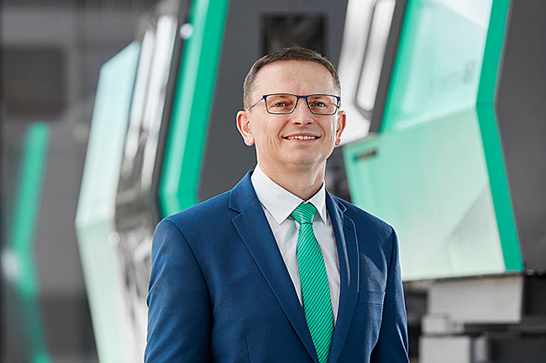

Daniel Orel, Managing Director of the Arburg subsidiaries in Czechia and Slovakia, also heads the newly established subsidiary in Romania on an interim basis.

Photo: ARBURG
Photo download:
https://media.arburg.com/web/7061ac5d39ffe9ea/new-subsidiary-romania-2024

Press release
File: Pressemitteilung neue Niederlassung Rumänien 2024_en_GB.docx
Characters: 3.793
Words: 600

This and other press releases are available for download from our website at www.arburg.com/de/presse/ (www.arburg.com/en/press/)

Contact
ARBURG GmbH + Co KG
Press office
Susanne Palm
Dr Bettina Keck
Postfach 1109
72286 Lossburg, Germany
Tel.: +49 7446 33-3463
Tel.: +49 7446 33-3259
presse_service@arburg.com

About Arburg
Founded in 1923, the German family-owned company is one of the world's leading manufacturers of plastic processing machines. The ARBURG family also includes AMKmotion and ARBURGadditive, including innovatiQ.
The portfolio includes injection moulding machines, 3D printers for industrial additive manufacturing, robotic systems and customer- and industry-specific turnkey solutions. It also includes digital products and services.
ARBURG is a pioneer in the plastics industry when it comes to energy and production efficiency, digitalisation and sustainability. ARBURG machines are used to manufacture plastic products for industries such as mobility, packaging, electronics, medicine, construction and equipment engineering, and leisure.
The company headquarters are located in Lossburg, Germany. In addition, ARBURG has its own organisations at 37 locations in 27 countries and, together with trading partners, is represented in over 100 countries. Of a total of around 3,700 employees, some 3,100 work in Germany while around 600 are based in ARBURG organisations around the world.
ARBURG is certified in accordance with ISO 9001 (quality), ISO 14001 (environment), ISO 27001 (information security), ISO 29993 (training) and ISO 50001 (energy).
Further information: www.arburg.com, www.amk-motion.com and www.arburg.com/arburgadditive.

