Arburg Technology Days 2024
Full house – great atmosphere: Over 5,100 guests from all over the world flock to Lossburg

- arburgSOLUTIONworld: Concentrated knowledge and expertise from Arburg in great demand
- More than a machine: Over 40 exhibits plus digitalisation, automation and solution expertise
- 25 years: Technology Days have inspired more than 100,000 visitors from 50 nations over this period

Lossburg, 19/03/2024
Over 5,100 guests from all over the world who flocked to Lossburg for the Arburg Technology Days 2024 from 13 to 16 March were thoroughly impressed and in high spirits. In total, this unique industry event has attracted over 100,000 visitors since it began 25 years ago. The company presented a huge variety of plastics processing applications in its “Think Tank”, which featured over 40 exhibits, including many innovations. However, the focus was not just on pure technology, but on “more than a machine”. For instance, arburgSOLUTIONworld presented the company’s comprehensive consulting and solution expertise, and the “Automation + Turnkey” area was very popular too. Visitors were also shown how easily and systematically Arburg digitalisation intelligently supports and connects all areas of injection moulding with a focus on the customer.

“We are very satisfied with the Technology Days 2024,” says Dr Christoph Schumacher, Vice President of Global Marketing at Arburg, in summary. “Despite the difficult economic environment worldwide and the upcoming NPE and Chinaplas trade fairs in North America and Asia, customers from over 40 countries came to Lossburg, knowing that we would assist them with all their questions and showcase innovations that can deliver real added value.”

Energy efficient: New Allrounder Golden Edition ASH
Customers looking for an entry-level hydraulic machine with an extremely attractive price/performance ratio, proven high performance and significantly reduced energy requirements were surprised by an interesting innovation: With immediate effect, all hydraulic Allrounder Golden Edition machines in sizes 420 to 570 have optional dual-circuit pump technology with the Arburg servo hydraulic system (ASH). Thanks to energy-optimised and speed-controlled servo motors, the specific energy requirement can be reduced by up to 50 per cent depending on the process. Sizes 270 and 320 will follow from the end of 2024. An Allrounder 470 C Golden Edition ASH with a clamping force of 1,000 kN celebrated its premiere at the 2024 Technology Days.

arburgSOLUTIONworld: Comprehensive advice and solutions
In arburgSOLUTIONworld, visitors were able to find out which parameters could be leveraged to increase efficiency and reduce costs in their own injection moulding production. Six stations around an eye-catching LED column provided personalised advice and information on topics such as Arburg’s “Action Plan: Energy”, the ALS host computer system and arburgXworld customer portal that can be linked to it, and the Gestica control system with its intelligent assistance and pilot functions.
The exciting keynote speech entitled “Enabling your future – smart and system-orientated solutions” by Managing Directors Gerhard Böhm and Guido Frohnhaus was also met with great interest. Around 300 guests attended the three keynote speeches followed by a panel discussion.

arburgXworld: All of Arburg’s knowledge in a single app
The many features of the arburgXworld customer portal, and in particular the new “Ask ARBURG” premium app, also met with a great response. The app offers decades of Arburg experience paired with artificial intelligence (AI) and is being continuously expanded. Working like the well-known large language model ChatGTP, it is being continuously populated with new content and will in future answer any questions relating to Arburg’s range of products and services, including injection moulding, additive manufacturing, automation, digital products, training and service.
The Arburg host computer system, which is now available in the new ALS 8.0 version, is the central MES for plastics processors, enabling them to digitally plan and control their entire production process and increase OEE (overall equipment effectiveness) by an average of around 26 per cent, as a representative survey has shown. Those also interested in the Arburg Remote Service, available “Ready2Go” machines or retrofits were in exactly the right place in the service area.

40 exhibits: Expertise and wide variety of applications
Arburg demonstrated its expertise in plastics processing with over 40 other exhibits. Application highlights included:
- The new Mantara lightweight construction process, which combines physical foaming with injection compression moulding and expansion stroke. The result is up to 60 per cent less clamping force and 30 per cent lighter parts with a homogeneous foam structure.
- High-quality IMD film technology for trims and control panels, for example. An electric Allrounder 820 A, which produced a “wallbox” demonstrator, showed how high-quality surfaces can be customised using this technology.
- The processing of Systalen® post-consumer recyclate (PCR). An electric Allrounder 720 A, equipped with the “aXw Control RecyclatePilot”, processed the PCR made from 100 per cent household waste into thin-walled flower pots.
- The production of 70,000 LSR sealing elements per hour was demonstrated by an electric Allrounder 520 A with a 256-cavity mould from Rico.
- The two-component injection moulding of food-safe spatulas made of PCB and LSR with an Allrounder More 2000.

“30 years of Automation + Turnkey”
In addition to machine technology, Arburg has been offering its own automation and turnkey solutions for exactly 30 years, and a number of current customer projects related to this were once again on display at the Technology Days 2024. One example was an electric Allrounder 370 A with a shortened linear robotic system mounted inside the machine guard, so that the footprint was not increased. An electric two-component Allrounder 520 A with a clean air module above the clamping unit was automated with a horizontally engaging Yaskawa six-axis robot positioned between the two injection units in the L-position to save space. Another particularly innovative application was the fully automated production of cartridges with IML labels made from mono-material on a hybrid Allrounder 820 H.

3D-printed operating equipment and fibre-reinforced components
With Freeformers and 3D printers from the TiQ and LiQ series, ARBURGadditive offers a suitable solution for practically every requirement. At the Technology Days 2024, visitors were shown the additive manufacturing of carbon fibre-reinforced components made of PPS with a TiQ 2 and the processing of LSR with an LiQ 5, for example, alongside high-temperature applications and multi-material combinations with the Freeformer 750-3X. The additive manufacturing of spare parts, grippers and operating equipment based on 3D scans is of particular interest to injection moulding plants.

Photos

Technology_Days_Overview_DSC5381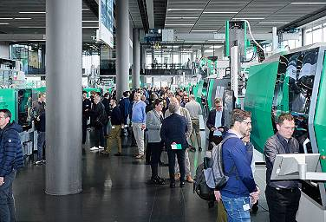
Over 5,100 guests attended the Arburg Technology Days 2024 in Lossburg, Germany. The exhibition area featured over 40 machine exhibits as well as many other exciting topics relating to plastics processing.

Technology_Days_Premiere_ASH_14032024_DSC5815
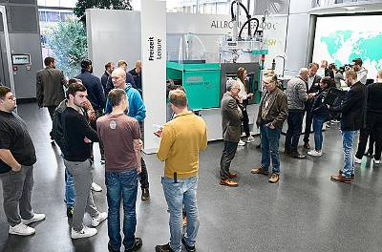
An Allrounder 470 C Golden Edition ASH celebrated its premiere. Thanks to the Arburg servo hydraulic system (ASH), the specific energy requirement can be reduced by up to 50 per cent depending on the process.

Technology_Days_arburgSOLUTIONworld_15032024_DSC6151
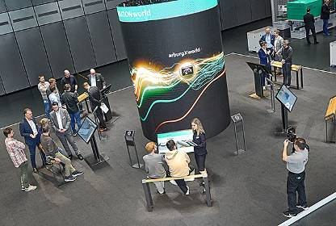
In arburgSOLUTIONworld, visitors were able to obtain individual advice on topics such as efficiency, automation, digitalisation and the shortage of skilled workers at six stations based around a striking LED column.

Technology_Days_Keynote_13032024_J0A6184
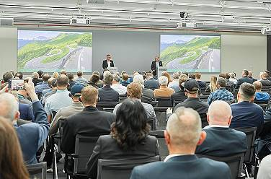
The exciting keynote speech entitled “Enabling your future – smart and system-orientated solutions” by Managing Directors Gerhard Böhm (left) and Guido Frohnhaus was met with great interest.

Technology_Days_ALS_14032024_DSC5810
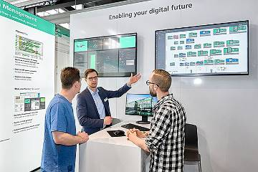
The new version 8.0 of the Arburg host computer system ALS, which ensures transparency in production and can significantly increase overall equipment effectiveness (OEE), was presented in the digitalisation area.

Technology_Days_Turnkey_Overview_DSC5561
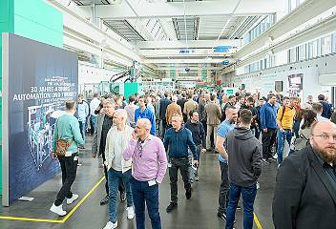
30 years of Automation + Turnkey: The entire range of robotic systems was presented as well as current customer projects.

Technology_Days_720A_plant pot_DSC5476
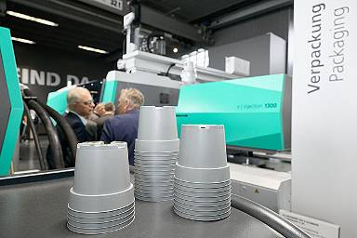
An electric Allrounder 720 A processed Systalen® post-consumer recyclate (PCR), which is made from 100 per cent household waste, into thin-walled flower pots.

Technology_Days_MORE_2000_14032024_DSC5831
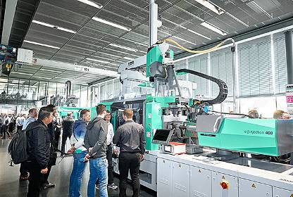
The injection moulding of spatulas made of PCB and LSR on an Allrounder More 2000 was an interesting two-component application.

Technology_Days_IMD_Wallbox_14032024_DSC5760
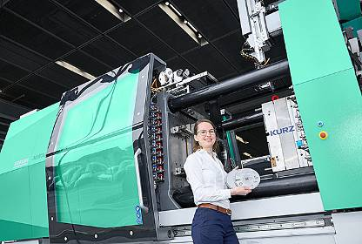
High-quality surfaces can be injection moulded using IMD film technology and customised in a laser cell, as shown using the example of a “wallbox” demonstrator.

Technology_Days_additive_14032024_DSC5849
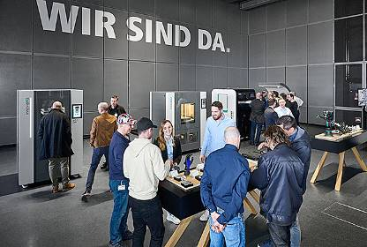
The complete range of 3D printers from ARBURGadditive was also on show at the Technology Days.
Photos: ARBURG

Photo download:
https://media.arburg.com/web/13b775e8ca5e33b5/review-technology-days-2024---arburg-press-release

Press release
File: ARBURG press review Technology Days 2024_en
Characters: 6,578
Words: 839

This and other press releases are available for download from our website at www.arburg.com/de/presse/ (www.arburg.com/en/presse/)

Contact(s)
ARBURG GmbH + Co KG
Press office
Susanne Palm
Dr Bettina Keck
Postfach 1109
72286 Lossburg, Germany
Tel.: +49 (0)7446 33 3463
Tel.: +49 (0)7446 33 3259
presse_service@arburg.com

About Arburg
Founded in 1923, the German family-owned company is one of the world’s leading manufacturers of plastic processing machines. The ARBURG family also includes AMKmotion and ARBURGadditive, including innovatiQ.
The portfolio includes injection moulding machines, 3D printers for industrial additive manufacturing, robotic systems and customer- and industry-specific turnkey solutions. It also includes digital products and services.
ARBURG is a pioneer in the plastics industry when it comes to energy and production efficiency, digitalisation and sustainability. ARBURG machines are used to manufacture plastic products for industries such as mobility, packaging, electronics, medicine, construction and equipment engineering, and leisure.
The company headquarters are located in Lossburg, Germany. In addition, ARBURG has its own organisations at 36 locations in 26 countries and, together with trading partners, is represented in over 100 countries. Of a total of around 3,700 employees, some 3,100 work in Germany while around 600 are based in ARBURG organisations around the world.
ARBURG is certified in accordance with ISO 9001 (quality), ISO 14001 (environment), ISO 27001 (information security), ISO 29993 (training) and ISO 50001 (energy).
Further information: www.arburg.com, www.amk-motion.com and www.arburg.com/arburgadditive.

