ARBURG at NPE 2024
Allrounder 720 E Golden Electric:
First world premiere in the USA

- Twice as new: Large "golden" electric Allrounder and first premiere on the international stage
- Attractive: Low investment costs, short delivery times, high level of flexibility
- Streamlined: New design saves space and increases overall output

Lossburg, 28/02/2024
In an unprecedented move, for the first time a new machine from Arburg is celebrating its world premiere not in Germany, but on the international stage. The new Allrounder 720 E Golden Electric with a clamping force of 2,800 kN extends the product range of the electric series of the same name upwards and is the highlight at NPE 2024 in Orlando, Florida, USA. Streamlined in terms of installation area and price – this summarises its main advantages. The new injection moulding machine continues to stand out for its electric precision and process stability and offers high component quality with low investment costs and short delivery times.

"The fact that we are holding the world premiere of the new electric machine at NPE 2024 reflects the great importance of the American market for Arburg, our leading position in the USA and the expansion of our international business," says Gerhard Böhm, Managing Director Sales and Aftersales from the company's German headquarters in Lossburg. "Extending our portfolio of electric machines helps customers to meet current challenges such as increasing price pressure combined with rising costs for labour, energy and materials, shorter product life cycles and ever faster product changeovers." Technical Director Guido Frohnhaus adds: "To make attractive investment costs and a quick return on investment (ROI) possible, we rely on standardised equipment without compromising on quality and performance. Our new 'golden' electric machine combines high precision with a streamlined design at a particularly attractive price."

Slim in design and price
Arburg has optimised the design so that the new Allrounder 720 E Golden Electric, with a width of just 1,848 millimetres, has a significantly reduced installation area compared to other machines in its class. This has been achieved, for example, with a new safety door featuring recessed handles. At the same time, the stroke has been widened to 1,400 millimetres to gain better access to the ejector area.
Due to its smaller installation area, the new Allrounder fits into existing production grids and lines. Thanks to the new design, more machines can be set up in injection moulding production, resulting in an increased output per square metre.

Reliable, stable machine technology
The Allrounder 720 E Golden Electric features high-quality machine technology to ensure stable and reliable plastic parts production. This includes a toggle-type clamping unit and direct drives from the subsidiary AMKmotion. With an electric mould height adjustment system, mould installation heights of up to 800 millimetres are possible. The drive components are optimised for a clamping force of 2,800 kN. The proven high-quality Arburg plasticising with the "aXw Control ScrewPilot" ensures reproducible injection and excellent moulded part quality. Optimised mould venting with two-stage mould locking also plays a part in this. For convenient maintenance, the new electric Allrounder has the same easily accessible control cabinet concept as the new hybrid machines. Lubrication unit and optional pneumatics are located on the operating side. The parts chute in the machine base has been widened to 850 millimetres, making it easily accessible.

Attractive price/performance ratio
The electric machine is not limited to a specific product and has short delivery times, which is particularly advantageous when it comes to urgent replacement purchases and capacity expansions. It is equipped with the Selogica ND control system as standard. If required, additional options and functions such as core pulls and heating and cooling circuits can be easily integrated and programmed. As a result, the new electric injection moulding machine produces a wide range of plastic parts flexibly, efficiently and reliably.

Flexible automation and application
The Allrounder 720 E Golden Electric can be automated with all robotic systems from Arburg – from simple sprue pickers to Multilift linear robotic systems and six-axis robots. The exhibit is equipped with a Multlift V 30. The new 'golden' electric machine is interesting for almost every industry. It is particularly suitable for less complex products and cycle times of around 15 seconds or more. Typical areas of application include dimensionally stable housings for electromobility, thick-walled closures for household goods, precision components for medical technology and the construction, leisure and technical injection moulding sectors.
At NPE 2024, the Allrounder 720 E Golden Electric with a clamping force of 2,800 kN and a size 800 injection unit will be producing razor covers from PP. A 24-cavity mould from Hack will be used. The cycle time is around 11.5 seconds and the moulded part weighs 1.2 grams.

Photo

197271

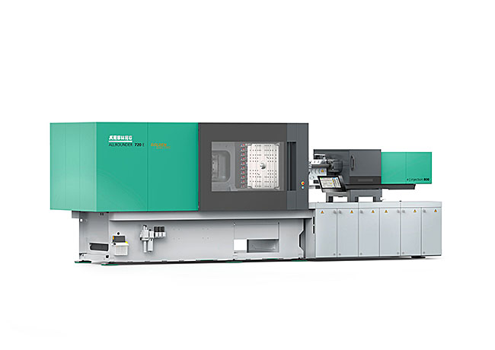

World premiere at NPE2024: the new electric Allrounder 720 E Golden Electric is particularly streamlined in terms of installation area and price thanks to its new design and standardised equipment.

Photo: Arburg
Photo download:
https://media.arburg.com/web/8600202294ec2c90/allrounder-720-e-golden-electric/

Press release
File: ARBURG Press release Allrounder 720E Golden Electric NPE 2024_en_GB.doc
Characters: 4,732
Words: 727

This and other press releases are available for download from our website at www.arburg.com/de/presse/ (www.arburg.com/en/press/)

Contact
Arburg GmbH + Co KG
Press office
Susanne Palm
Dr Bettina Keck
Postfach 1109
72286 Lossburg
Tel.: +49 (0)7446 33-3463
Tel.: +49 (0)7446 33-3259
presse_service@arburg.com

About Arburg
Founded in 1923, the German family-owned company is one of the world's leading manufacturers for plastics processing machines. AMKmotion and ARBURGadditive including innovatiQ also belong to the ARBURG family.
The portfolio encompasses injection moulding machines, 3D printers for industrial additive manufacturing, robotic systems as well as customer- and industry-specific turnkey solutions. It also includes digital products and services.
ARBURG is a pioneer in the plastics industry when it comes to energy and production efficiency, digitalisation and sustainability. ARBURG machines are used to manufacture plastic products for the mobility, packaging, electronics, medical, construction and equipment engineering and leisure industries, for example.
The company headquarters are located in Lossburg, Germany. In addition, ARBURG has own organisations in 26 countries at 36 locations and is represented in over 100 countries together with trading partners. Of a total of roughly 3,700 employees, around 3,100 work in Germany, with another 600 employees based in ARBURG's organisations around the world.
ARBURG is certified to ISO 9001 (quality), ISO 14001 (environment), ISO 27001 (information security), ISO 29993 (training) and ISO 50001 (energy).
Further information: www.arburg.com, www.amk-motion.com as well as www.arburg.com/arburgadditive.

