Cooperation between Arburg and carbonauten
Goal: To reduce the footprint of plastic products with CO₂-negative compounds

- Cooperation: Injection moulding machine manufacturer and climate start-up working on decarbonisation
- Cost-effective industrial solution: Use of CO₂-negative NET Materials®
- Relevant for Scope 3: Compounds with biocarbons reduce CO₂ footprint in injection moulding

Lossburg/Giengen an der Brenz, 22/10/2024
The ink has been dry on the cooperation agreement between climate start-up carbonauten GmbH, Giengen, Germany, and Arburg GmbH + Co KG, Lossburg, Germany, since 3 August 2024. Both companies are working together to increase the industrial use of NET Materials® at fair market prices in order to make decarbonisation economically attractive for industry, with an impact on Scope 3 emissions as well.

carbonauten is a start-up that develops and produces industrial base materials and primary products in decentralised factories (minus CO₂ factory) and is committed to developing its own large-scale carbonisation technology that can flexibly process all types of woody biomass residues into CO₂-negative biocarbons. For the plastics market, carbonauten polymers offers CO₂-negative composites with a biocarbon content.

CO₂-negative primary products for the plastics industry
The so-called NET materials®, or negative emission technology materials, are CO₂-negative primary products for the plastics, chemical, agricultural and construction industries. Arburg wants to make the CO₂-reduced material suitable for injection moulding applications. From 2025, Arburg and all other companies that fall under the Corporate Sustainability Reporting Directive (CSRD) must also measure Scope 3 emissions in addition to Scope 1 emissions (emissions from the company's own sources) and Scope 2 emissions (indirect emissions from the purchase of energy or electricity), and must disclose these in their sustainability report. Scope 3 emissions are all indirect emissions that are not generated within the company, but in the upstream supply chain or through the downstream use of the products manufactured and services offered.

Decentralised production of CO₂-negative biocarbons
This unique carbonisation technology from carbonauten enables the cost-efficient and decentralised production of CO₂-negative biocarbons. carbonauten develops and produces industrial base materials and primary products based on biocarbons and bio-oils in decentralised factories. Biocarbons permanently bind up to 3.67 tonnes of CO₂ equivalent per tonne of biocarbon. The bio-oils produced as a byproduct are used as a CO₂-negative base material for the chemical industry. Another byproduct is renewable energy capable of meeting baseload requirements.
The active reduction of CO₂ started at the "minus CO₂ factory 001" in Eberswalde near Berlin. It is the first of what will be dozens of factories worldwide. A second factory will be built in Chibi, China, by 2025. In addition to industrial production, Eberswalde is also a research and development location for hardware, technological expansions and production process optimisation.

What the cooperation actually involves
The biocarbons are processed into very fine powders and compounded with polymers to create the NET Materials® (patent pending). As one of the world's leading manufacturers of high-quality machine technology for plastics processing, Arburg has expertise in application and process technology that enables the practical adaptation of these bio-based wood materials for industrial processing.
The central objective of the cooperation is to use the CO₂-negative compounds from carbonauten in conjunction with Arburg's injection moulding technology to develop prototypes. This should result in a wide range of plastic applications and subsequently the development of joint processing technologies to bring CO₂-negative plastic products to the market.
carbonauten polymers has developed globally unparalleled expertise in the development and production of CO₂-negative plastics with improved properties that are no more expensive than their conventional counterparts. The ready-to-use masterbatches and compounds are plastic granules filled with technical biocarbons. This improves many of the properties of the plastics, while reducing costs and maintaining their recyclability. Permanently stable or biodegradable polymers and biopolymers can be used as a base. The granules are processed in the same way as other plastics, which makes defossilisation simple and, for the first time, economically attractive for producers.
The product and solution results will be presented at the Arburg Technology Days 2025 and at other trade fairs and exhibitions. In addition, the cooperation will be expanded to cover sustainability and the reduction of CO₂ emissions, the collection of market information to support further product development, and workshops and seminars organised by Arburg, carbonauten or other institutions. Joint marketing campaigns and the organisation of webinars to present technologies, applications and the benefits of the combined offering complete the cooperation.

Senior decision-makers are positive
Dr Cristian Hedesiu, CTO carbonauten polymers, and Torsten Becker, Managing Director carbonauten, will first visit Arburg and its Customer Center with 42 injection moulding machines in order to make further targeted progress towards the common goal of developing technologies for the cost-effective processing of CO₂-negative compounds. "In the medium term, we intend to acquire injection moulding machines from Arburg so that we can manufacture our own plastic parts in the ‘minus CO₂ factories’. This will enable us to achieve deep value creation and use our surplus energy to operate the injection moulding machines," says Dr Cristian Hedesiu.
"We are currently conducting promising application technology trials with the new compound at the Customer Center. I am very confident that we are on the right track here," explains Manuel Witte, Director Applications & Industries at Arburg. "carbonauten and Arburg have entered into this exclusive cooperation because sustainable CO₂ reduction in plastics processing is important to us, and we want to use the experience gained with this material for our own production. However, our customers should also be able to benefit from sustainability when it comes to application technology. After all, the more CO₂-reduced and recycled material is used in plastics processing, the greater the benefits for the entire industry and ultimately for all of us."

Photo

Carbonauten 2024_DSC5053

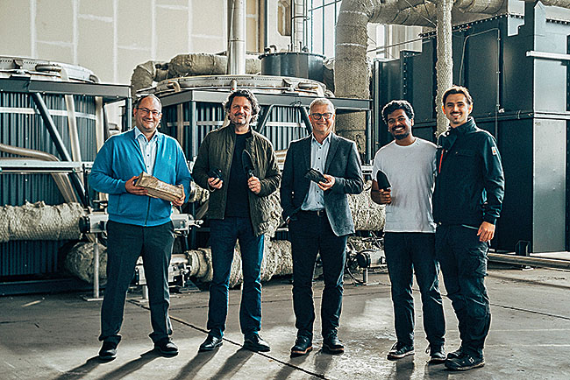

Cooperation between Arburg and carbonauten:Manuel Witte (left), Director Applications & Industries at Arburg, and Gerhard Böhm (centre), Arburg Managing Director at the time of contract signing, together with Christoph Hiemer (2nd from left), co-founder of carbonauten, and team in the "minus CO₂ factory 001" in Eberswalde near Berlin.

Photo: carbonauten

Photo download:
https://media.arburg.com/web/43b119706d84bf65/carbonauten-2024

Press release
File: Pressemitteilung Kooperation Arburg carbonauten 2024_en_GB.docx
Characters: 6,139
Words: 883

This and other press releases are available for download from our website at www.arburg.com/de/presse/ (www.arburg.com/en/press/)

Contact
Arburg GmbH + Co KG
Press office
Susanne Palm
Dr Bettina Keck
Postfach 1109
72286 Lossburg
Tel.: +49 (0)7446 33-3463
Tel.: +49 (0)7446 33-3259
presse_service@arburg.com

carbonauten GmbH
Head of Communications
Aaron Ertler
Dr Bettina Keck
Riedstrasse 40/1
89537 Giengen, Germany
Tel.: +49 177 472 3421
presse@carbonauten.com

About Arburg
Founded in 1923, the German family-owned company is one of the world's leading manufacturers of plastic processing machines. The ARBURG family also comprises AMKmotion and ARBURGadditive, including innovatiQ.
Its portfolio includes injection moulding machines, 3D printers for industrial additive manufacturing, robotic systems and customer- and industry-specific turnkey solutions. It also includes digital products and services.
ARBURG is a pioneer in the plastics industry when it comes to energy and production efficiency, digitalisation and sustainability. ARBURG machines are used to manufacture plastic products for industries such as mobility, packaging, electronics, medicine, construction and equipment engineering, and leisure.
The company headquarters are located in Lossburg, Germany. In addition, Arburg has its own organisations at 37 locations in 27 countries and, together with trading partners, is represented in over 100 countries. Of a total of around 3,700 employees, some 3,100 work in Germany while around 600 are based in ARBURG organisations around the world.
ARBURG is certified in accordance with ISO 9001 (quality), ISO 14001 (environment), ISO 27001 (information security), ISO 29993 (training) and ISO 50001 (energy).
Further information can be found at: www.arburg.com, www.amk-motion.com and www.arburg.com/arburgadditive.

About carbonauten
carbonauten produces ready-to-use and cost-effective industrial base materials that permanently bind CO2 from woody biomass residues. The company's proprietary carbonisation technology facilitates the cost-efficient and decentralised production of CO2-negative biocarbons. These are compounded into NET Materials® for plastics. carbonauten aims to make decarbonisation economically attractive for manufacturers as a means of reducing Scope 3 greenhouse gas emissions. More information: www.carbonauten.com

