Laszlo Csizmadi, Managing Director of Arburg Hungária Kft. on Juniális 2025

The Juniális summer event, organised by Arburg Hungária Kft., is a firm fixture on the Hungarian plastics market. The high response this year has once again demonstrated the success of the concept of showcasing the latest injection moulding technology and industry trends to customers on site together with expert information and a great opportunity for networking. Read more in the interview with Laszlo Csizmadi, Managing Director of Arburg Hungary.

How satisfied were you with Juniális 2025?
The event was a complete success. We had a great turnout from both existing and new customers and partners. Our Open Day has been a tradition for decades now and is very popular with our customers. Juniális is an excellent opportunity for us to demonstrate our expertise and our strong commitment to the Hungarian plastics market.

Were you able to make new contacts?
With Juniális, we are of course first and foremost pursuing the goal of involving our existing customers. We also want to continue to develop year on year, also by attracting new interested parties and potential partners. We have succeeded in doing that once again this year, viewing it as very important for the long-term development of our company.

What were the main topics of the Juniális 2025?
When putting together the event concept, we take care to present our expertise as comprehensively and in as much detail as possible. Juniális 2025 focussed on answers to questions that are currently of great concern to our customers. These include increasing machine availability, automation of injection moulding production, industrial digitalisation, sustainability and after-sales and service. At Juniális, we demonstrated not only that Arburg is an outstanding machine manufacturer, but that it can also fully support its customers as a holistic service and solution provider. In addition, the company plays a pioneering role in the industry when it comes to digitalisation and resource-saving production, making active contributions towards a sustainable future.

Which machines and highlights did you showcase?
The focus was on two exciting injection moulding applications. Using a hybrid Allrounder 470 H with a clamping force of 1,000 kN, equipped with a Multilift Select 8 linear robotic system, we demonstrated the automated production of a toy car made of PC-MA – a material characterised by high impact and heat resistance as well as special scratch resistance.
Paper injection moulding is particularly innovative. A hydraulic Allrounder 420 C Golden Edition with a clamping force of 1,000 kN used this process to transform what are known as “paper pearls” into a 3D puzzle. The main component of the sustainable material comprises paper fibres. These are made injection mouldable using bio-based and biodegradable plastics, e.g. based on lignin, starch or corn.

Please tell us more about the Focus Points.
These Focus Points were a special feature of the event: At three stations, participants were able to experience the most important elements of the Arburg range interactively. The focus was on the operability of the Gestica control system, the details of the current services and Arburg's digital products. Participants were able to ask our experts their questions directly.
One highlight was the presentation of the assistance and pilot functions of the Gestica control system. For example, great interest was shown in our “aXw Control FillAssist”. Using a practical example, we demonstrated how this filling simulation, integrated into the control system, can be used to reach good part status quickly, together with a stable production phase during start-up.

And classic specialist lectures rounded off the programme?
Indeed, they did. In line with the current challenges facing the industry, these specialist presentations focused on digitalisation, sustainability, automation and innovation. A particular high point was the “aXw Control RecyclatePilot” control function. This reliably compensates for fluctuating material qualities and enables stable part quality even when processing recyclates. After all, in the 21st century, global plastics consumption will continue to increase, in tandem with the importance of efficiency in recycling and a functioning circular economy.
In addition, the participants were given a comprehensive insight into the latest developments in our robot portfolio, learning how Arburg is positioning itself in the turnkey sector. With our holistic approach, we can offer our customers complete, customised automated manufacturing systems. In addition, external partners gave presentations on innovative materials, providing a practical insight into digital transformation and reporting on results from sustainability research.

What was the feedback from visitors?
Feedback showed clearly that the diversity of our programme is highly appreciated. The lectures and presentations that went beyond pure machine technology were particularly well received by the participants: For many, it was new to learn how comprehensively Arburg supports its customers with services such as training and service. The guest lectures, which gave participants an insight into injection moulding from the perspective of raw material manufacturers, for example, also generated great interest.

Which current developments are you observing in the Hungarian plastics market?
In Hungary, many companies are currently pursuing a more cautious strategy and the willingness to invest is subdued. At the same time, we have noticed that most customers are consciously prioritising: They are looking for solutions that will make their processes more efficient and sustainable in the long term. This is supported, for example, by preventive maintenance, specialised training, digital developments and automation.
Topics such as digitalisation, turnkey and automation as well as sustainability are of crucial importance for the future of Hungarian industry. With the help of turnkey systems, companies are able to react more rapidly to changing market conditions. Sustainability is increasingly becoming a basic requirement, meaning that these trends will continue to intensify in the coming years.

Why should Hungarian customers also visit K 2025 in Düsseldorf after Juniális in autumn?
K 2025 is the world's most important trade fair for the plastics industry, where the latest technologies, developments and international trends are presented at first hand. For our Hungarian customers, it offers an excellent opportunity for professional orientation, establishing new contacts and gaining inspiration.
While Juniális is a national event with a personal atmosphere, the K trade fair showcases the future of the industry on a global level. Here, Arburg will be showcasing its entire portfolio at stand “13A13” and in the arburgGREENworld pavilion, as well as world premieres that are not to be missed. Both events are valuable but offer different experiences and complement one another perfectly.

Pictures

Laszlo Csizmadi 02-175

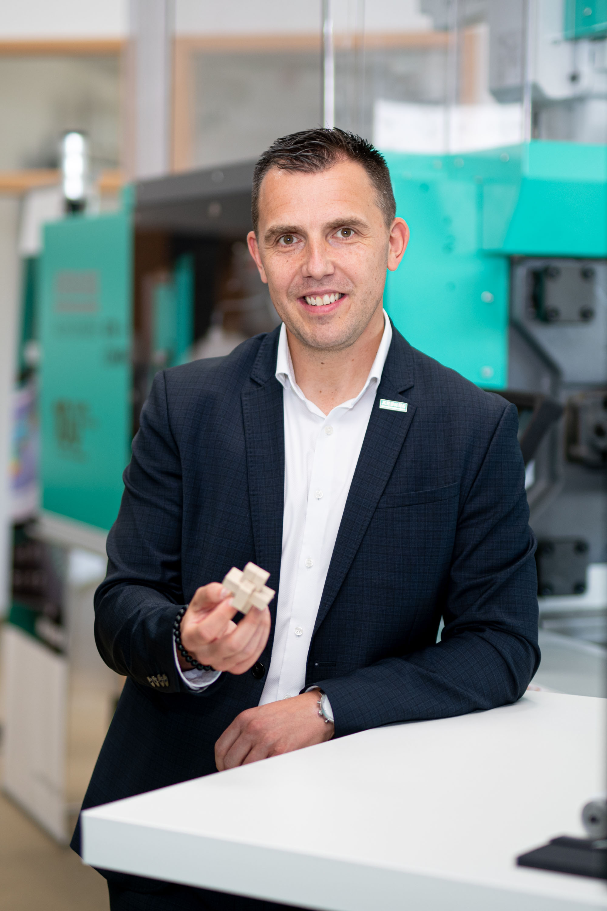

Laszlo Csizmadi, Managing Director of Arburg Hungary, with a 3D puzzle produced by paper injection moulding at Juniális 2025.

Showroom 01-239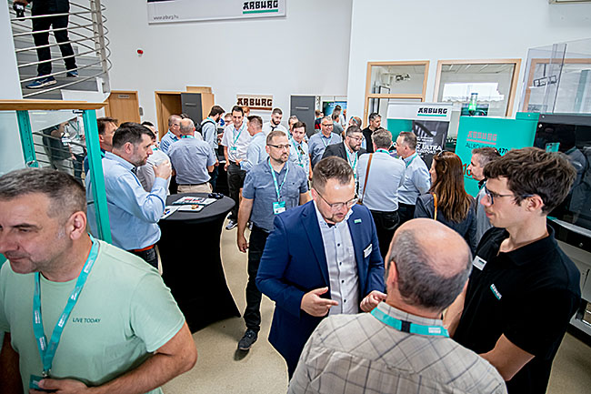

Successful Juniális 2025 at Arburg Hungary: The participants appreciated the combination of machine exhibits, interactive stations, technical presentations and exchange of experiences.

Lecture 01-145

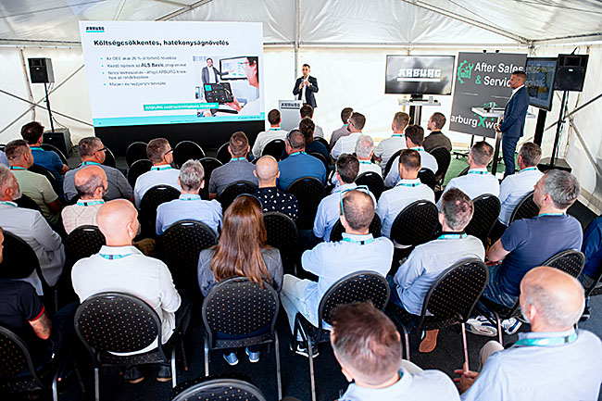

Participants at Juniális 2025 were particularly positive about the talks and presentations that went beyond pure machine technology - for example on digital transformation.

Photos: ARBURG
Photo Download:
https://media.arburg.com/web/d3648e28c7e58831/junialis-2025-press-review/

Press Release
File: ARBURG Interview review Junialis 2025_en_GB.docx
Character: 6,957
Words: 1,048

You can also download this and other press releases from our website at www.arburg.com/de/presse/ (www.arburg.com/en/presse/)

Contact us
ARBURG GmbH + Co KG
Press office
Susanne Palm
Dr Bettina Keck
PO Box 1109
72286 Lossburg
Phone: +49 7446 33-3463
Phone: +49 7446 33-3259
presse_service@arburg.com

About Arburg
Founded in 1923, the German family-owned company is one of the world's leading machine manufacturers for plastics processing. The ARBURG family also includes AMKmotion and ARBURGadditive including innovatiQ.
The portfolio includes injection moulding machines, 3D printers for industrial additive manufacturing, robotic systems and customer- and industry-specific turnkey solutions. It also includes digital products and services.
ARBURG is a pioneer in the plastics industry when it comes to energy and production efficiency, digitalisation and sustainability. ARBURG machines are used to manufacture plastic products for the mobility, packaging, electronics, medical, construction and apparatus engineering and leisure sectors, for example.
The company headquarters are located in Lossburg, Germany. In addition, ARBURG has its own organisations in 27 countries at 37 locations and is represented in over 100 countries together with trading partners. Of the total workforce of around 3,700, around 3,100 are employed in Germany and around 600 in the ARBURG organisations worldwide.
ARBURG is certified in accordance with ISO 9001 (quality), ISO 14001 (environment), ISO 27001 (information security), ISO 29993 (training) and ISO 50001 (energy).
Further information: www.arburg.com, www.amk-motion.com and www.arburg.com/arburgadditive.

