Arburg at the Plast Eurasia 2025
Turkey premiere: Allrounder Trend - the new global standard

- Focus: Arburg expands its portfolio in the standard segment with a new electric machine concept
- New Allrounder Trend: Fast and easy to set up, operate and produce
- New Gestica lite: Easy and intuitive control system

Lossburg, 13.10.2025
At the 34th Plast Eurasia from 3 to 6 December 2025 in Istanbul, Arburg will be presenting the Eurasia premiere of its brand-new electric Allrounder Trend at its stand 1114B in hall 11. With its large catchment area, the trade fair is of great importance for Arburg and its Turkish subsidiary. The exhibit, an Allrounder 1000 e Trend, is equipped with the likewise new and remarkably easy-to-operate Gestica lite control system.
By way of example, it produces a Cross Knot game of patience.

“Especially in these challenging times, which we are also experiencing in our markets, we are offering a completely newly developed machine concept. One that is tailored precisely to the current market and customer requirements across all industries”, emphasises Cagri Ünver, Managing Director of the Turkish Arburg branch in Istanbul. “With the Allrounder Trend, we at are setting a new standard in injection moulding. These electric machines have short delivery lead times, and they are easy to set up, operate and maintain - all available at a truly outstanding price. Coupled with that, we consistently embody the highest standards of quality and backed up by seamless and globally standardised service”.

Fast and simple: New Allrounder Trend
The new Allrounder Trend is predestined for all sectors in which standard applications are required. These include, for example, technical injection moulding and the electronics industry. At market launch, there are four sizes in the clamping force range from 500 to 2,000 kN and with electric injection units in sizes 100 to 800. The remarkably slim design translates into a compact footprint for production in an optimum space. Setup is easy and convenient thanks to the easily accessible, large mould installation space and mould-related interfaces for electronics, pneumatics and cooling water. Peripheral devices have Plug & Work connections and the cylinder module can be replaced quickly. Optional retrofits include up to two serial core pulls and freely configurable I/O interfaces. These machines are prepared for an IIoT gateway for entry into digitalisation. The Allrounder Trend has been available to order since October 2025 and will be delivered from spring 2026. The exhibit at Plast Eurasia produces a “Cross Knot” game of patience to demonstrate its capabilities.

Intuitive operation and clear layout: new Gestica lite
Even inexperienced employees can quickly become operational thanks to the intuitive Gestica lite control variant, another new developed by Arburg, together with optional smart assistants. It shares an identical software platform to the Gestica, making their data records fully intercompatible. The new version's extended user interface makes operation an easy proposition even for non-specialists, while also providing enhanced flexibility to experienced operators. The Dashboard stands out as a new feature on the user interface. This initial page clearly displays all the important functions for day-to-day work. This includes information on the job, the current process and direct access to the most important parameters - all intelligently and actively supported by assistance functions. The touch function can be used to jump directly to the detailed parameter pages for the clamping and injection unit, temperatures and robotic system.

Pictures

ALLROUNDER 1800 e TREND_359

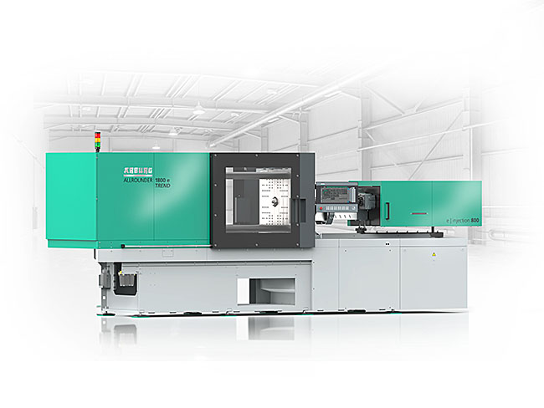

New: The electric Allrounders Trend are particularly fast and easy to set up and are specifically designed for the efficient production of standard injection moulded parts.

Cagri Uenver_J0A1728

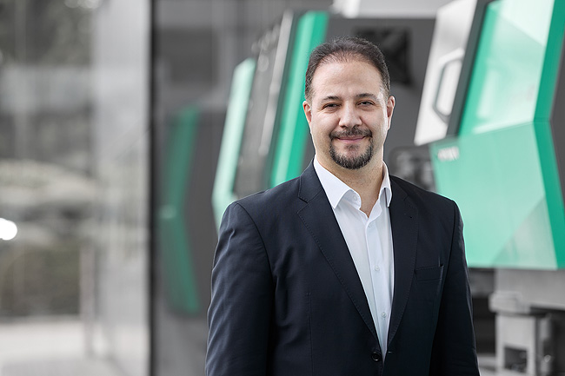

Cagri Ünver, Managing Director of Arburg Turkiye, also has his eye on the Eurasian market.

Photos: ARBURG

Photo Download:
https://media.arburg.com/web/cf8934eff87309e5/plast-eurasia-2025-press-preview/

press release
File: Pressevorbericht Plast Eurasia 2025_en_GB.docx
Characters: 3,311
Words: 508

You can also download this and other press releases from our website at www.arburg.com/de/presse/ (www.arburg.com/en/presse/)

Please contact
Arburg GmbH + Co KG
Press Office
Susanne Palm
Dr Bettina Keck
P.O. Box 1109
72286 Lossburg, Germany
Phone: +49 7446 33-3463
Phone: +49 7446 33-3259
presse_service@arburg.com

About Arburg
Founded in 1923, the German family-owned company is one of the world's leading manufacturers of injection moulding machines. AMKmotion, a manufacturer of electric drive technology, also belongs to the Arburg family.
The portfolio for plastics processing encompasses Allrounder injection moulding machines, robot systems as well as customer- and industry-specific turnkey solutions. It also includes digital products and services. Arburg is a pioneer in the plastics industry when it comes to energy and production efficiency, digitalisation and sustainability. Arburg machines are used to manufacture plastic products for the mobility, packaging, electronics, medical, construction and equipment engineering and leisure industries, for example.
The company headquarters are located in Lossburg, Germany. In addition, Arburg has own organisations in 27 countries at 37 locations and is represented in over 100 countries together with trading partners. Of a total of roughly 3,450 employees, about 2,850 work in Germany, with another 600 employees based in Arburg's organisations around the world.
Arburg is certified to ISO 9001 (Quality), ISO 14001 (Environment), ISO 27001 (Information Security), ISO 29993 (Education and Training) and ISO 50001 (Energy).
Further information: www.arburg.com, www.amk-motion.com.

