Arburg at Plastec West 2026
New Allrounder Trend: Premiere in the USA

- New Allrounder Trend: Fast and easy set-up, operation and production
- Expansion: Arburg expands its portfolio in the standard segment with a new electric machine concept
- Focus: Automation, digitalisation and medical technology

Lossburg, 11/12/2025
Plastec West will take place in Anaheim, California, USA, from 3 to 5 February 2026. There, Arburg will present the new Trend electric machine concept, which sets the new standard in injection moulding, to the US market for the first time. These machines are easy to maintain, delivery lead times are short, and they provide uncompromising performance and reliability. The exhibit, an Allrounder 1000 e Trend, is equipped with the new and remarkably easy-to-use Gestica lite control system. Other focal points at Stand 4611 will include automation and digitalisation.

Plastec West takes place parallel to MD&M (Medical Device & Manufacturing) West, the leading trade fair for medical products in the USA, where innovations in the field of medical plastic parts and their manufacture are presented and manufacturers and customers from the medical industry meet annually.
Martin Baumann, President & CEO of Arburg Inc. in the USA, is looking forward to the trade fair: “Here we can show customers how our machines and systems can be used to efficiently manufacture medical technology products, while establishing a direct link to their production requirements”.

Trend: Fast and easy
He is also especially proud to be able to introduce the new Allrounder Trend electric machine concept to the US industry for the first time: “With the Allrounder Trend, we are setting a new standard in injection molding”. These electric machines have short delivery lead times. They are also easy to set up, operate and maintain – without compromising in any way on quality, precision and reliability. They also impress with their low energy consumption and low investment and operating costs. The intuitive Gestica lite control system even enables relatively inexperienced personnel to operate the Allrounder Trend machines with ease. This control system is another recent Arburg development, also supported by optional smart assistants.

Automation: Flexible and networked
At the stand, an Allrounder 1000 e Trend with a clamping force of 1,000 kN will be producing a technical part fully automatically using an 8-cavity hot runner mould from Adler Industrial Solutions Inc. The parts will be removed by a Multilift robot system, which is fully integrated into the control system, and fed into a storage system developed by Arburg, separated by cavity size.
Trends in the plastics industry that Arburg is observing on site are that injection moulding cells are becoming increasingly integrated, More specifically that customers are pushing for greater networking between injection moulding machines and peripherals for productivity reasons. Accordingly, there is a growing search for solutions to partially or fully automate and digitalise production, as well as to offer greater transparency in production processes in terms of quality, service and support. “And at Arburg, we can offer them all of this from a single source”, reports Baumann.
At Plastec West, Arburg will showcase a simple automation solution as a complete unit with a focus on greater flexibility and control. Arburg will also be exhibiting its digital products, including the arburgXworld customer portal and the Arburg ALS host computer system, Arburg's MES system. Here, both service and real-time production data from the Allrounder 1000 e Trend running at the Arburg stand will be accessed.
Digitalisation also supports the arburgXworld customer portal, e.g. through quick and easy access to service data, documentation, reports and more. The aim is always to ensure maximum efficiency, sustainability and high-quality production.

Photos

ALLROUNDER 1800 e TREND_359

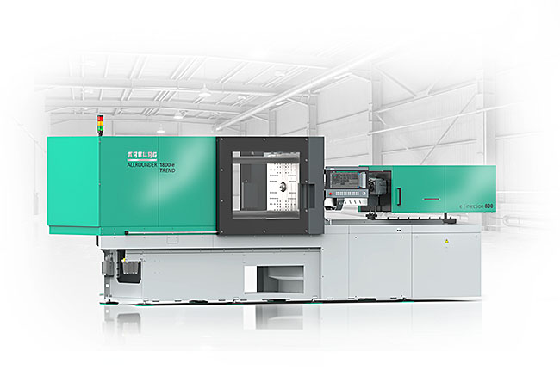

New: The electric Allrounder Trend machines can be set up remarkably quickly and easily and are specifically designed for the efficient production of standard injection moulded parts.

Martin Baumann 193952

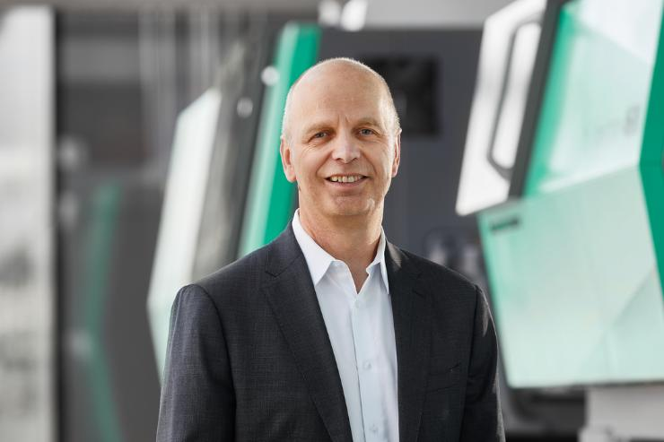

Martin Baumann, President & CEO of Arburg Inc., is delighted to be introducing the new electric Allrounder Trend to the US market at Plastec West.

Photo: ARBURG

Photo download:
https://media.arburg.com/web/4cc0418fc546d858/plastec-west-2026-press-preview/

Press release
File: Press preview Plastec West2026_en.docx
Characters: 3,478
Words: 537

This and other press releases are also available for download on our website at www.Arburg.com/de/presse/ (www.Arburg.com/en/presse/).

Contact
Arburg GmbH + Co KG
Press Office
Susanne Palm
Dr Bettina Keck
P.O. Box 1109
72286 Lossburg
Tel.:
Tel.: +49 7446 33-3259
presse_service@Arburg.com

About Arburg
Founded in 1923, the German family-owned company is one of the world's leading manufacturers of injection moulding machines. AMKmotion, a manufacturer of electric drive technology, also belongs to the Arburg family.
The portfolio for plastics processing encompasses Allrounder injection moulding machines, robot systems as well as customer- and industry-specific turnkey solutions. It also includes digital products and services. Arburg is a pioneer in the plastics industry when it comes to energy and production efficiency, digitalisation and sustainability. Arburg machines are used to manufacture plastic products for the mobility, packaging, electronics, medical, construction and equipment engineering and leisure industries, for example.
The company headquarters are located in Lossburg, Germany. In addition, Arburg has own organisations in 27 countries at 37 locations and is represented in over 100 countries together with trading partners. Of a total of roughly 3,450 employees, about 2,850 work in Germany, with another 600 employees based in Arburg's organisations around the world.
Arburg is certified to ISO 9001 (Quality), ISO 14001 (Environment), ISO 27001 (Information Security), ISO 29993 (Education and Training) and ISO 50001 (Energy).
Further information: www.arburg.com, www.amk-motion.com.

