Arburg at the K 2025
All in! arburgSOLUTIONworld:
Everything to deliver customer success

- Solution expertise: arburgSOLUTIONworld contains the entire Arburg portfolio and know-how
- Innovative strength: Arburg unveils world premieres and the future of plastics processing at stand 13A13
- Sustainability: arburgGREENworld pavilion focuses on recyclate processing and energy efficiency

Lossburg, 07.10.2025
“The Power of Plastics: Green - Smart – Responsible” is the motto of the world’s leading trade fair K 2025 from 8 to 15 October in Düsseldorf, Germany. These focal points are a perfect fit for Arburg. This innovative company defines itself as a solution partner for sustainable plastics processing, a vision reflected in the unique arburgSOLUTIONworld. Here, trade visitors will find the right answers to important topics such as sustainability, digitalisation and automation, as well as to the spectrum of issues facing plastics processors today and tomorrow. A total of 18 machine exhibits will be on display at the Arburg stand, 13A13, in the arburgGREENworld pavilion on the outdoor area in front of Hall 16 and at partner stands - including several world premieres that are not to be missed.

“The focal points of K 2025 also suit us very well because they are firmly rooted in Arburg’s DNA. We meet the challenges in the market with a high level of innovation, expertise and solution competence”, explains Juliane Hehl, Managing Partner Global Marketing and Business Development at Arburg.

Success factor arburgSOLUTIONworld
“arburgSOLUTIONworld simply brings together everything our customers need to be sustainable and successful in the long term”, says the partner. Dr Christoph Schumacher, Vice President Global Marketing, adds: “The ’All in! arburgSOLUTIONworld’ communication concept expresses the fact that we bring absolutely everything to arburgSOLUTIONworld. The entire product portfolio - which includes machines, robotic systems, turnkey systems and control systems - as well as digital products and services, the vast scope of Arburg expertise and exciting innovations.”

arburgGREENworld pavilion: Focus on sustainability
The Power of Plastics Forum in the open-air area in front of Hall 16 at K 2025 will be showcasing how the circular economy works in practice. Arburg will be represented for the second time with its arburgGREENworld pavilion, under the aegis of Arburg trainees. Here, visitors can immerse themselves in water worlds and experience in a multifaceted way the power and vision with which Arburg acts as an enabler in a green, intelligent and responsible manner. The central exhibit is an automated turnkey system that efficiently processes recycled old fishing nets into model dolphins. At various stations and during presentations, including one by the ‘swimming professor’ and Arburg brand ambassador Prof Dr Andreas Fath, interested visitors can find out more about how the future of plastics as a recyclable material can be actively shaped.

13A13: Machines, software and services
Trade visitors to the Arburg stand in Hall 13 can look forward to ground-breaking exhibits. Leading machine technology for efficient injection moulding will be on display, as well as robotic systems and new products in the areas of software, digitalisation and service. And, of course, Arburg will once again have plenty of surprises in store at the world's leading trade fair in Düsseldorf, although not all of them will be revealed in advance. The world premieres include, for example, a vertical Allrounder with a clamping force of 1,000 kN. The characteristic features of this unit are ts small footprint, high energy efficiency, new control system and attractive price-performance ratio. Here, it demonstrates the film back injection moulding in the mobility sector. The application highlights include
- An Allrounder Cube 1800 machine that produces fully automated two-component closures for the personal care sector.
- An automated two-component Allrounder More 2000 that produces dominoes for the toy industry.
- Two electric Allrounders, the 570 A and 520 A, which communicate intelligently with the mould and open up new IML applications for medical technology.
- An electric Allrounder 720 A that shows that the injection compression moulding of IML cups can be an alternative to thermoforming for the packaging industry.

Exciting practical examples from the electronics industry, technical injection moulding, lightweight construction and LSR processing can also be seen at Arburg and at partner stands.

Expert lectures
Arburg will be participating in events at K 2025 with some thought-provoking expert presentations: On ‘Smart Saturday’ (11.10.2025, VDMA Pavilion, outdoor area), Werner Faulhaber, Head of Research and Development, and Stephan Reich, Head of Global IT and Digital Services, will speak about digitalisation in plastics processing. Arburg will also be hosting its own series of lectures with renowned speakers from research and industry in the arburgGREENworld pavilion.

Pictures

Key Visual K-2025
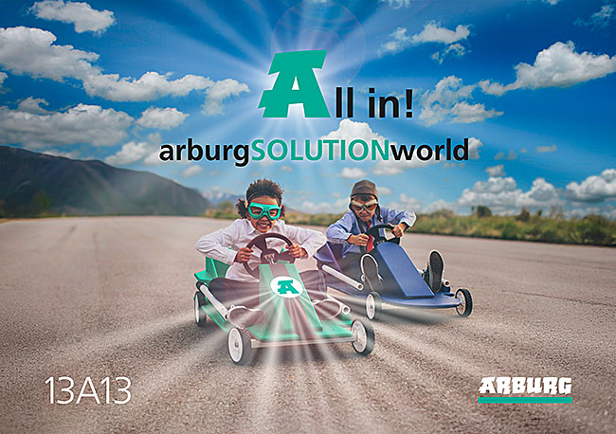
Arburg at K 2025: The ‘All in! arburgSOLUTIONworld’ communication concept expresses the fact that the company includes all its solutions for sustainable plastics processing in the arburgSOLUTIONworld.

Juliane Hehl 130401

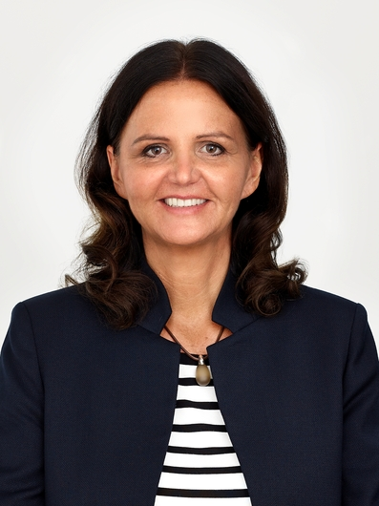

Juliane Hehl, Arburg Managing Partner Global Marketing and Business Development.
Photos: ARBURG

Photo download:
https://media.arburg.com/web/16f54a4265b8929d/k2025-press-preview/

Press Release
File: ARBURG Pressevorbericht K2025_en_GB.docx
Characters: 4.605
Words: 699

You can also download this and other press releases from our website at www.arburg.com/de/presse/ (www.arburg.com/en/presse/)

Contact us
ARBURG GmbH + Co KG
Press office
Susanne Palm
Dr Bettina Keck
PO Box 1109
72286 Lossburg, Germany
Phone: +49 7446 33-3463
Phone: +49 7446 33-3259
presse_service@arburg.com

About Arburg
Founded in 1923, the German family-owned company is one of the world’s leading machine manufacturers for plastics processing. The ARBURG family also includes AMKmotion and ARBURGadditive including innovatiQ.
The portfolio includes injection moulding machines, 3D printers for industrial additive manufacturing, robotic systems and customer- and industry-specific turnkey solutions. It also includes digital products and services.
ARBURG is a pioneer in the plastics industry when it comes to energy and production efficiency, digitalisation and sustainability. ARBURG machines are used to manufacture plastic products for the mobility, packaging, electronics, medical, construction and apparatus engineering and leisure sectors, to name just a few examples.
The company headquarters are located in Lossburg, Germany. In addition, ARBURG has its own organisations in 27 countries at 37 locations and is represented in over 100 countries together with trading partners. Of the total workforce of around 3,700, about 3,100 are employed in Germany with the remaining 600 in the ARBURG organisations worldwide.
ARBURG is certified in accordance with ISO 9001 (Quality), ISO 14001 (Environment), ISO 27001 (Information Security), ISO 29993 (Training) and ISO 50001 (Energy).
Further information: www.arburg.com, www.amk-motion.com and www.arburg.com/arburgadditive.

