Arburg at the Moldplas 2025
Focus on New electric Allrounder Trend, efficiency and smart solutions

- New: Electric Allrounder Trend expands Arburg’s portfolio in the standard segment
- Efficient: Hybrid Allrounder 470 H produces live beverage jug as a give-away
- Economical: Customer portal and host computer system reduce time and costs

Lossburg, 09.10.2025
Moldplas from 13 to 15 November 2025 in Batalha is the trade fair for the injection moulding market in Portugal. Arburg will be showcasing its comprehensive range of products and services at stand 3B12 in hall 3. The highlight is the online presentation of the new Allrounder Trend, celebrating its world premiere at K 2025. The injection moulding exhibit is an energy-efficient hybrid Allrounder 470 H, which automatically produces a beverage jug from PC using a Multilift Select 6 linear robotic system. Smart digital products and services, above all the arburgXworld customer portal with its numerous apps and new features, as well as the Arburg host computer system, will round off the trade fair.

“As in many places, there is currently great uncertainty on the market in Portugal. This makes it all the more important that we present ourselves as a long-term, reliable partner,” emphasises Martín Cayre, who as Managing Director of Arburg Spain is also responsible for the Portuguese market. “As a special highlight, we will be presenting the Allrounder Trend, which thus celebrates its Portugal premiere”.

Presented online: Portugal premiere of the Allrounder Trend
The Allrounder Trend will be presented for the first time in Portugal via a monitor. Arburg expands its portfolio with the completely new machine concept and heralds an exciting new era: Besides of proven high-end technology the Allrounder Trend opens up an additional segment for standard applications. It is specifically designed to meet current market requirements, quick to set up, particularly easy to operate and maintain and produces injection moulded parts extremely reliably and energy-efficiently.
(more see press release Allrounder Trend)

Automated: Hybrid Allrounder 470 H produces a beverage jug
At Moldplas 2025, a hybrid Allrounder 470 H with a clamping force of 1,000 kN and a single-cavity mould will produce a transparent polycarbonate (PC) beverage jug in a cycle time of around 30 seconds. The 0.5 litre moulded part is a sensible and sustainable alternative to glass and disposable items.
This example of automation formed part of a local turnkey project. The thick-walled plastic jug is handled quickly and gently by a Multilift Select 6 linear robotic system, fully integrated into the Gestica control system. Each moulded part receives a visually inspection before being placed on a conveyor belt and handed out to trade fair visitors as a give-away.

Customer portal and host computer save time and money
Arburg will demonstrate on a monitor how plastic parts can be produced with maximum efficiency, flexibility, transparency and flawless quality using digital technologies. The advantages and innovations of the arburgXworld customer portal and the Arburg host computer system ALS will be presented here. of particular interest is the AI-supported “Ask Arburg” app in the Premium package, which contains easily accessible, comprehensive injection moulding knowledge from Arburg and answers specific questions about all Arburg products and processes relating to injection moulding. The Arburg host computer system ALS, in turn, is a central MES with which the entire production can be digitally planned, optimally utilised and controlled, and all relevant information to be tracked. A major advantage is that production data can be recorded and analysed in real time. In summary, ALS delivers greater flexibility, efficiency and transparency in a smart production environment.

All-round support for customers in Portugal
Arburg is represented in Portugal by a highly qualified team from its Marinha Grande site. Long-term relationships are maintained with many customers, primarily based in the mobility, medical, packaging and electronics sectors. They receive first-class advice, service and training quickly and directly on site, right through to the commissioning of the machines. The Arburg subsidiary on the Iberian Peninsula offers professional support with regard to application, process and mould technology as well as automation and turnkey systems.

Pictures

Martin Cayre_J0A6020

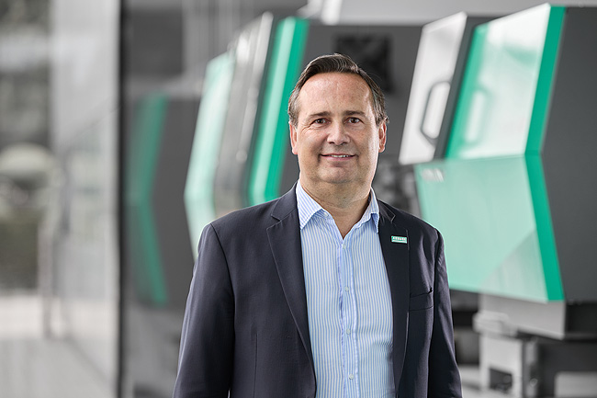

As Managing Director of Arburg Spain, Martin Cayre is also responsible for the Portuguese market.

ALLROUNDER 1800 e TREND_359

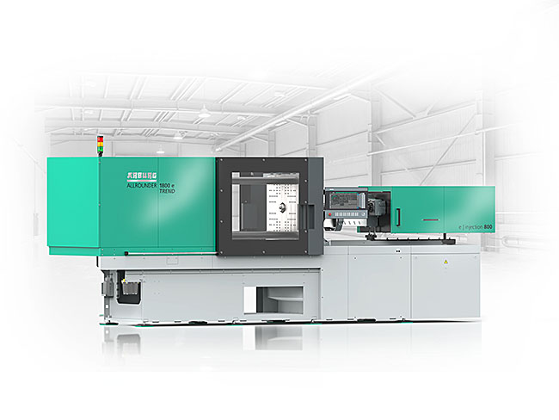

New performance level: The electric Allrounder Trend can be set up remarkably quickly and easily and is specifically designed for the efficient production of standard injection moulded parts.

186073

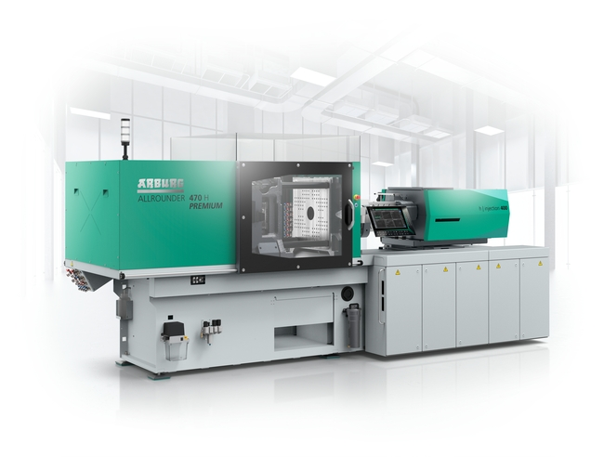

Efficient and customisable: At Moldplas 2025, a hybrid Allrounder 470 H with a clamping force of 1,000 kN will be producing beverage jugs as give-aways.

Photos: ARBURG

Photo download:
https://media.arburg.com/web/5aedf1dea5570bb6/moldplas-2025-press-preview/

press release
File: ARBURG Press preview Moldplas 2025_en_GB.docx
Characters: 4,046
Words: 619

You can also download this and other press releases from our website at www.arburg.com/de/presse/ (www.arburg.com/en/presse/)

Please contact
Arburg GmbH + Co KG
Press Office
Susanne Palm
Dr Bettina Keck
P.O. Box 1109
72286 Lossburg, Germany
Phone: +49 7446 33-3463
Phone: +49 7446 33-3259
presse_service@arburg.com

About Arburg
Founded in 1923, the German family-owned company is one of the world’s leading manufacturers of injection moulding machines. The Arburg family also includes AMKmotion, a manufacturer of electric drive technology.
The Arburg portfolio for plastics processing includes Allrounder injection moulding machines, robotic systems as well as customer- and industry-specific turnkey solutions. In addition, there are digital products and services. In the plastics industry, Arburg is a pioneer in the areas of energy and production efficiency, digitalisation and sustainability. Arburg machines are used to manufacture plastic products for the mobility, packaging, electronics, medical, construction and apparatus construction and leisure sectors to name just a few examples.
The company headquarters are located in Lossburg, Germany. In addition, Arburg has its own organisations in 27 countries at 37 locations and is represented in over 100 countries together with trading partners. Of the total of around 3,450 employees, roughly 2,850 are employed in Germany and about 600 in the Arburg organisations worldwide.
Arburg is certified in accordance with ISO 9001 (Quality), ISO 14001 (Environment), ISO 27001 (Information Security), ISO 29993 (Training) and ISO 50001 (Energy).
Further information: www.arburg.com, www.amk-motion.com.

