Arburg at the Plástico Brasil 2025
Injection moulding instead of thermoforming: Efficient turnkey system for packaging industry

- Allrounder 720 H(P): Hybrid high-performance machine for high-speed packaging applications
- Turnkey: Arburg Brazil realises sophisticated injection moulding applications with local partners
- Digital products and services: Host computer system and customer portal increase efficiency and transparency

Lossburg, 20/01/2025
At Plástico Brasil from 24 to 28 March 2025 in São Paulo, Brazil, Arburg will be presenting a high-speed application for the packaging industry: a hybrid Allrounder 720 H in packaging design will produce four IML margarine containers in less than five seconds. Arburg realised the complete turnkey system with local partners. Trade visitors to stand I040 will also learn how the ALS host computer system, the arburgXworld customer portal and other digital products and services can be used to further increase production efficiency and competitiveness in injection moulding production.

"Plástico Brasil is a very important plastics trade fair for our country and the whole of South America," emphasises Alfredo Fuentes, Managing Director of Arburg Ltda. in Brazil. "We will be presenting a turnkey system consisting of a precisely coordinated combination of Allrounder, mould and IML robotic system, which is specifically designed for the packaging industry - a sector with growth potential in the dynamic Brazilian plastics market. We want to show that our injection moulding solution is an efficient alternative to thermoforming. The production of IML cups shows in concrete terms how optimised process control can achieve short cycle times as well as high productivity and process stability."

Hybrid high-performance machine
In IML applications, fast and high-quality series production with the lowest possible material and energy consumption is particularly important. This is exactly what the hybrid Allrounders from the Hidrive series are designed for, combining an electric, energy-efficient and precise clamping unit with a hydraulic, powerful and dynamic injection unit. At Plástico Brasil 2025, an Allrounder 720 H in packaging version with a clamping force of 2,900 kN and a size 1300 injection unit will be on show as an example of this. The hybrid high-performance machine produces four 250 millilitre IML margarine containers in a cycle time of less than five seconds. The IML automation comes from the Brazilian manufacturer G3 Automation, the 4-cavity mould from RK Ferramentaria. The Gestica control system with its numerous "smart" assistance functions offers a high level of operating convenience and extensive support.

Efficiency thanks to special packaging design
The packaging version (P) was developed by Arburg specifically for the packaging industry and is available for machines from the Hidrive (H) and Alldrive (A) series in sizes 520 to 1020. The package includes FEM-optimised mould mounting plates and resilient machine bases, highly wear-resistant cylinder modules with barrier screws as well as servo-electric toggle-type clamping units and dosing drives as standard. There are also additional control functions such as start-up parameters and cross-cycle dosing. The result is very short dry cycle times, high plasticising capacities and injection speeds as well as reduced energy requirements.

Digitalisation increases production efficiency
Arburg Brazil's presence at the trade fair will be rounded off by the presentation of its comprehensive digital products and services, which customers can use to significantly increase production efficiency and transparency in their injection moulding plants. As a provider of complete solutions, Arburg offers "more than a machine". The exhibit is networked with the Arburg ALS host computer system so that, for example, process data and key figures can be visualised clearly and excellently in real time. The experts will also be providing detailed information on the arburgXworld customer portal, preventive maintenance and the comprehensive range of after-sales services.

Pictures

164929

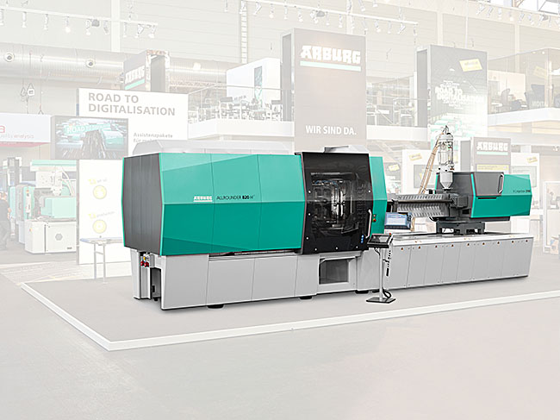

The hybrid Allrounder Hidrive (H) in packaging version is specifically designed for the efficient production of packaging items. At Plástico Brasil, Arburg will be presenting a turnkey system centred around a hybrid Allrounder 720 H(P) that produces IML cups.

Alfredo Fuentes 183586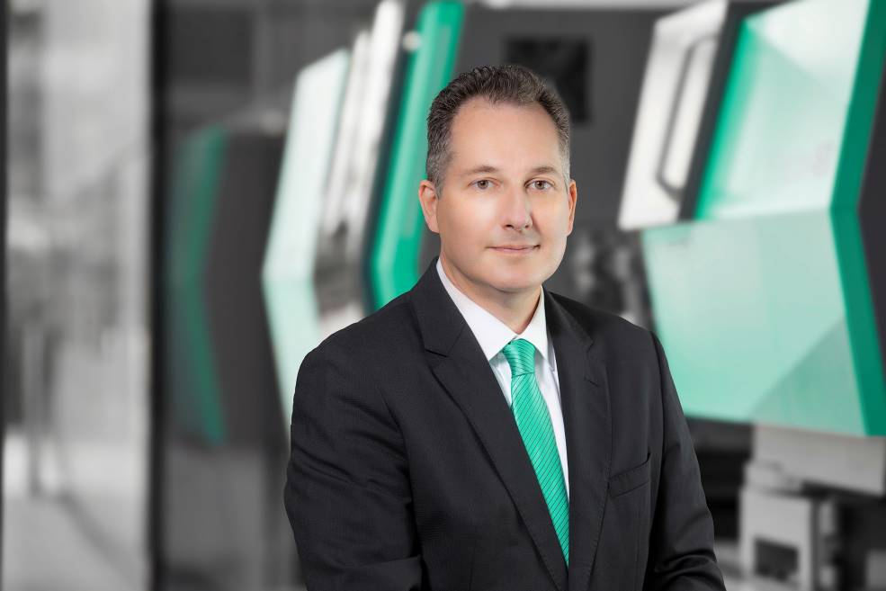

Alfredo Fuentes, Managing Director of Arburg Ltda. in Brazil.

Photos: ARBURG
Photo Download:
https://media.arburg.com/web/c6e91521b2efc437/press-preview-pl-stico-brasil-2025//

Press Release
File: Pressevorbericht Plastimagen 2025_en.docx
Character: 4,441
Words: 671

You can also download this and other press releases from our website at www.arburg.com/de/presse/ (www.arburg.com/en/presse/)

Contact us
ARBURG GmbH + Co KG
Press office
Susanne Palm
Dr Bettina Keck
PO Box 1109
72286 Lossburg
Phone: +49 7446 33-3463
Phone: +49 7446 33-3259
presse_service@arburg.com

About Arburg
Founded in 1923, the German family-owned company is one of the world's leading machine manufacturers for plastics processing. The ARBURG family also includes AMKmotion and ARBURGadditive including innovatiQ.
The portfolio includes injection moulding machines, 3D printers for industrial additive manufacturing, robotic systems and customer- and industry-specific turnkey solutions. It also includes digital products and services.
ARBURG is a pioneer in the plastics industry when it comes to energy and production efficiency, digitalisation and sustainability. ARBURG machines are used to manufacture plastic products for the mobility, packaging, electronics, medical, construction and apparatus engineering and leisure sectors, for example.
The company headquarters are located in Lossburg, Germany. In addition, ARBURG has its own organisations in 27 countries at 37 locations and is represented in over 100 countries together with trading partners. Of the total workforce of around 3,700, around 3,100 are employed in Germany and around 600 in the ARBURG organisations worldwide.
ARBURG is certified in accordance with ISO 9001 (quality), ISO 14001 (environment), ISO 27001 (information security), ISO 29993 (training) and ISO 50001 (energy).
Further information: www.arburg.com, www.amk-motion.com and www.arburg.com/arburgadditive.

