Arburg at the K 2025
World premiere Allrounder 475 V: Small footprint, high clamping force

- Space-saving: Vertical Allrounder 475 V with small footprint
- Efficient: Arburg servo hydraulic system (ASH) reduces energy consumption by up to 60 per cent
- Flexible: For manual and automated overmoulding of inserts

Lossburg, 04.09.2025
The Allrounder 475 V with a clamping force of 1,000 kN is celebrating its world premiere at the K 2025. It showcases high energy efficiency, a small footprint and an attractive price-performance ratio. The new vertical machine from Arburg can be used flexibly and looks predestined for both manual and automated overmoulding of inserts. At stand 13A13, the Allrounder 475 V can be seen as part of a turnkey system that produces, marks and post-processes high-quality covers for car radio keys from PC/ABS recyclate in combination with in-mould decoration (IMD).

The new vertical machine is specifically designed for standard applications, for example for the growth sector of e-mobility as well as for electronics and medical technology. These include the manual or automated overmoulding of cables, contacts and infusion accessories.

Small footprint - large space for the mould
The footprint is particularly compact but, despite this, the new vertical machine offers extra space also for larger moulds. The standard installation height is 250 millimetres with the option of extending it by 100 or 200 millimetres. Side doors and the upwardly offset clamping cylinder ensure good accessibility to the mould and ejector. An off-centre ejector is available as an option. The table height is 900 millimetres for improved ergonomic working.

Energy consumption reduced by up to 60 per cent
The Allrounder 475 V has a clamping force of 1,000 kN and can be equipped with hydraulic injection units in sizes 100 to 400.
For energy-efficient operation, the machine is equipped as standard with the Arburg servo hydraulics system (ASH), which continuously adjusts the water-cooled, speed-controlled servo motors to the actual power requirement. This minimises idling losses and reduces the specific energy requirement by up to 60 percent compared to conventional hydraulic machines.

New Gestica lite control variant
The new "Gestica lite" control variant ensures particularly simple and intuitive operation. Even inexperienced personnel can get to grips with this quickly. The clear dashboard provides everything needed for the work at a glance: information on the job, the current process and the upcoming tasks - all intelligently and actively supported by optional assistance functions that ensure high-quality plasticising and moulded part quality.

Vertical machine can be automated in a flexible manner
If required, the vertical machine can be automated flexibly, for example with a six-axis or linear Multilift robotic system. Arburg can fulfil almost any customer requirement, including simple sprue removal, difficult component handling or customised automation for complex production cells including upstream or downstream process steps. The Arburg turnkey experts supply CE-compliant machines, automation and peripherals from a single source.

Practical example of a wireless key cover
At K 2025, the turnkey system based around an Allrounder 475 V will show how products with high-quality designs and surfaces can be created efficiently for the mobility sector. This is demonstrated by the cover of a wireless key, featuring a design based on the "Generic Keyfob" from company Huf. Its plastic cover is made of post-industrial recyclate (PIR) based on PC/ABS. A high-quality surface is created using the new PLF technology (Protective Layer Finish) for In-Mould Decoration (IMD) from partner Leonhard Kurz in combination with a structured tool insert. For this purpose, a wafer-thin PET film including decoration system is fed into the mould from the outside via a feed unit. There, the decorative film is applied to the plastic surface by means of in-mould lamination. An Arburg logo and a textured surface are also applied to the moulded part via the mould insert. The cover is punched out rectangularly in the mould and the remaining film is rolled up in the installation space of the vertical machine. Subsequent painting is not necessary and the product can be recycled. Different films featuring a variety of designs and colours that can be used flexibly for product variants.

Automated parts handling and R-Cycle
The fully automated application is also a successful practical example of the R-Cycle initiative. Data relating to recycling such as the material composition can be retrieved via a code on the component. Such digital product passports lay the groundwork for data-based material flows and a closed plastics cycle.
A Kuka six-axis robot is used for the complete part handling. It first removes the moulded part from the mould and feeds it to a laser station, where it is labelled with a code. The robot then transfers the part to a milling station and, with the gripper, guides it along the milling path to remove excess film and generate the final contour. In a subsequent cleaning station, the wireless key cover is deburred before finally getting placed on a conveyor belt by the six-axis robot and ejected from the production cell.

Picture

Allrounder 475V_407

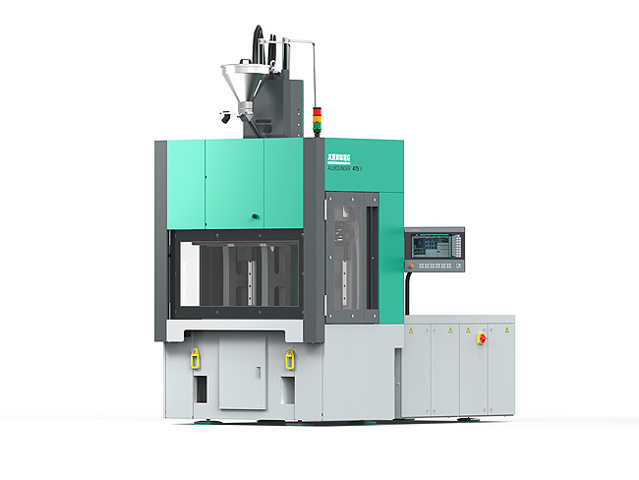

World premiere at the K 2025: The Allrounder 475 V is an energy-efficient, space-saving, cost-effective and flexible vertical injection moulding machine.

Photo: Arburg

Photo Download:
https://media.arburg.com/web/945382004dd858cb/allrounder-475v-press-release/

press release
File: Press release Allrounder 475V K2025_en.docx
Characters: 4,938
Words: 776

This and other press releases are available for download from our website at www.arburg.com/de/presse/ (www.arburg.com/en/press/)

Contact
ARBURG GmbH + Co KG
Press office
Susanne Palm
Dr Bettina Keck
Postfach 1109
72286 Lossburg, Germany
Tel.: +49 (0)7446 33-3463
Tel.: +49 (0)7446 33-3259
presse_service@arburg.com

About Arburg
Founded in 1923, the German family-owned company is one of the world's leading manufacturers for plastics processing machines. AMKmotion and ARBURGadditive including innovatiQ also belong to the ARBURG family.
The portfolio encompasses injection moulding machines, 3D printers for industrial additive manufacturing, robotic systems as well as customer- and industry-specific turnkey solutions. It also includes digital products and services.
ARBURG is a pioneer in the plastics industry when it comes to energy and production efficiency, digitalisation and sustainability. ARBURG machines are used to manufacture plastic products for the mobility, packaging, electronics, medical, construction and equipment engineering and leisure industries, for example.
The company headquarters are located in Lossburg, Germany. In addition, ARBURG has own organisations in 27 countries at 37 locations and is represented in over 100 countries together with trading partners. Of a total of roughly 3,700 employees, around 3,100 work in Germany, with another 600 employees based in ARBURG's organisations around the world.
ARBURG is certified to ISO 9001 (quality), ISO 14001 (environment), ISO 27001 (information security), ISO 29993 (training) and ISO 50001 (energy).
Further information: www.arburg.com, www.amk-motion.com as well as www.arburg.com/arburgadditive.

