Arburg at the K 2025
IML Medical - exhibit demonstrates the added value of labelled medical technology products

- IML added value: Labels are functional, recyclable, customised and have a high-quality design
- Precision: Repeatable IML application for medical technology
- Production efficiency: Expert partners develop marketable solution for medical IML labels

Lossburg, 12.09.2025
On a complex production cell built around an electric Allrounder 520 A, Arburg will be demonstrating at its stand 13A13 how in-mould labelling (IML) can open up new possibilities in medical technology. The added value offered by the IML process compared to printing or labelling will be demonstrated. The innovative IML solution offers added functionality, design freedom and recyclability, e.g. for medical technology products such as centrifuge tubes, auto-injectors or measuring cups.

In-mould labelling (IML) and functional labels place high demands on the precision of the injection moulding process and automation. Thanks to the combined expertise in the areas machine (Arburg), mould technology (Kebo), label (MCC), automation (Beck) and camera inspection (Intravis) experts, a production cell has been created that sets standards in the industry. At the K 2025, ready-to-use centrifuge tubes with functional labels made of PP will be produced as an example. The system concept presented can be transferred to many different medical technology products and, if required, can also be customised, e.g. for automated downstream process steps.

IML labels - functional, customised, sustainable
As an example of functional integration, products with filling scales and thermochromic imprints that can monitor temperature profiles by means of colour change will be provided at K 2025. Information on safety and use can also be added, which is useful for auto-injectors or inhalers, for example. IML technology achieves further added value by applying codes for seamless traceability. IML products with NextCycle labels can be mechanically recycled without the label having any effect on the PP material.
While sensitive information on patient data is initially printed invisibly and, for example, can only be read under UV light patient numbers can be applied to labels that react photonically with light directly in the hospital using a laser station.
Various demonstrators and designs will also be presented at the trade fair. Interesting examples include auto-injectors that can be given a high-quality finish with a matt, glossy, raised or metallic surface.

Small footprint - high performance
The injection moulding exhibit is production cell built around an electric Allrounder 520 A with a clamping force of 1,500 kN in a clean room design. The machine in the „Ultimate“ performance variant is designed for fast and demanding processes and fulfils the requirements for production in cleanroom class ISO 7. An important aspect is the compact footprint of the production cell, which fits into the specified production grid. The centrifuge tubes, each with a capacity of 15 millilitres, are produced in a cycle time of around ten seconds using an 8-cavity mould from Kebo. An important prerequisite for functionality is the precise alignment and accurate positioning of the labels. This is done using automation and a label adjustment head from Beck, which can compensate for the production tolerance to within a few hundredths. Visual inspection is performed by a camera system integrated into the automation system. Each tube is given a QR code and a part-specific ID for 100 per cent traceability. As there are no additional work steps for labelling the products, such as subsequent printing or gluing, production is very time- and cost-efficient - without any additional hygiene risk or effort for personnel and logistics. In addition, there is no contamination with liquid colours or adhesives. Waste can be reduced by a factor of ten.

Pictures

Allrounder 520 A Medical_DSC9878

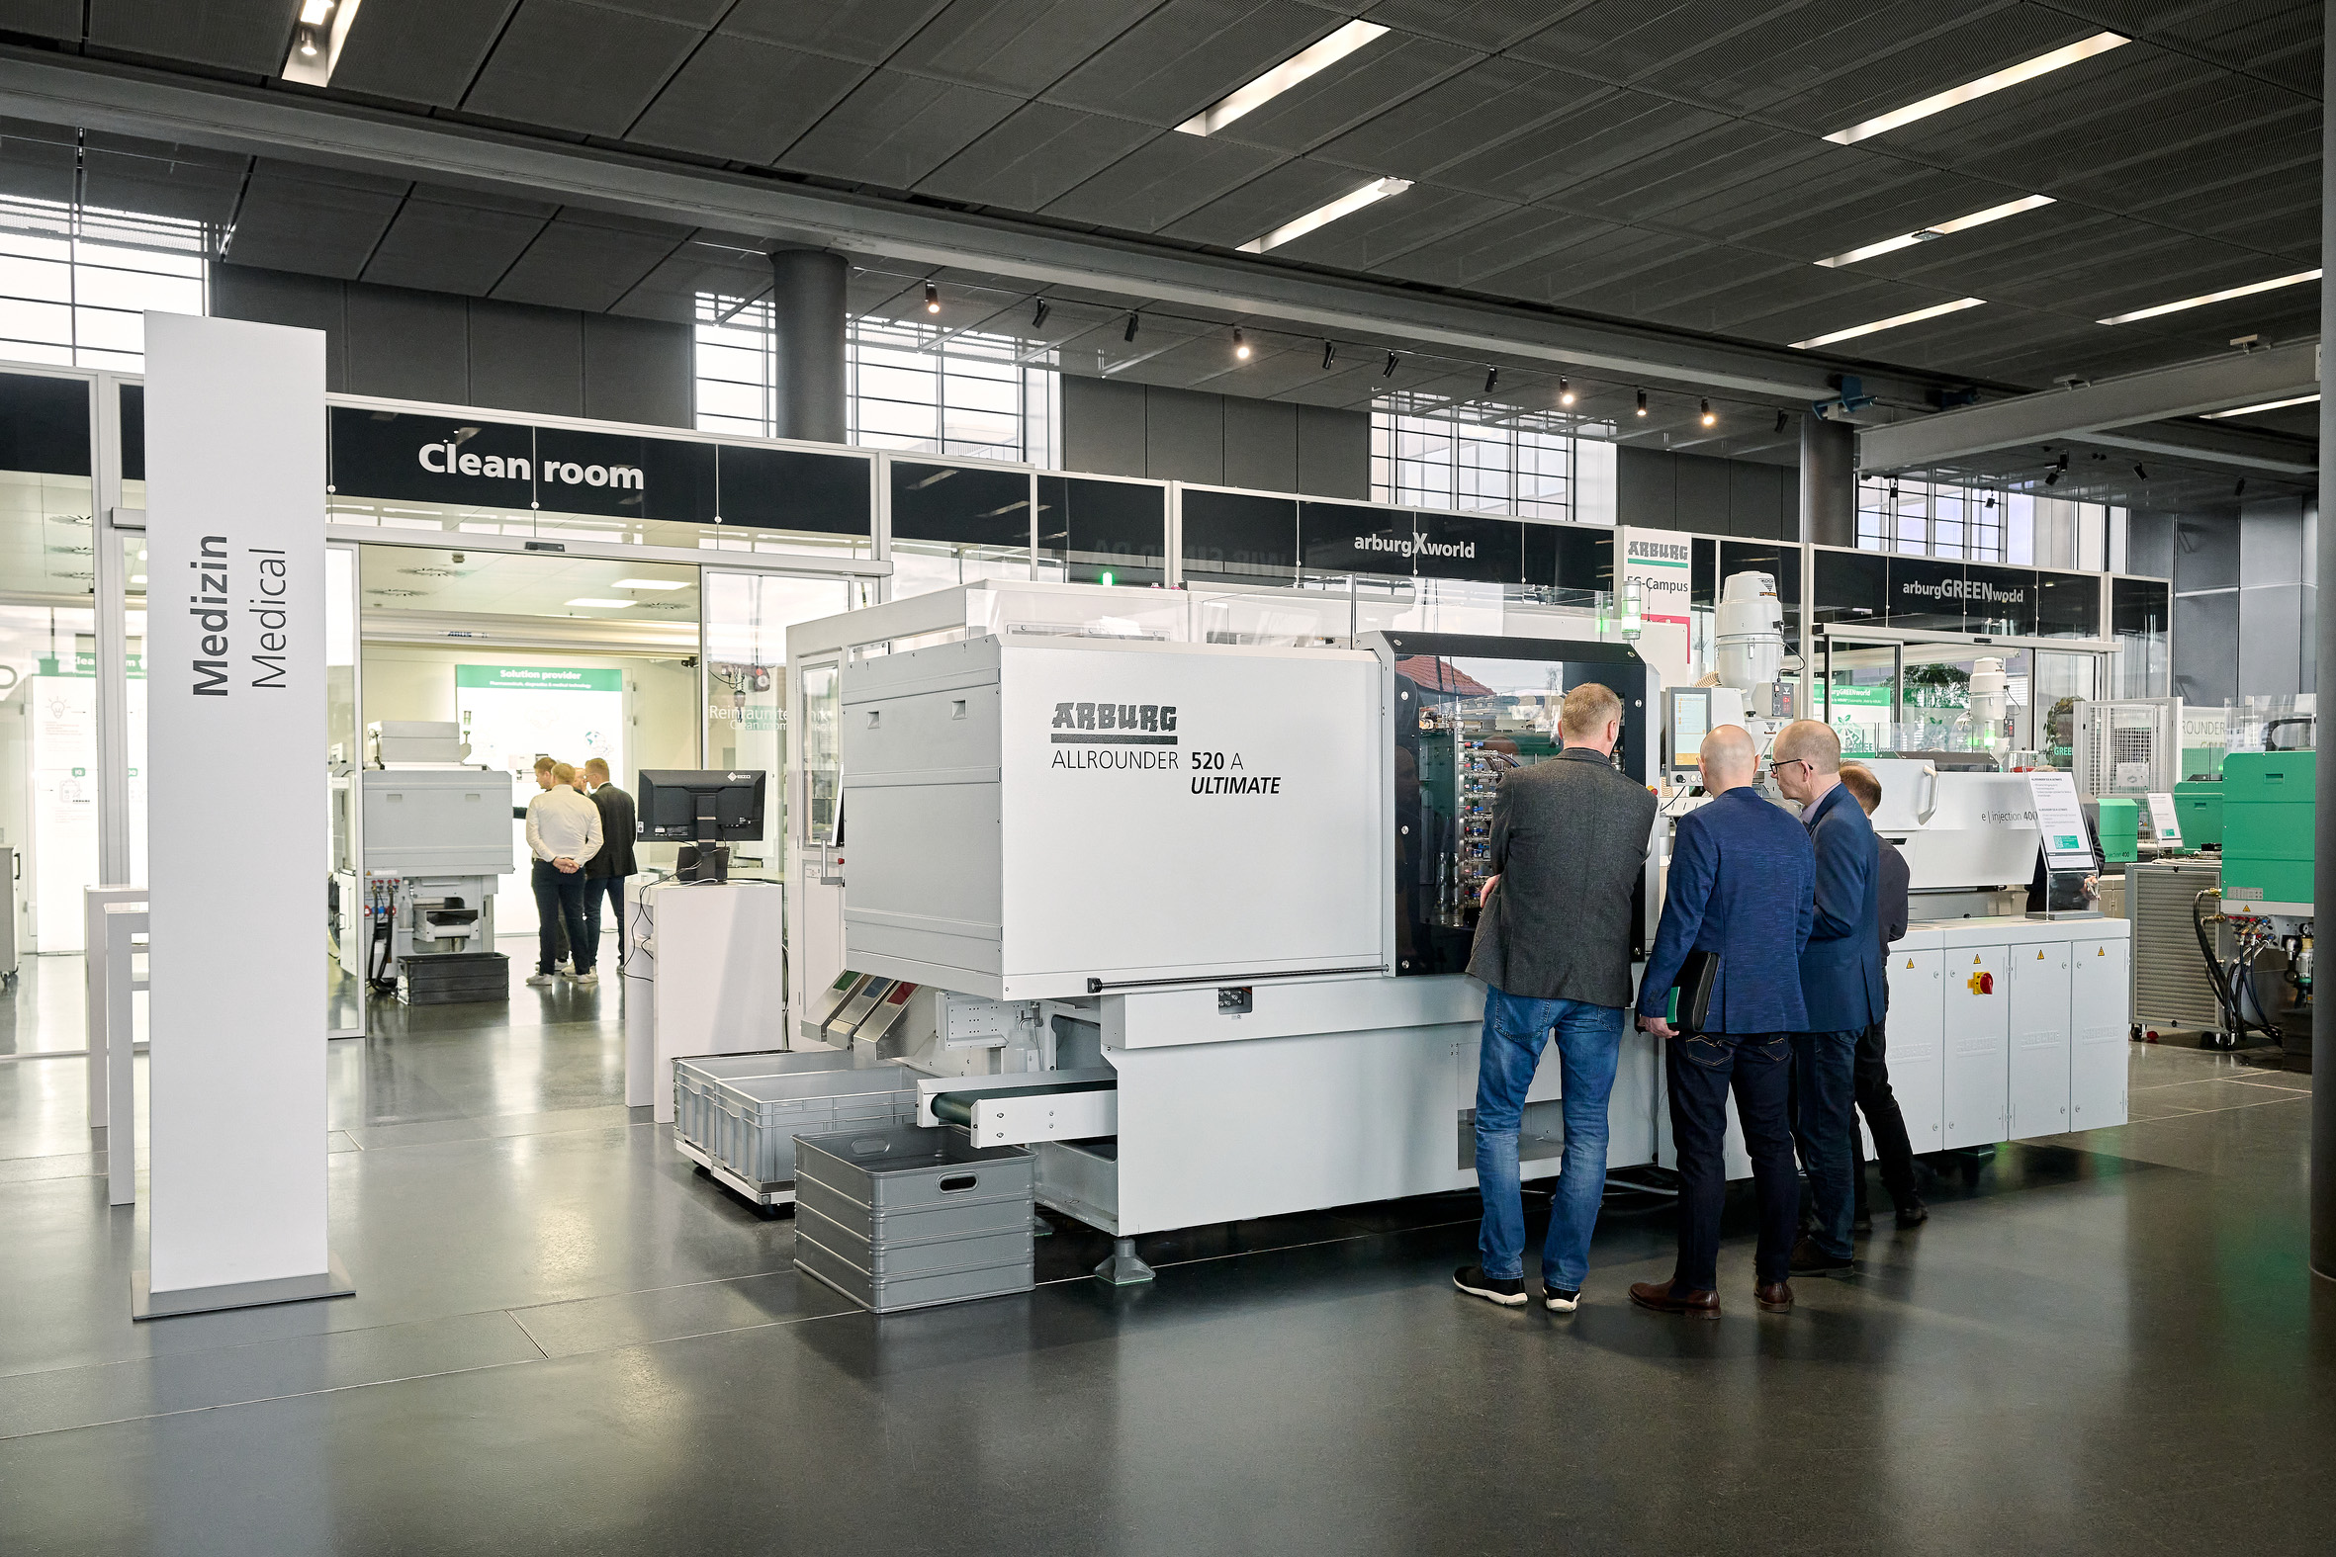

At K 2025, a production cell centred around an electric Allrounder 520 A produces medical products with the added value of functional IML labels.

Sample IML medical_DSC00702

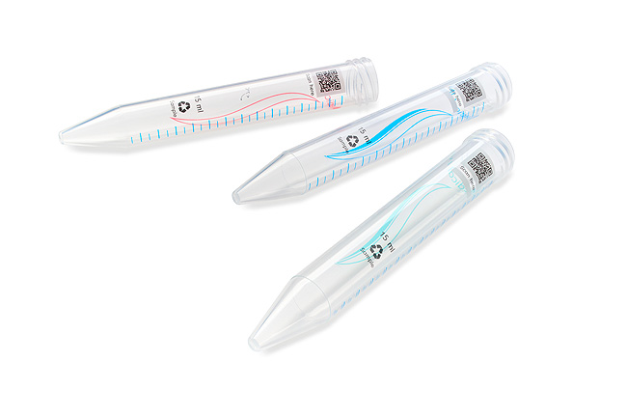

Example of centrifuge tubes: Functional IML labels can be supplemented with a filling scale, QR codes or thermochromic-sensitive elements, for example.

Photos: Arburg

Photo download:
https://media.arburg.com/web/96bb1b08a35dd884/iml-medical-k2025/

Press Release
File: Press release IML Medical K2025_en.docx
Characters: 3.537
Words: 548

You can also download this and other press releases from our website at www.arburg.com/de/presse/ (www.arburg.com/en/presse/)

Contact us
Arburg GmbH + Co KG
Press Office
Susanne Palm
Dr Bettina Keck
P.O. Box 1109
72286 Lossburg, Germany
Phone: +49 7446 33-3463
Phone: +49 7446 33-3259
presse_service@arburg.com

About Arburg
Founded in 1923, the German family-owned company is one of the world's leading manufacturers of injection moulding machines. AMKmotion, a manufacturer of electric drive technology, also belongs to the Arburg family.
The portfolio for plastics processing encompasses Allrounder injection moulding machines, robot systems as well as customer- and industry-specific turnkey solutions. It also includes digital products and services. Arburg is a pioneer in the plastics industry when it comes to energy and production efficiency, digitalisation and sustainability. Arburg machines are used to manufacture plastic products for the mobility, packaging, electronics, medical, construction and equipment engineering and leisure industries, for example.
The company headquarters are located in Lossburg, Germany. In addition, Arburg has own organisations in 27 countries at 37 locations and is represented in over 100 countries together with trading partners. Of a total of roughly 3,450 employees, about 2,850 work in Germany, with another 600 employees based in Arburg's organisations around the world.
Arburg is certified to ISO 9001 (Quality), ISO 14001 (Environment), ISO 27001 (Information Security), ISO 29993 (Education and Training) and ISO 50001 (Energy).
Further information: www.arburg.com, www.amk-motion.com.

