Arburg at the K 2025
Colourful series of lectures: From ocean bound plastic to “floating professor”

- Expert information: Colourful series of lectures rounds off Arburg performance at the K 2025
- arburgGREENworld: Speakers shed light on sustainability along the value chain
- Highlights: CO₂-negavite compounds, reuse of ocean-bound plastic and “floating professor”

Lossburg, 25.09.2025
Arburg will round off its presence at K 2025 in the arburgGREENworld pavilion (open-air area in front of Hall 16) with a colourful array of expert presentations. Whether projects such as “Carbon Busters”,“pureelbe”, CO₂-negative compounds with biochar or e-fuels for DTM motorsport - the speakers’ commitments and the topics they are driving forward are as diverse as the facets of sustainability. Every day, various aspects of the future of plastic as a recyclable material will be highlighted. Afterwards, anyone who wants to can enjoy what is probably the best coffee at K 2025 at the barista in the arburgGREENworld pavilion and continue the dialogue with the experts from Arburg and partners from industry and science.

The lecture programme will be rounded off by Arburg's participation in the “Power of Plastics Forum” in the VDMA pavilion and at the “Women in Plastics” event with short presentations on topics such as digitalisation, circular economy and careers.

Expert knowledge at first hand
The "swimming professor" and Arburg brand ambassador Prof Andreas Fath from Furtwangen University talks about his commitment to combating microplastics in bodies of water. His spectacular campaigns include “cleandanube” and “pureelbe”, in which he swam the Danube and Elbe rivers from their source to their mouths. An interesting approach to ridding the oceans of plastic waste is being pursued by the company Healix. CEO Marcel Alberts presents his vision of returning “ocean-bound plastics” to the plastic cycle. The exhibit in the arburgGREENworld pavilion, which uses recycled material from Healix based on discarded fishing nets to make model dolphins, also shows how this works. Prof. Hans-Josef Endres from the Institute of Plastics and Circular Economy (IKK) at Leibniz Universität Hannover will be speaking about the challenges of processing recyclate and highlighting ways to optimise energy consumption during injection moulding.
Another topic will be alternative materials. Harry Unflath, Head of Sports Marketing at ABT Sportsline GmbH, which Arburg is sponsoring for the first time in the 2025 DTM season, will focus on the use of environmentally friendly e-fuels in motorsport. Torsten Becker, CEO of the start-up carbonauten, will be looking at how CO₂-negative coumpounds can be produced from biochar from plants.
Luca Simon, Applications Manager Circular Economy at Arburg, explains how the CO₂ footprint of injection moulding machines can generally be reduced and presents Arburg's comprehensive activities on the topic of sustainability. The “Carbon Busters” project, with which the VDMA association honours young climate protectors, will be presented by the trainees in their lecture. Miriam Lutz, Manager Product Management at Arburg, will explain the role that strong women play in a sustainable future using the example of the Frauen@ARBURG women network.

Overview of presentations in the arburgGREENworld pavilion
(most of them in German language)
- Wed 08.10., (11.30 a.m.): “Energieeffizienz beim Spritzgießen”, Prof. Hans-Josef Endres, IKK Hannover.
- EN: Wed 08.10., (2.30 p.m.): “Hightech material made from ocean-bound plastics”, Marcel Albers, Healix.
- Thu 09.10., (11:30 a.m.): “Rescuing our planet from plastics pollution”, Marcel Albers, Healix.
- Thu 09.10., (2.00 p.m.): “Vom Allgäu in die Welt hinaus”, Harry Unflath, ABT Sportsline.
- Fri 10 Oct (1.00 p.m.): “Schwimmen für die Wissenschaft”, Prof. Andreas Fath, Furtwangen University.
- EN: Fri 10 Oct 4.00 p.m.): “Swimming for science”, Prof. Andreas Fath, Furtwangen University.
- Sat 11 Oct (11:30 a.m.): “Nachhaltige Produktion: CO₂-Fußabdruck reduzieren mit der arburGREENworld“, Luca Simon, Arburg.
- Sat 11.10. (2.00 p.m.): “Carbon Busters Award”, Arburg trainees.
- Sun 12 October (11.30 a.m.): “Frauen@ARBURG - strong women for a sustainable future”, Miriam Lutz, Manager Product Management.
- Mon 13 Oct (11:30 a.m.): “CO₂-negative biokohlegefüllte Compounds”, Torsten Becker, carbonauten.
- Mon 13 Oct (2.00 p.m.): “Herausforderungen beim Recycling und der Verarbeitung von Rezyklaten”, Prof. Hans-Josef Endres, IKK Hannover.
- Mon 13 October (4.00 p.m.): “CO₂-negative biokohlegefüllte compounds”, Torsten Becker, carbonauten.
- Tue 14 Oct (11:30 a.m.): “Carbon Busters Award”, Arburg trainees.
- Wed 15 October (14:00): “Frauen@ARBURG - starke Frauen für eine nachhaltige Zukunft”, Miriam Lutz, Manager Product Management.
(for more on sustainability, see the arburgGREENworld press release: https://www.arburg.com/en/company/news-press/detail/k-2025-arburggreenworld-pavilion-showcases-water-worlds/)
Arburg's participation in VDMA and “Woman in Plastics”
In the VDMA pavilion, Arburg will be participating in selected English-language theme days of the “Power of Plastics Forum”:
- 08 Oct, The Power of Plastic Wednesday (12.00 noon):
“We are the Power of Plastics”, introduction with Dr Christoph Schumacher, Vice President Global Marketing.
- 09.10., Circular Thursday (12:00 noon):
Short presentation by Marcel Albers, Healix on “High-tech materials made from ocean-bound plastics”.
- 11 Oct, Smart Saturday (2.00 p.m.):
“Digitalisation in plastics processing”, short presentation on “Connectivity and smart production” by Werner Faulhaber, Vice President Research & Development, and Stephan Reich, Vice President Global IT & Digital Services.
- 13 October, Innovation Monday (2.00 p.m.):
“Innovative technology for a circular economy”, short presentation on “driving sustainability with expertise” by Simon Luca, Applications Manager Sustainability.
- 14 Oct, Visionary Tuesday (11:45 a.m.):
“Carbon Busters” by Jaqueline Fritz, trainee.

Miriam Lutz, Manager of Product Management, will also present the “Frauen@ARBURG” network at the “Woman in Plastics” networking event at K 2025 on Sunday 12 October (4 p.m.).

Picture

Lecture aGw-pavilion 184278
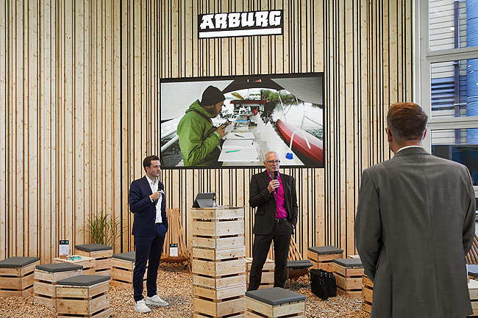
series in the arburgGREENworld pavilion: Numerous speakers will round off Arburg's activities at K 2025 on the topic of sustainability. Prof. Andreas Fath (centre), Arburg brand ambassador, will give the lecture “Swimming for science”, for example.

Photo: Arburg
Photo download:
https://media.arburg.com/web/dbe1d9bd8f35d2de/lectures-agw-pavilion-k2025/

Press Release
File: ARBURG press release aGw lectures K2025_en_GB.docx
Characters: 5,802
Words: 820

You can also download this and other press releases from our website at www.arburg.com/de/presse/ (www.arburg.com/en/presse/)

Contact
Arburg GmbH + Co KG
Press Office
Susanne Palm
Dr Bettina Keck
P.O. Box 1109
72286 Lossburg, Germany
Phone: +49 7446 33-3463
Phone: +49 7446 33-3259
presse_service@arburg.com

About Arburg
Founded in 1923, the German family-owned company is one of the world's leading manufacturers of injection moulding machines. AMKmotion, a manufacturer of electric drive technology, also belongs to the Arburg family.
The portfolio for plastics processing encompasses Allrounder injection moulding machines, robot systems as well as customer- and industry-specific turnkey solutions. It also includes digital products and services. Arburg is a pioneer in the plastics industry when it comes to energy and production efficiency, digitalisation and sustainability. Arburg machines are used to manufacture plastic products for the mobility, packaging, electronics, medical, construction and equipment engineering and leisure industries, for example.
The company headquarters are located in Lossburg, Germany. In addition, Arburg has own organisations in 27 countries at 37 locations and is represented in over 100 countries together with trading partners. Of a total of roughly 3,450 employees, about 2,850 work in Germany, with another 600 employees based in Arburg's organisations around the world.
Arburg is certified to ISO 9001 (Quality), ISO 14001 (Environment), ISO 27001 (Information Security), ISO 29993 (Education and Training) and ISO 50001 (Energy).
Further information: www.arburg.com, www.amk-motion.com.

