Arburg at the K 2025
New in digitalisation: From the AI-supported “Ask Arburg” app to the Virtual Twin

- New: Gestica lite - easy-to-use basic control system for standard machines
- New: “aXw Control MoldlifeAssist” – smart communicate between machine and mould
- Comprehensive: arburgXworld - support for everyday injection moulding with AI

Lossburg, 10.10.2025
Arburg has always been a pioneer when it comes to digitalisation and artificial intelligence (AI). Arburg will be presenting numerous innovations at its K trade fair stand 13A13. Highlights include the new Gestica lite control system for standard machines, including a virtual twin of an exhibit, as well as AI-supported assistants and pilots such as the “aXw Control MoldlifeAssist” for communication between machine and mould and the “aXw Control RecyclatePilot” for recyclate processing. There are also new features in the Arburg ALS host computer system and the arburgXworld customer portal. The enhanced customer portal app “Ask Arburg” is a striking case in point.

Arburg has extensive expertise and fields a wide range of digital products and services. These are continuously being developed in line with market requirements to enable new customised digital solutions to be implemented.

Gestica lite: Remarkably easy and intuitive to use
Gestica lite, a new control variant that is extremely interesting for standard machines, is celebrating its premiere at K 2025. It features a distinctively robust industrial panel. The software basis is identical to Gestica and their data records are fully inter-compatible. The new version is reassuringly easy and intuitive to operate using the extended user interface, even for non-specialists; at the same time, flexibility is maintained for experienced operators. The “Dashboard” is a distinctive new feature on the user interface. The screen homepage clearly displays all the crucial functions for day-to-day work in a clear format. Those functions include information on the job, the current process and direct access to the most important parameters and key figures - all supported intelligently and actively by assistance functions. The touch function can be used to jump directly to the detailed parameter pages for the clamping and injection unit, temperatures and robotic system. The new “Status Center” offers added value with access to all pending alarms, while the “Help Center” provides access to online support. The “Tasks” area is dedicated to maintenance, material supply and parts disposal. Here, individual notes can be added to the digital “Pinboard” for collaborative work, eliminating the need for paper notes on the machine. This is complemented by simplified navigation and search with AI functionality as well as rapid support for the operator when troubleshooting thanks to assisted workflows with visual solution trees. Assistance and pilot functions such as the “aXw EnergyAssist” or the “aXw Control RecyclatePilot” are available as options. At the K 2025, four exhibits - the electric Allrounder Trend and the vertical Allrounder 475 V - are already equipped with this new control variant. Individual features can also be explained on a demonstrator monitor.

MoldlifeAssist: set up, monitor and maintain the mould
Arburg offers smart assistants and pilots for its machine control systems to make everyday injection moulding work much easier with digital products and services. The “aXw Control MoldlifeAssist” - the “Moldlife Sense” computer system from partner Hack Digital Solutions, which is fully integrated into the Gestica - is new and particularly predestined for complex moulds and endurance runners. This now enables "smart" communication directly between the machine or production cell and the injection mould on base of the the Euromap 82.5 interface. The associated hardware is a connector on the fixed mould plate and a box on the rear of the machine. This means that one system can be used for several moulds.
The “MoldlifeAssist” function supports the set-up, monitoring and maintenance of the mould and improves availability and operator safety. Its “Set-Up Assistant” with digital alignment aid guides the operator step by step visually through the entire set-up operation and process. During daily operation, the tool is monitored over its entire life cycle in terms of temperature, acoustics, breathing and alignment using integrated sensor technology (condition monitoring). The measured values from various sensors can be visualised in the Gestica control system and individual “Events” - such as warnings, alarms and error messages - can be displayed and the tool data logged and documented. Another major advantage is the option of predictive maintenance. This prevents expensive unscheduled downtime periods while also avoiding the need for costly maintenance. Instead, the “MoldlifeAssist” enables condition-based maintenance cycles and also assists with maintenance. A maintenance logbook can be called up via Gestica and all maintenance points can be acknowledged and documented.
At K 2025, the “MoldlifeAssist” will be getting showcased as part of a digitally networked production cell based around an electric Allrounder 570 A, which produces caps for injector pens.
(for more see press release Allrounder 570A NextGen)

New pilot features for recyclate processing
While the digital assistance functions in the machine control system support the operator in everyday tasks, the pilots independently optimise the injection moulding process once activated.
The “aXw Control RecylatePilot” improves part quality by using the existing machine sensors to reliably compensate for material fluctuations and keep the shot weight constant. This is of equal interest to recyclate processing and to batch changes or inhomogeneous virgin material. A new feature of the “RecyclatePilot” is the ability to adjust the holding pressure level to the viscosity of the material. During a cycle, the injection volume is regulated via the switchover point from shot to shot. In addition, the metering volume can be corrected across cycles to compensate for long-term volume fluctuations.

Virtual twin in the arburgXworld
The arburgXworld customer portal with its numerous apps and features is no less intelligent than the assistants and pilots in the control system. One highlight at K 2025 is the virtual twin to Gestica lite. This new feature will be available in the “Virtual Control” premium app from 2026. This will not only make it possible to optimise a program directly on the PC, but also to run it in an automatic cycle in order to further optimise the process and cycle time.
Based on the data set of an injection moulding application, the complete cycle, including injection, holding pressure, etc., can be simulated and the associated graphics and curve diagrams displayed. The integration of automation or the time span until the granulate container needs to be refilled can also be simulated in advance using such a virtual twin.
At K 2025, the virtual twin of the Allrounder 1000 e Trend, which produces connectors at the trade fair stand, will be demonstrated live on a monitor.

Help wanted – “Ask Arburg” delivers
Artificial intelligence (AI) creates completely new perspectives and possibilities when it comes to processing large amounts of data or querying injection moulding knowledge. The premium app “Ask Arburg” is a pioneering example of integration in the customer portal. The AI-supported feature works like ChatGTP - but in a secure, self-contained environment - and can answer specific questions about all Arburg products and processes relating to injection moulding. The answers are now even more specific, as the app is supplemented with machine-specific knowledge about the customer machines via an interface to the master data. In various customer portal apps such as “DataDecoder” or “Programs”, “Ask Arburg” provides contextual support using an AI agent that can perform tasks without human intervention. Furthermore, the intelligent app can now also be called up within the Arburg host computer system ALS and directly on the Gestica control system.
Access is also possible “offline” using a QR code or, with the latest software version, online via smartphone. A new app for the free basic version of the customer portal is the “Energy Calculator", which can be used to create energy calculations in accordance with Euromap 60.2 - an important prerequisite for applying for subsidies or certifications. E-mail notifications are available to integrate the customer portal into daily work. In addition, "Notifications" can now also be used to display push messages directly on a smartwatch or smartphone as soon as the status of tickets and machines changes, for example.

News about the Arburg ALS host computer system
Complex production environments and high-precision components in particular require precise process control. This is where Arburg’s own MES, also in conjunction with the customer portal, can achieve significant advantages in terms of transparency, process reliability, energy and production efficiency. For example, the digital “Shift Planner” tool for detailed planning and optimisation within the shifts will be presented. This provides transparency regarding responsibilities and enables the manual allocation of employees based on ALS data. To further digitalise individual processes in the production environment with the help of ALS, there is also the new “Workflow” module. Incidentally, event-driven push notifications can also be displayed directly on smartphones, PCs and other end devices in the host computer system via “Notification” - if required, also via the arburgXworld app. In future, users will also be able to have reports analysed via AI, e.g. to compare shift reports.

Images

Gestica lite K2025 DE_DSC6996
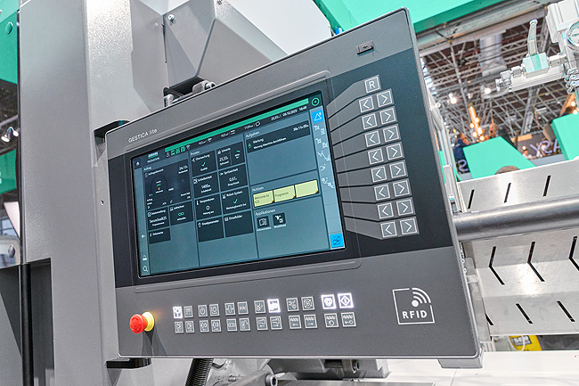

New control variant Gestica lite: easy to operate with a new, clear dashboard.

GESTICA EN MoldlifeAssist K2025 DE_D1A0923
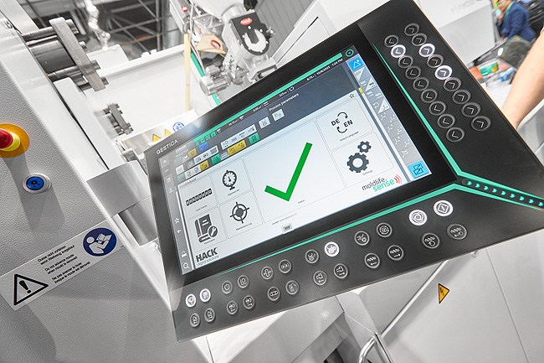

With the new “aXw Control MoldlifeAssist”, which is fully integrated into Gestica, smart communication between the machine or production cell and the injection mould is now possible.

GESTICA lite Virtual Twin K2025 DE_DSC6258
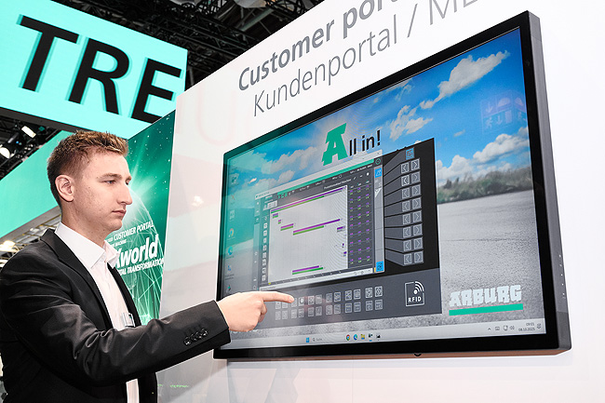

New feature of the customer portal app “Virtual Control”: With the help of a virtual twin in the Gestica lite, the process and cycle time can be further optimised directly on the PC based on a data set.

Photos: Arburg

Photo download:
https://media.arburg.com/web/886df53456471583/digitalisation-k2025/

Press release
File: ARBURG press release digitalisation K2025_en_GB.docx
Characters: 9,411
Words: 1,441

You can also download this and other press releases from our website at www.arburg.com/de/presse/ (www.arburg.com/en/presse/)

Please contact
Arburg GmbH + Co KG
Press Office
Susanne Palm
Dr Bettina Keck
P.O. Box 1109
72286 Lossburg, Germany
Phone: +49 7446 33-3463
Phone: +49 7446 33-3259
presse_service@arburg.com

About Arburg
Founded in 1923, the German family-owned company is one of the world's leading manufacturers of injection moulding machines. AMKmotion, a manufacturer of electric drive technology, also belongs to the Arburg family.
The portfolio for plastics processing encompasses Allrounder injection moulding machines, robot systems as well as customer- and industry-specific turnkey solutions. It also includes digital products and services. Arburg is a pioneer in the plastics industry when it comes to energy and production efficiency, digitalisation and sustainability. Arburg machines are used to manufacture plastic products for the mobility, packaging, electronics, medical, construction and equipment engineering and leisure industries, for example.
The company headquarters are located in Lossburg, Germany. In addition, Arburg has own organisations in 27 countries at 37 locations and is represented in over 100 countries together with trading partners. Of a total of roughly 3,450 employees, about 2,850 work in Germany, with another 600 employees based in Arburg's organisations around the world.
Arburg is certified to ISO 9001 (Quality), ISO 14001 (Environment), ISO 27001 (Information Security), ISO 29993 (Education and Training) and ISO 50001 (Energy).
Further information: www.arburg.com, www.amk-motion.com.

