Sustainability report for the year 2024
Arburg delivers convincing facts, figures
- and action

- Online: New sustainability report from Arburg
- Successful: Activities and measures of the arburgGREENworld programme
- Impressive: 130,000 tonnes less CO₂since 2010

Lossburg, 31.07.2025
The new sustainability report for 2024 is here - and presents the successful measures and activities of the arburgGREENworld programme with convincing facts, figures and actions. The fifth edition of the Arburg sustainability report is also available exclusively online as an interactive PDF on the Arburg website to conserve resources.

Sustainability has always played an important role at Arburg, and since 2019 all activities and measures have been bundled in the arburgGREENworld programme. In addition to the topics of resource efficiency, circular economy and CO₂ footprint, this programme also covers Arburg's entire ESG strategy (Environmental, Social, Governance) and relates both to the company itself and to its customers and partners.

Sustainability is part of Arburg's DNA
“Sustainability issues in the two dimensions of 'economic' and 'ecological' are firmly rooted in Arburg's DNA and are also very close to the hearts of our shareholders,” emphasises Michael Hehl, Managing Partner of Arburg. “Solutions for greater sustainability are a task for society and the world as a whole and will increasingly be an important part of a successful business model in the future.”

Successful awards
Arburg's new sustainability report is available online at “https://www.arburg.com/en/company/sustainability-at-arburg/” and summarises all the activities, measures and progress of the arburgGREENworld programme in 2024 in a clear and readable way.
The CDP classification in 2024 with a "B" rating proves that Arburg is above average in the areas of climate protection, ecology and CO₂ emissions compared to other mechanical engineering companies. Another success of the previous year is the EcoVadis Gold award, for which the criteria become more demanding from year to year. This means that Arburg continues to be among the top five percent of independently assessed companies in terms of environmental, labour and human rights, ethics and sustainable procurement.

Impressive figures
The following figures prove that Arburg is constantly improving in terms of resource efficiency, circular economy and CO₂footprint:
- In 2024, the Arburg electricity mix has a CO₂ footprint that is up to 88 per cent lower than the German electricity mix.
- In 2024, Arburg generated around 2,600,000 kWh of solar power for its own use using photovoltaics.
- The proportion of self-generated electricity from renewable sources was almost 17 per cent.
- 130,000 tonnes of CO₂ emissions were saved between 2010 and 2024.
- Almost 25 per cent of Arburg's total water consumption comes from rainwater collected in cisterns.
- 71 per cent of the total waste generated was recycled in 2024.

Many other impressive figures can be found in the Arburg Sustainability Report 2024, as well as exciting results from research and development.

Picture

Sustainability Report 2024 EN

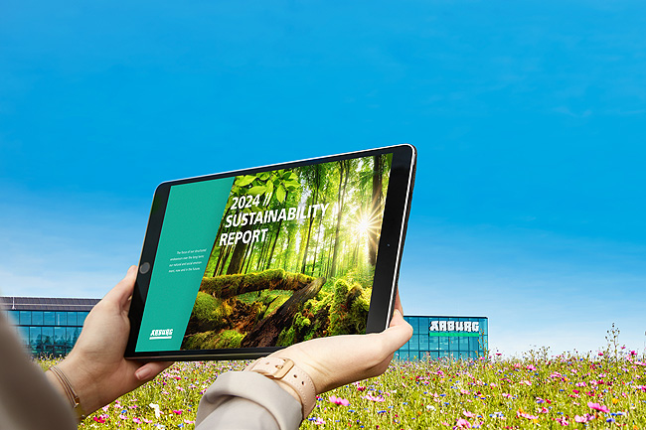

Conserving resources: The Arburg Sustainability Report 2024 is only available online on the Arburg website: https://www.arburg.com/en/company/sustainability-at-arburg/

Photo: Arburg

Photo download:
https://media.arburg.com/web/9e2ed497d7a9e755/sustainability-report-2024/

Press release:
File: Press Release Sustainability Report2024_en.docx
Characters: 2,800
Words: 424

This and other press releases are available for download from our website at www.arburg.com/de/presse/ (www.arburg.com/en/press/)

Contact
ARBURG GmbH + Co KG
Press office
Susanne Palm
Dr Bettina Keck
Postfach 1109
72286 Lossburg
Tel.: +49 (0)7446 33-3463
Tel.: +49 (0)7446 33-3259
presse_service@arburg.com

About Arburg
Founded in 1923, the German family-owned company is one of the world's leading manufacturers for plastics processing machines. AMKmotion and ARBURGadditive including innovatiQ also belong to the ARBURG family.
The portfolio encompasses injection moulding machines, 3D printers for industrial additive manufacturing, robotic systems as well as customer- and industry-specific turnkey solutions. It also includes digital products and services.
ARBURG is a pioneer in the plastics industry when it comes to energy and production efficiency, digitalisation and sustainability. ARBURG machines are used to manufacture plastic products for the mobility, packaging, electronics, medical, construction and equipment engineering and leisure industries, for example.
The company headquarters are located in Lossburg, Germany. In addition, ARBURG has own organisations in 27 countries at 37 locations and is represented in over 100 countries together with trading partners. Of a total of roughly 3,700 employees, around 3,100 work in Germany, with another 600 employees based in ARBURG's organisations around the world.
ARBURG is certified to ISO 9001 (quality), ISO 14001 (environment), ISO 27001 (information security), ISO 29993 (training) and ISO 50001 (energy).
Further information: www.arburg.com, www.amk-motion.com as well as www.arburg.com/arburgadditive.

