Arburg event in South America
Anniversary: 25 years of Arburg Brazil

- Together: High-ranking delegation from Lossburg celebrates with customers and employees
- Successful: Arburg has had its own subsidiary in South America since 2000
- First class: Customers receive comprehensive support at the Arburg Technology Centre

Lossburg, 03.07.2025
Arburg’s history in Brazil dates back to 1988, when the Romi sales agency took over the marketing of Allrounder injection moulding technology. The market in South America developed so successfully that Arburg opened its own subsidiary in São Paulo in 2000. Its 25th anniversary was celebrated with customers and employees on 25 and 26 June 2025 in the presence of Managing Partner Juliane Hehl and Sales Director Tobias Baur from Arburg’s Lossburg headquarters.

In her speech, Juliane Hehl thanked the customers for their trust in Arburg and for successful cooperation over the past decades, also praising the accomplishments of the Brazilian Arburg team: “We are very impressed by what our team here has achieved over the past 25 years. Existing customer contacts have been cultivated intensively, new collaborations have been developed, innovative projects have been launched and this has ensured that our colour ‘mint green’ is prominently represented in Brazilian injection moulding companies.” Together with Tobias Baur, she presented the anniversary plaque and certificate to Alfredo Fuentes, who has managed the branch since 2017, as a token of thanks and recognition for his commitment.

Three employees have been with the company for decades
As part of the internal anniversary event, the Managing Partner also honoured three long-serving employees: Jeziel de Oliveira, Service and After-Sales Manager, and Joelson da Silva Freitas, who is responsible for Warehousing and Spare Parts, each with the company for 25 years, as well as Service Technician Renato Gouvea for ten years of loyalty to the company.

ATC for comprehensive customer support
The 25-strong team at Arburg-Brazil now provides comprehensive support to around 3,000 customers. This ranges from expert advice during the purchasing process and commissioning of machines and systems through to training and service on the customers’ premises. The central point of contact is the Arburg Technology Center (ATC) in São Paulo. This 700 square metre facility is home to customer training, spare parts, service, consulting and sales. The centrepiece is the showroom for the presentation of Allrounders, trials, tool tests and practical courses. These are also offered in the local language.
Picture

ARBURG Brazil 25 years BR 2025_001

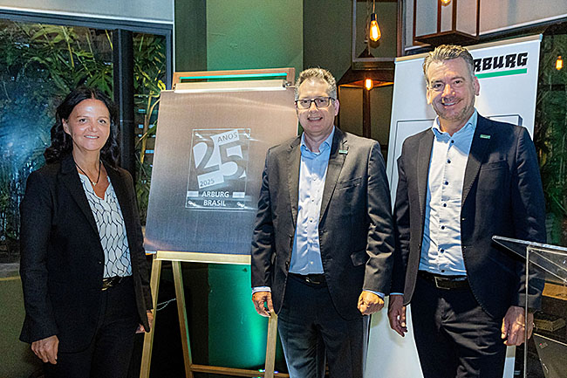

25 years of Arburg Brazil: Arburg Managing Partner Juliane Hehl and Managing Director Sales Tobias Baur (right) present the anniversary sculpture to Alfredo Fuentes, Managing Director of Arburg Ltda.

Photo: ARBURG
Photo Download:
https://media.arburg.com/web/1ac037b8db7e1672/25-year-arburg-brazil-press-review/

Press Release
File: Press release 25 years of Arburg Brazil_en.docx
Characters: 2,253
Words: 346

You can also download this and other press releases from our website at www.arburg.com/de/presse/ (www.arburg.com/en/presse/)

Contact
ARBURG GmbH + Co KG
Press Office
Susanne Palm
Dr Bettina Keck
P.O. Box 1109
72286 Lossburg, Germany
Phone: +49 7446 33-3463
Phone: +49 7446 33-3259
presse_service@arburg.com

About Arburg
Founded in 1923, the German family-owned company is one of the world's leading manufacturers for plastics processing machines. AMKmotion and ARBURGadditive including innovatiQ also belong to the ARBURG family.
The portfolio encompasses injection moulding machines, 3D printers for industrial additive manufacturing, robotic systems as well as customer- and industry-specific turnkey solutions. It also includes digital products and services.
ARBURG is a pioneer in the plastics industry when it comes to energy and production efficiency, digitalisation and sustainability. ARBURG machines are used to manufacture plastic products for the mobility, packaging, electronics, medical, construction and equipment engineering and leisure industries, for example.
The company headquarters are located in Lossburg, Germany. In addition, ARBURG has own organisations in 27 countries at 37 locations and is represented in over 100 countries together with trading partners. Of a total of roughly 3,700 employees, around 3,100 work in Germany, with another 600 employees based in ARBURG's organisations around the world.
ARBURG is certified to ISO 9001 (quality), ISO 14001 (environment), ISO 27001 (information security), ISO 29993 (training) and ISO 50001 (energy).
Further information: www.arburg.com, www.amk-motion.com as well as www.arburg.com/arburgadditive.

