Anniversary event in France
Arburg France celebrates its 40th anniversary

- Festive atmosphere: High-ranking delegation from Lossburg celebrates with around 100 customers and employees
- Successful: Arburg has been represented in France with its own subsidiary since 1985
- Global role model: First subsidiary for on-site customer support

Lossburg, 11.11.2025
Founded in 1985 as Arburg's very first foreign subsidiary, Arburg France laid the groundwork for what is now the company’s global presence. On 5 November 2025, the Arburg SAS team celebrated the 40th anniversary with around 100 participants in the presence of Managing Partner Juliane Hehl and Tobias Baur, Managing Director Sales and After Sales, as well as Steffen Eppler, Vice President Sales Europe, from Arburg’s German headquarter. Before the festive evening, customers were given an opportunity to learn about current topics and trends in injection moulding. This took the form of exhibits and specialist presentations at the Arburg Technology Centre (ATC) in Tremblay-en-France.

Forty years ago, Arburg successfully took an important first step towards its early international expansion. Consequently, Arburg France still has a very special status today. Arburg is now represented by its own organisations in 27 countries at 37 locations and, together with its trading partners, it has a worldwide sales and service network.

Ceremonial handover of the anniversary sculpture
“Our aim of establishing a global presence with our own organisations was and still remains to provide our customers with first-class and comprehensive on-site support. We are deeply impressed by what our French team has achieved over the past four decades”, emphasised Juliane Hehl in her speech. “Even back then, it was very important to my father Eugen Hehl to convey the image of our company worldwide through uniform appearance of the Arburg buildings at home and abroad – and of course our technology and expertise”. The Managing Partner thanked the customers for their great trust in Arburg and the French Arburg team for their successful work.
In recognition of this commitment, she presented the anniversary sculpture and certificate together with Tobias Baur and Steffen Eppler to Pascal Laborde, Managing Director of Arburg SAS.

A diverse range of anniversary events
To commemorate this anniversary, Arburg France laid on a multi-faceted and informative programme, including specialist presentations by its customers Com'inject and Schneider Electric France. Their speakers reported on their specific experiences with the Arburg host computer system (ALS) and the arburgXworld customer portal, as well as with the Gestica control system and the “aXw Control FillAssist” assistance function. In addition, two other external companies spoke about diversification strategies in the plastics industry and the potential applications of artificial intelligence (AI) in the industrial sector and corresponding customer experiences.
Those wishing to learn more, for example about the FillAssist function, had an opportunity to do so in the showroom. Here, an electric Allrounder 370 A with Gestica control system was producing small plastic boxes. A hybrid Allrounder 470 H equipped with a Multilift linear robot system demonstrated the automated production of closure clips. In addition, Arburg specialists presented the latest features of ALS and arburgXworld on monitors. One highlight was the video presentation of the brand new electric Allrounder Trend which celebrated its world premiere at the K 2025 trade fair in October. “With this machine concept, we are creating a new standard in injection moulding. The new electric Allrounder Trend are quick to set up, particularly easy to operate and maintain and it can produce injection moulded parts extremely reliably and energy-efficiently. This was very well received by our guests”, said Pascal Laborde, looking back on the successful event. “With our mix of exhibits and presentations on current topics, followed by a festive evening in a casino atmosphere with cocktails and live music, we delighted our customers and celebrated our 40th anniversary in style”.

Presence in France paves the way for global success
Arburg France can look back on a long history of success. The foundation stone for Arburg’s international sales and service network was laid in 1985 when this subsidiary was established in Aulnay-sous-Bois near Paris. At that time, it was possible to build upon a successful trading partnership dating back to 1963. The concept of being able to provide customers with comprehensive on-site support has proven its worth in the French subsidiary ever since Day One. Arburg was continuously expanding its presence in the French market and is now one of the leading injection moulding machine manufacturers there. Since 2022, customers have been served by the Arburg Technology Centre (ATC) in Tremblay-en-France near Paris. There, a representative cross-section of the Arburg portfolio is showcased on a floor space of more than 1,500 square metres. The team in France currently comprises a staff of 26. This team maintains close contact with existing customers, it develops new partnerships, and it initiates innovative projects. In addition, they deliver on-site service, hotline support, a prompt supply of spare parts, all backed up by professional advice regarding application technology and training. Arburg France also serves customers in Algeria, Morocco and Tunisia.

Image

40 Years ARBURG FR_P1004810 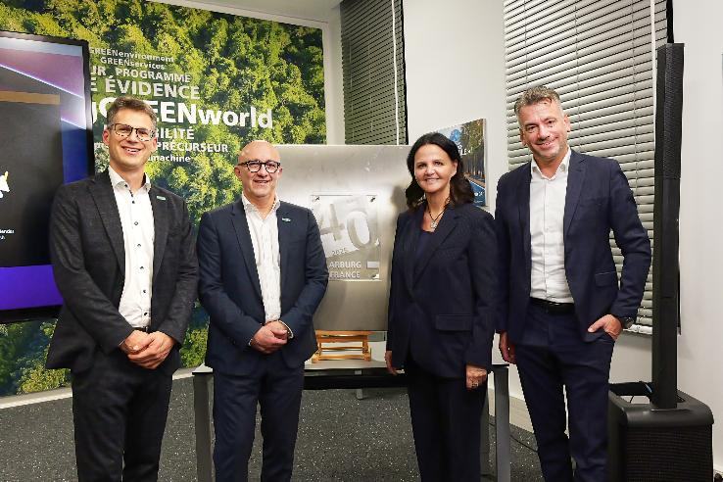

To commemorate the 40th anniversary of Arburg France, Managing Partner Juliane Hehl (2nd from right), Tobias Baur (right), Managing Director Sales and After Sales, and Steffen Eppler, Vice President Sales Europe, presented the anniversary sculpture to Pascal Laborde, Managing Director of Arburg SAS.

Photo: ARBURG
Photo download:
https://media.arburg.com/web/ee1055681509fa72/40-years-arburg-france/

Press release
File: Press release 40 years of Arburg France_en.docx
Characters: 5,116
Words: 782

This and other press releases are also available for download on our website at www.arburg.com/de/presse/ (www.arburg.com/en/presse/).

Contact
ARBURG GmbH + Co KG
Press office
Susanne Palm
Dr Bettina Keck
Postfach 1109
72286 Lossburg, Germany
Tel.: +49 (0)7446 33-3463
Tel.: +49 (0)7446 33-3259
presse_service@arburg.com

About Arburg
Founded in 1923, the German family-owned company is one of the world's leading manufacturers of injection moulding machines. AMKmotion, a manufacturer of electric drive technology, also belongs to the Arburg family.
The portfolio for plastics processing encompasses Allrounder injection moulding machines, robot systems as well as customer- and industry-specific turnkey solutions. It also includes digital products and services. Arburg is a pioneer in the plastics industry when it comes to energy and production efficiency, digitalisation and sustainability. Arburg machines are used to manufacture plastic products for the mobility, packaging, electronics, medical, construction and equipment engineering and leisure industries, for example.
The company headquarters are located in Lossburg, Germany. In addition, Arburg has own organisations in 27 countries at 37 locations and is represented in over 100 countries together with trading partners. Of a total of roughly 3,450 employees, about 2,850 work in Germany, with another 600 employees based in Arburg's organisations around the world.
Arburg is certified to ISO 9001 (Quality), ISO 14001 (Environment), ISO 27001 (Information Security), ISO 29993 (Education and Training) and ISO 50001 (Energy).
Further information: www.arburg.com, www.amk-motion.com.

