Arburg at Freudenstadt Baiersbronn Garden Show
CarbonX: Arburg sponsors coal-themed week at the Tal X Garden Show

- Diverse: Black coal - colourful theme bouquet
- Sustainable: Garden shovels with biochar
- Long-term: Arburg practises resource conservation

Lossburg, 28.07.2025
As part of the “CarbonX” theme week from 18 to 25 July 2025, visitors to the Tal X garden show in Freudenstadt and Baiersbronn, Germany, were able to learn everything there is to know about charcoal and biochar. Arburg participated as a sponsor with an exhibit in the specially erected glass pavilion in the “Xentrum”, the heart of the garden show grounds, as well as with exciting presentations. Under the motto "High-tech meets charcoal burning", an electric Allrounder injection moulding machine produced live garden shovels from an innovative, sustainable material consisting of recycled plastic (PP) and biochar.

With its strong commitment to the “CarbonX” theme week, Arburg, whose company headquarters in Lossburg are just a few kilometres from Freudenstadt, made its responsibility for the environment and society and its value-based actions visible to a broad public outside the plastics industry.

Commitment to environmentally friendly plastics processing
Coalman and initiator Thomas Faißt officially opened the CarbonX week with the kick-off event “Carbon through the ages” on 19 July in Freudenstadt. In his opening speech, Arburg Managing Partner Michael Hehl explained the reasons for Arburg's intensive involvement: “This week is all about innovation, sustainability and the power of change. As a global leader in the plastics industry with headquarters in Lossburg, we are also setting a strong example here in the region for environmentally friendly production methods and sustainable business practices.” For decades, Arburg has also been involved in the use of so-called alternative materials - i.e. alternatives to conventional plastics - and supports entire branches of industry in manufacturing sustainable products from them.

Black coal – “green” garden shovels
In the Arburg pavilion, the energy-efficient electric Allrounder 470 E Golden Electric demonstrated how traditional craftsmanship and state-of-the-art injection moulding technology go hand in hand. The machine produced more than 3,500 garden shovels live in the “Xentrum” during the theme week, which visitors could take away with them. A particularly sustainable material was processed, half of which consisted of the recycled plastic polypropylene (PP) and half of “biochar”. This CO₂-negative material from the start-up Carbonauten consists of 50 per cent biochar. The starting material is plant waste such as waste wood, damaged wood and wood chips. This is pyrolysed, i.e. burnt at high temperatures without oxygen. The biochar is then pulverised, mixed with recycled polymers, for example, and compounded to produce injection-mouldable granules.

Will biochar solve the climate crisis?
At the event “Conversations by the fire. Solving the climate crisis with biochar?” on 22 July in Freudenstadt, Arburg application engineer Jonas Bletscher presented the internationally active family business in addition to the daily live presentation. He explained that Arburg is a pioneer in the plastics industry when it comes to energy and production efficiency, digitalisation and sustainability. All aspects and activities relating to resource conservation, the circular economy and CO₂ reduction are bundled in the “arburgGREENworld” programme. “Our customers can manufacture products for a wide range of industries on Allrounder injection moulding machines,” explained Jonas Bletscher. “Alternative materials and fillers such as sunflower seed and egg shells, paper, coffee grounds or, as shown at the garden show, biochar from carbonauten can also be processed.” The idea, potential and initial projects with the innovative, CO₂-negative carbon material were then explained by Torsten Becker, Managing Director of Carbonauten GmbH, before a panel discussion followed.

Pictures

CarbonX Pavilion_DSC3172

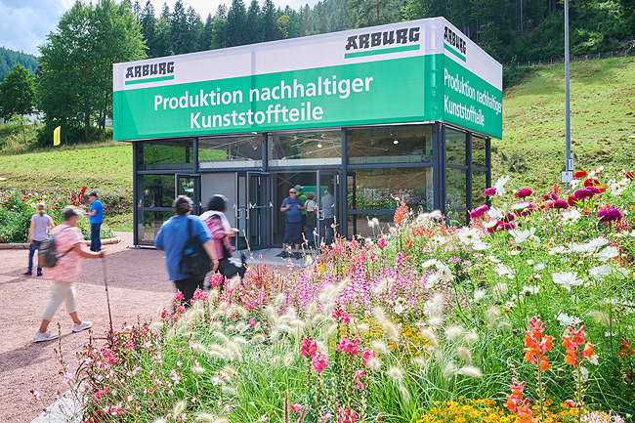

The glass Arburg pavilion with Allrounder injection moulding machine in the "Xentrum" was a visitor magnet during the CarbonX theme week at the Tal X Gartenschau Freudenstadt Baiersbronn, Germany.

CarbonX Pavilion_DSC3196

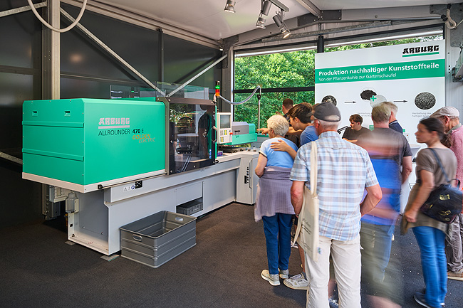

An energy-efficient Allrounder 470 E Golden Electric produced around 3,500 sustainable garden shovels, with 25 per cent made from biochar, during the CarbonX theme week.

all photos: Arburg
Photo download:
https://media.arburg.com/web/41583e4d6637200d/carbonx-2025-press-release/

press release
File: ARBURG press release CarbonX-Week 2025_en.docx
Characters: 4,021
Words: 490

You can also download this and other press releases from our website at www.arburg.com/de/presse/ (www.arburg.com/en/presse/)

Contact
Arburg GmbH + Co KG
Press Office
Susanne Palm
Dr Bettina Keck
PO Box 1109
72286 Lossburg, Germany
Phone: +49 7446 33-3463
Phone: +49 7446 33-3259
presse_service@arburg.com

About Arburg
Founded in 1923, the German family-owned company is one of the world's leading manufacturers for plastics processing machines. AMKmotion and ARBURGadditive including innovatiQ also belong to the ARBURG family.
The portfolio encompasses injection moulding machines, 3D printers for industrial additive manufacturing, robotic systems as well as customer- and industry-specific turnkey solutions. It also includes digital products and services.
ARBURG is a pioneer in the plastics industry when it comes to energy and production efficiency, digitalisation and sustainability. ARBURG machines are used to manufacture plastic products for the mobility, packaging, electronics, medical, construction and equipment engineering and leisure industries, for example.
The company headquarters are located in Lossburg, Germany. In addition, ARBURG has own organisations in 27 countries at 37 locations and is represented in over 100 countries together with trading partners. Of a total of roughly 3,700 employees, around 3,100 work in Germany, with another 600 employees based in ARBURG's organisations around the world.
ARBURG is certified to ISO 9001 (quality), ISO 14001 (environment), ISO 27001 (information security), ISO 29993 (training) and ISO 50001 (energy).
Further information: www.arburg.com, www.amk-motion.com as well as www.arburg.com/arburgadditive.

