Frauen@Arburg: Networking event in Lossburg
Giving courage, being courageous - renowned women speak and discuss at and with Arburg

- Inspiring: Leading women from the industry provide inspiration on the topic of courage
- In-depth: Panel discussion sheds light on how to get ahead with courage, both privately and professionally
- Encouraging: Themed evenings organised by the Arburg women's network are in high demand

Lossburg, 22.07.2025
On 17 July 2025, the Frauen@Arburg network held an event at the company headquarters in Lossburg, Germany, on the topic of courage. Katrin Wolf, Managing Director of the family-owned company Wolf Produktionssysteme in Freudenstadt, and Isabel Diaz Rohr, member of the Arburg Advisory Board, highlighted exciting aspects in their presentations. Around 50 participants took the opportunity to gain direct insights and tips on the topic of courage from women in management positions and then take part in a lively panel discussion.

The evening was hosted by Lea Kicherer, Global Key Account Manager at Arburg and Alexandra Klüssendorf, Application Engineer at Arburg Plastic Freeforming (APF).

Courage: One topic - many facets
The two speakers talked about their experiences and reflected on what they understand by courage. They talked about their personal careers, but also about challenges in their private and everyday lives. Katrin Wolf gave insights into how she made progress in her life through courageous steps and how she masters her professional and private life as a young mother: "It wasn't courageous that I studied mechanical engineering, but to see my studies through to the end and show perseverance." Other examples she cited included the transformation of the organisational structure to give the about 100 employees more scope for decision-making and the implementation of a crèche in the family business. "Keeping at it, making decisions and showing responsibility - that's my personal conclusion on how to move forward with courage."
Isabel Diaz Rohr, who has been supporting the mechanical engineering company Arburg as a member of the Advisory Board since the beginning of 2024, then reported on her decades of experience. She presented the "map of my life", on which many different professional stations in Spain and Germany were marked. "I didn't think I was brave because I moved around a lot. I was brave because I was prepared to move from job to job, always starting from scratch and learning new things. Courage is also not being afraid to make mistakes. You don't have to be perfect!" The most important thing is to be human and to be open to other people and new things in life.

Lively panel discussion
The subsequent panel discussion, moderated by Alexandra Klüssendorf, was attended by the speakers as well as Arburg Trainer Stefanie Scheffold-Tritschler, Global Account Manager Sonja Oesterle and Steffen Kroner, Managing Director of Finance, Controlling, IT and HR Management. Questions such as "What does courage mean to me?", "When was the last time I was courageous?", "Why was I not courageous and what were the consequences?" and "What gives me courage?" were discussed. They all emphasised how important it is to move out of your comfort zone and pursue your personal goals. They also agreed that not only big (career) steps are courageous, but also the many small ones. For personal progress, you have to think about what is important to you and then follow through consistently and with self-confidence. If you celebrate yourself for every small courageous step, then the big one will come of its own accord.

Networked: Frauen@Arburg
The Frauen@Arburg network has been in place at Arburg since June 2023 and has a Teams channel with around 200 interested female colleagues and some male colleagues. Regular after-work events and functions are organised to encourage the exchange of ideas. The programme ranges from informal get-togethers in their free time to selected events with a wide range of topics and in-depth guided tours and discussion rounds within the company.

Picture

Women's Network Courage 2025_DSC2961

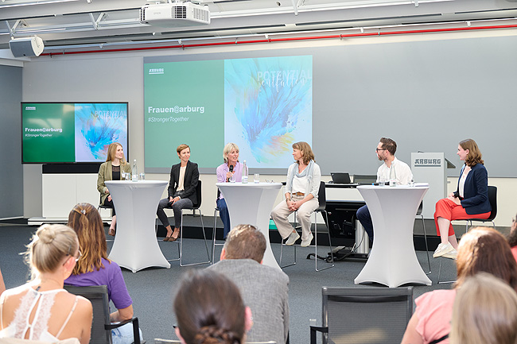

Panel discussion at the women's network meeting on 17 July 2025 (from left): Katrin Wolf, Managing Director of Wolf Produktionssysteme, Sonja Oesterle, Global Account Manager at Arburg, Isabel Diaz Rohr from the Arburg Advisory Board as well as trainer Stefanie Scheffold-Tritschler, Managing Director Steffen Kroner and Frauen@Arburg moderator Alexandra Klüssendorf.

Photo: Arburg
Photo download:
https://media.arburg.com/web/165f00723ba89479/frauennetzwerk-mut-event-2025-07/

Press release
File: Press release MUT-Event Arburg 2025_en.docx
Characters: 3,607
Words: 579

This and other press releases are available for download from our website at www.arburg.com/de/presse/ (www.arburg.com/en/press/)

Contact
ARBURG GmbH + Co KG
Press office
Susanne Palm
Dr Bettina Keck
Postfach 1109
72286 Lossburg, Germany
Tel.: +49 (0)7446 33-3463
Tel.: +49 (0)7446 33-3259
presse_service@arburg.com

About Arburg
Founded in 1923, the German family-owned company is one of the world's leading manufacturers for plastics processing machines. AMKmotion and ARBURGadditive including innovatiQ also belong to the ARBURG family.
The portfolio encompasses injection moulding machines, 3D printers for industrial additive manufacturing, robotic systems as well as customer- and industry-specific turnkey solutions. It also includes digital products and services.
ARBURG is a pioneer in the plastics industry when it comes to energy and production efficiency, digitalisation and sustainability. ARBURG machines are used to manufacture plastic products for the mobility, packaging, electronics, medical, construction and equipment engineering and leisure industries, for example.
The company headquarters are located in Lossburg, Germany. In addition, ARBURG has own organisations in 27 countries at 37 locations and is represented in over 100 countries together with trading partners. Of a total of roughly 3,700 employees, around 3,100 work in Germany, with another 600 employees based in ARBURG's organisations around the world.
ARBURG is certified to ISO 9001 (quality), ISO 14001 (environment), ISO 27001 (information security), ISO 29993 (training) and ISO 50001 (energy).
Further information: www.arburg.com, www.amk-motion.com as well as www.arburg.com/arburgadditive.

