Arburg at the K 2025
A perfect bullseye: Outstanding response to Arburg's world of solutions

- Concept worked out: “All in! arburgSOLUTIONworld” - solution world leaves nothing to be desired
- Trendsetter: World premiere of the electric standard Allrounder Trend inspires trade visitors
- Focus on sustainability: arburgGREENworld pavilion highlights the many facets of the circular economy

Lossburg, 16.10.2025
Arburg's appearance at K 2025, the world's leading trade fair, was an outstanding success: With its “All in! arburgSOLUTIONworld” communication concept and the arburgGREENworld pavilion, the company once again presented itself convincingly to the global plastics industry as a solution provider for sustainable plastics processing. Trailblazing high-end machines, innovative applications and exciting digital products and services were showcased. With the world premiere of its new machine concept, Arburg once again proved itself to be a trendsetter: The electric Allrounder Trend, which expands the portfolio in the standard segment, met with a great deal of interest from visitors worldwide.

“K 2025 has fully lived up to its status as the world’s leading trade fair and has impressively demonstrated the global economic importance of the plastics market. Despite the volatile economic situation, sentiment was riding high and visitors flocked to our stand all day long”, sums up Dr Christoph Schumacher, Head of Global Marketing at Arburg, and emphasises: "The 'K' is home for us. We are proud that we were once again able to present the Arburg brand to the plastics world with great success and demonstrate that we are investing even - or rather, especially - in challenging times and that we have answers to all of our customers’ questions and requirements with our integrative solution approach 'arburgSOLUTIONworld': Wir sind da!”

Allrounder Trend: World premiere a real showstopper
With the world premiere of the new electric Allrounder Trend, Arburg surprised the experts and successfully defined the new standard for injection moulding. These new machines are quick to set up, easy to operate and maintain. They produce standard injection moulded parts reliably and energy-efficiently. Their short delivery lead times of four weeks ex works and their extremely attractive prices are also impressive. The Allrounder Trend can be ordered immediately. They are available with clamping forces from 500 to 2,000 kN and with injection units in sizes 100 to 800. Visitors from all over the world unanimously confirmed that this new machine concept for standard applications is a precise match for current market and customer requirements. Interest in the Trend exhibits was correspondingly high and global: An Allrounder 1000 e Trend produced free-falling connectors for the electronics industry. An Allrounder 1800 e Trend produced batches of 64 LSR seals. These were removed by a Multilift Select and deposited separately in their respective cavities.
The new Gestica lite control system also met with an extremely positive response. It has a robust industrial panel and is remarkably easy and intuitive to operate, even for non-specialists.

Trailblazing high-end solutions
As a solution partner for sustainable plastics processing, Arburg also showcased pioneering projects and processes in the high-end sector that were developed together with renowned partners.
- A “NextGen Medical” production cell based around an Allrounder 570 A - a joint project between Arburg, Sanofi, Hack and HB-Therm - demonstrated how significant cost and energy benefits can be achieved through early-stage optimisation and how the machine and mould can communicate intelligently with each other.
- Arburg and its partners Beck and Kebo demonstrated the benefits of functional IML components in medical technology: An electric Allrounder 520 A in cleanroom design produced centrifuge tubes. Demonstrators for autoinjectors with functional labels were also on display.
- Thin-walled IML cups for the packaging industry were produced by an electric Allrounder 720 A using injection compression moulding. This process achieves significant reductions in clamping force as well as energy consumption.
- Together with its partner Leonhard Kurz, Arburg used a new Allrounder 475 V vertical machine to demonstrate the back injection moulding of housings with decorative film using in-mould decoration (IMD) for wireless car keys with high-quality surfaces.
- A two-component Allrounder More 1800, which used a 32-cavity mould from Polarform together with innovative hot runner technology from Hasko to produce a ready-to-use domino game, was also attractive to trade fair visitors. Here, a Multilift V linear robotic system and a cobot worked hand in hand.
- Efficient cube technology was presented with mould partner Foboha, with an Allrounder Cube 2000 producing two-colour closures. A space-saving suspended six-axis robot was used for cycle time-neutral removal.

arburgGREENworld: Examples of the circular economy
The arburgGREENworld pavilion, which was supervised by Arburg trainees, was also scored a perfect bullseye. This time, visitors to the trade fair were able to immerse themselves in maritime water worlds and experience the topic of sustainability and its great importance for Arburg and its customers in a multi-faceted way along the recycling cycle. “This made it clear that the topic has ‘come of age’ and arrived in the industry” stated Dr Christoph Schumacher with convinction. The programme in the pavilion was enriched by numerous presentations by renowned speakers from science and industry.

Pictures

Press Conference K2025 DE_D1A0503
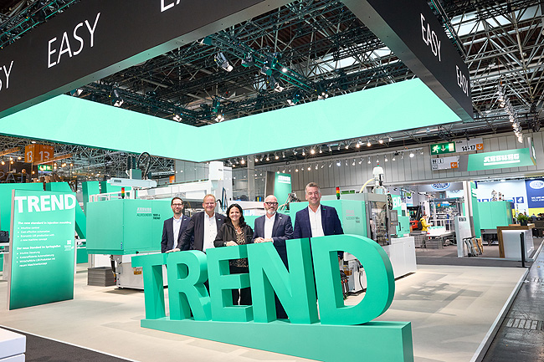
Proud of the Arburg world premiere of the Allrounder Trend (from right): Managing Director Sales Tobias Baur, Managing Director Technology Guido Frohnhaus, Managing Partners Juliane Hehl and Michael Hehl and Steffen Kroner Managing Director Finance, Controlling, IT and HR Management.

Overview K2025 DE_DSC6803

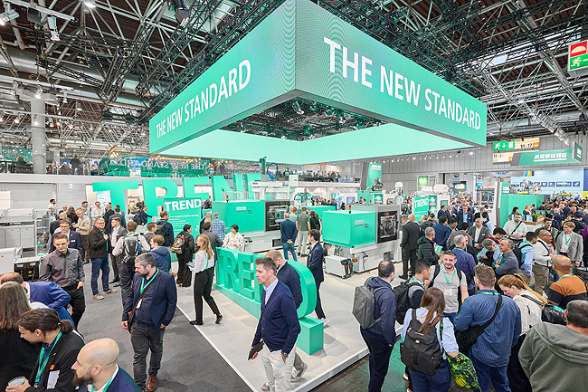

Visitor magnet: At stand 13A13, Arburg presented itself as a sustainable full-service provider with its “All in! arburgSOLUTIONworld”. The extensive product portfolio was extremely well received by trade visitors from all over the world.

Christoph Schumacher K2025 DE_DSC7033

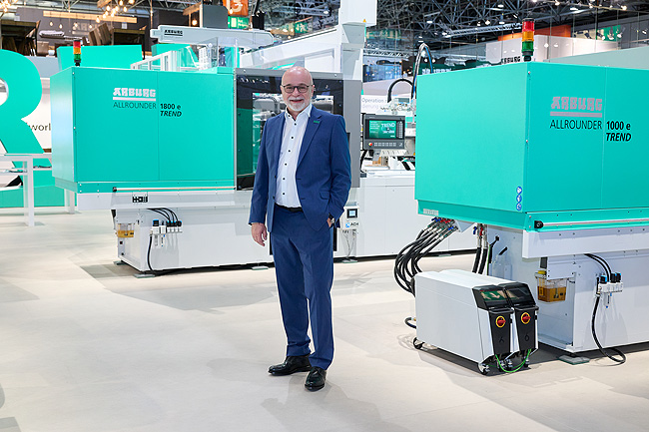

Proud and happy: Dr Christoph Schumacher, Head of Global Marketing, is delighted with the great success of the new Allrounder Trend.

TREND Overview K2025 DE_DSC6610

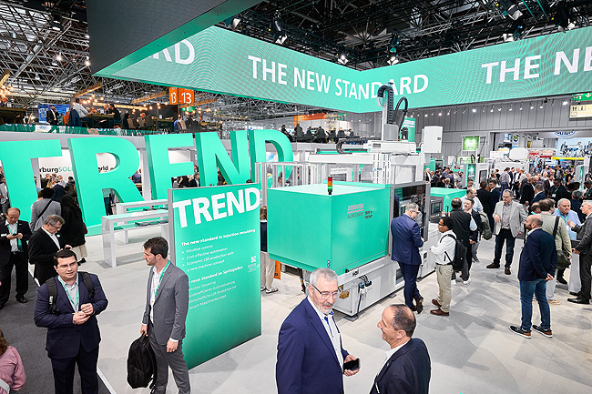

New standard in injection moulding: The Allrounder Trend met with great interest among experts.

Allrounder 475V K2025 DE_DSC6744

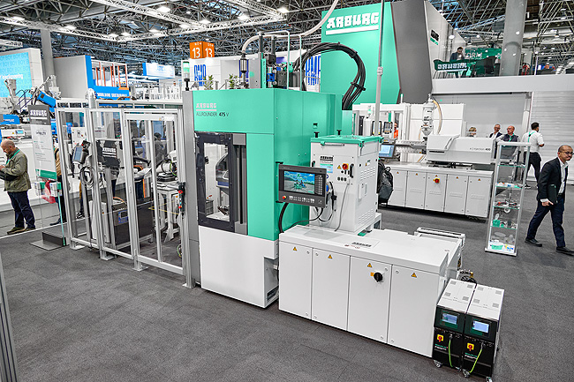

World premiere: At the K 2025, Arburg presented the vertical standard machine Allrounder 475 V, which is particularly interesting for the mobility and electronics sectors, for the first time worldwide.

475V keyfob K2025 DE_DSC6736 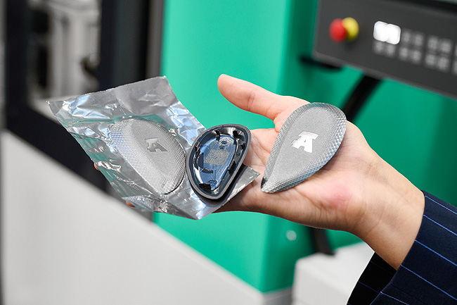

High quality: A production cell built around a vertical Allrounder 475 V used in-mould decoration (IMD) to produce covers for wireless keys with an attractive surface.

Gestica lite K2025 DE_DSC6996

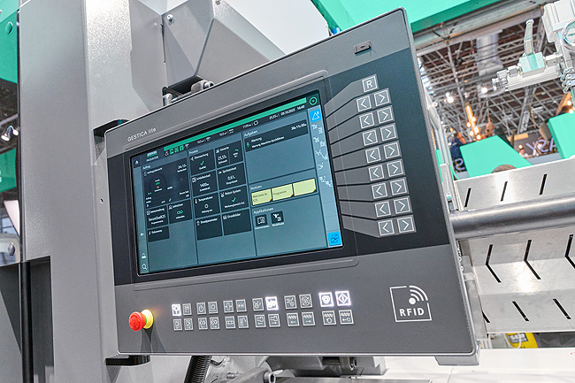

Digitalisation: Arburg also showcased numerous new smart products and services at K 2025. In pole position, the remarkably easy-to-use Gestica lite control system with a clear dashboard.

aGw Pavilion K2025 DE_DSC6918

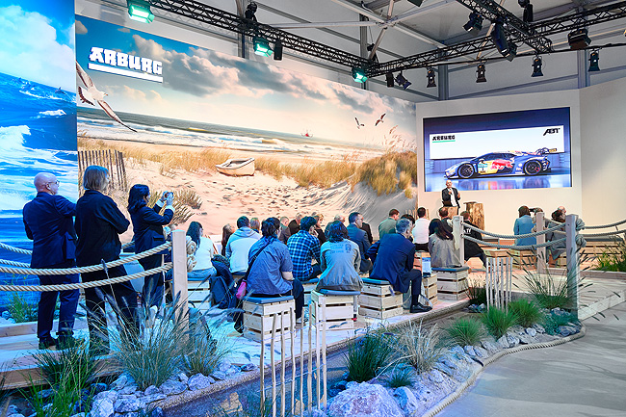

The arburgGREENworld pavilion focussed on the topic of sustainability, which was examined along the entire material cycle. The programme was enriched by numerous specialist presentations, e.g. from ABT Sportsline on the subject of e-fuels.

dolphin K2025 DE_DSC6964

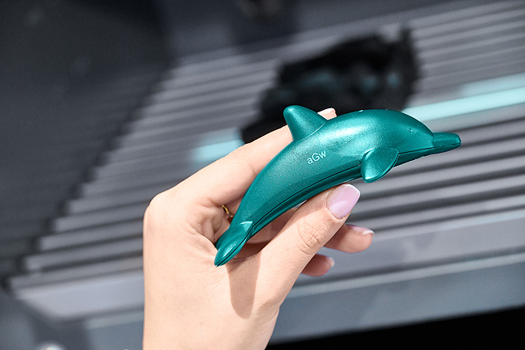

In the arburgGREENworld pavilion, an Allrounder 1000 e Trend produced dolphins from recycled material based on old fishing nets. Afterwards, visitors to the trade fair were able to have their moulded part individually labelled at a laser station.

Photos: ARBURG

Photo download:
https://media.arburg.com/web/afe27bc91a535e36/press-review-k2025/

press release
File: Pressenachbericht K2025_en_GB.docx
Characters: 5,180
Words: 777

These and other press releases can also be downloaded from our website at www.arburg.com/de/presse/ (www.arburg.com/en/presse/)

Contact
ARBURG GmbH + Co KG
Press
Susanne Palm
Dr. Bettina Keck
P.O. Box 1109
72286 Lossburg
Phone: +49 7446 33-3463
Phone: +49 7446 33-3259
presse_service@arburg.com

About Arburg
Founded in 1923, the German family-owned company is one of the world's leading manufacturers of injection moulding machines. AMKmotion, a manufacturer of electric drive technology, also belongs to the Arburg family.
The portfolio for plastics processing encompasses Allrounder injection moulding machines, robot systems as well as customer- and industry-specific turnkey solutions. It also includes digital products and services. Arburg is a pioneer in the plastics industry when it comes to energy and production efficiency, digitalisation and sustainability. Arburg machines are used to manufacture plastic products for the mobility, packaging, electronics, medical, construction and equipment engineering and leisure industries, for example.
The company headquarters are located in Lossburg, Germany. In addition, Arburg has own organisations in 27 countries at 37 locations and is represented in over 100 countries together with trading partners. Of a total of roughly 3,450 employees, about 2,850 work in Germany, with another 600 employees based in Arburg's organisations around the world.
Arburg is certified to ISO 9001 (Quality), ISO 14001 (Environment), ISO 27001 (Information Security), ISO 29993 (Education and Training) and ISO 50001 (Energy).
Further information: www.arburg.com, www.amk-motion.com.

