Open House “Iniezione Next!” in Italy
Arburg celebrates Italian premiere of Allrounder Trend

- Open House: More than 200 guests delighted by the event on 29 and 30 October 2025 at Arburg Italy
- Focus: Presentation of the new Allrounder Trend, expert lectures and consulting services
- Everyone there: Partners, German consulate, trade press and Arburg Managing Director from head office

Lossburg, 04.11.2025
Arburg Italy held its Open House event “Iniezione Next!” in Peschiera Borromeo on 29 and 30 October 2025, an event attended by more than 200 participants. High-ranking guests included Susanne Welter, Consul General of the Federal Republic of Germany in Milan, and Guido Frohnhaus, Managing Director Technology & Engineering from Arburg head office; the Italian trade press was also well represented. The focus was on the Italian premiere of the electric Allrounder Trend, with which Arburg is defining a new standard in injection moulding. Further exhibits, expert lectures and consulting services together with partners on topics such as digitalisation, automation and government subsidies rounded off the successful event.

“Today we are celebrating a very special event: the presentation of our brand new electric Allrounder Trend, which celebrated its world premiere a few weeks ago at the world’s leading trade fair K 2025 with great success”, said Guido Frohnhaus, Managing Director Technology & Engineering, as he welcomed the guests on behalf of the Arburg shareholders and of the entire organisation. Arburg has thus developed an entirely new machine concept, one precisely tailored to current market and customer requirements for standard applications across all industries.

Italian premiere: New electric Allrounder Trend
Particular interest was attracted by the thought-provoking expert lecture by Luca Fasoli, sales expert at Arburg Italy, on the highlights and details of the Allrounder Trend. These new electric machines are now available in the clamping force range from 500 to 2,000 kN at short notice, easy to set up, operate and maintain – and available at an excellent price point.
The new Allrounder 1000 e Trend was in live operation in the showroom, demonstrating its practicality: Using an innovative paper injection moulding process and a mould from partner Lercher, the exhibit processed so-called “Paper Pearls” from company Model into assembly aids for furniture.

Exciting and informative programme
In keeping with the Allrounder Trend, the latest Multilift Select 4 linear robot system was on display, an ideal introduction for those new to automation. Another live exhibit, an electric Allrounder 470 A with a mould from Adoma, produced transparent and break-proof reusable cups made of copolyester.
Supplementary expert lectures focused on process optimisation, automation and ways to reduce energy consumption. Information was provided on digital products such as the Arburg ALS host computer system and the arburgXworld customer portal. Guests were also interested in the assistance and pilot functions of the control system, and in particular the new Gestica lite. The Italian German Chamber of Commerce (AHK Italy) also received a great response at its stand. Customers could obtain advice on issues such as international projects, trade contacts and export assistance. Partner Atlante Group provided information on the possibility of government subsidies for machine investments.

An all-round successful event
“Our event was a great success and an excellent platform for presenting our products, services and partnerships”, said Raffaele Abbruzzetti, Managing Director of Arburg Italy. “The guests took a close look at our innovations and exhibits – above all the new Allrounder Trend – obtained information on a wide range of topics relating to injection moulding, digitalisation and government subsidies, and made extensive use of the networking opportunities”. In addition, the strong economic cooperation between Northern Italy and Germany showcased one of the most industrially wealthy regions in Europe.

Pictures

Group photo OH 2025 IT_0438
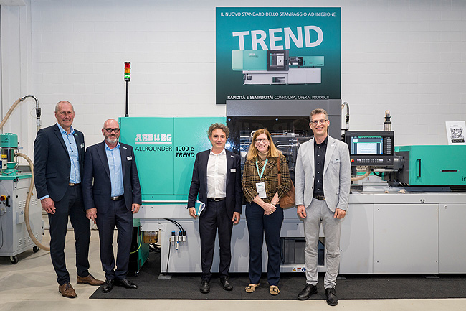
Special guest at the Arburg Italy Open House: Susanne Welter, Consul General of the Federal Republic of Germany, learned about the new Allrounder Trend and the strong economic cooperation between Italy and Germany from Raffaele Abbruzzetti, Managing Director Arburg Italy (centre), Guido Frohnhaus, Managing Director Technology & Engineering (2nd from left), and Vice Presidents Markus Kilgus (left) and Steffen Eppler from Arburg head office.

Overview OH 2025 IT_0313
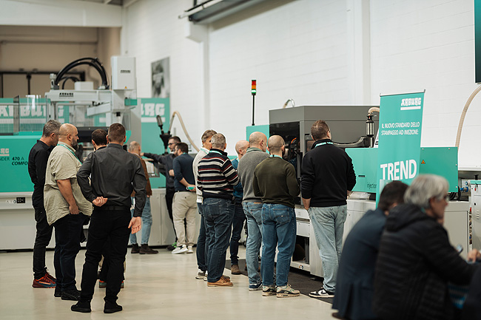
As part of an Open House event on 29 and 30 October 2025, the Arburg subsidiary celebrated the Italian premiere of the Allrounder Trend with more than 200 invited guests.

Lectures OH 2025 IT_0183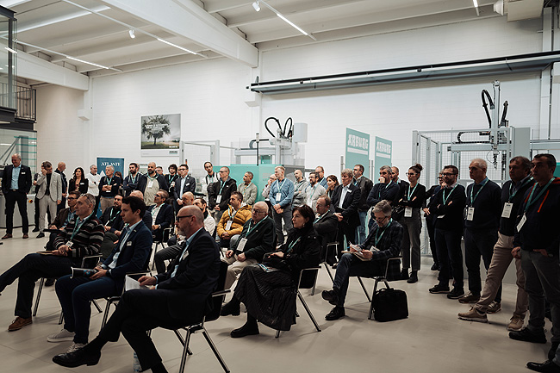
In addition to the premiere of the Allrounder Trend and the live applications, exciting expert lectures were very well received at the Arburg Italy’s Open House event.

Photos: ARBURG

Photo download:
https://media.arburg.com/web/c65ad730c543b9b7/open-house-arburg-italy-2025/

Press release
File: Press release Open House Italy 2025_en.docx
Characters: 543
Words: 3,635

This and other press releases can also be downloaded from our website at www.arburg.com/de/presse/ (www.arburg.com/en/presse/)

Contact
ARBURG GmbH + Co KG
Press
Susanne Palm
Dr. Bettina Keck
P.O. Box 1109
72286 Lossburg
Phone: +49 7446 33-3463
Phone: +49 7446 33-3259
presse_service@arburg.com

About Arburg
Founded in 1923, the German family-owned company is one of the world's leading manufacturers of injection moulding machines. AMKmotion, a manufacturer of electric drive technology, also belongs to the Arburg family.
The portfolio for plastics processing encompasses Allrounder injection moulding machines, robot systems as well as customer- and industry-specific turnkey solutions. It also includes digital products and services. Arburg is a pioneer in the plastics industry when it comes to energy and production efficiency, digitalisation and sustainability. Arburg machines are used to manufacture plastic products for the mobility, packaging, electronics, medical, construction and equipment engineering and leisure industries, for example.
The company headquarters are located in Lossburg, Germany. In addition, Arburg has own organisations in 27 countries at 37 locations and is represented in over 100 countries together with trading partners. Of a total of roughly 3,450 employees, about 2,850 work in Germany, with another 600 employees based in Arburg's organisations around the world.
Arburg is certified to ISO 9001 (Quality), ISO 14001 (Environment), ISO 27001 (Information Security), ISO 29993 (Education and Training) and ISO 50001 (Energy).
Further information: www.arburg.com, www.amk-motion.com.

