Arburg at Swiss Plastics Expo 2026
New approaches to injection moulding

- Start of the year: Swiss Plastics Expo in Lucerne from 20 to 22 January 2026
- The future: electric Allrounder, automation and digitalisation
- Alternative: injection moulding of “paper pearls”

Lossburg, 28/11/2025
The 2026 trade fair year begins for Arburg with the Swiss Plastics Expo in Lucerne, Switzerland. A forward-looking exhibit will be presented at stand C1061 in hall 1: an electric Allrounder 370 A with Gestica control system processes so-called “paper pearls”, an alternative material, instead of petroleum-based plastic.

Marcel Spadini, Managing Director of Arburg AG in Münsingen, is looking forward to the trade fair: “The Swiss Plastics Expo is of great importance for the technically demanding market in Switzerland and has top priority for us. The trade fair is unique, only takes place every three years and only the leading technology providers present their products there – therefore the trade visitors is also very technology-oriented”.

Electric Allrounder processes innovative material
In Lucerne, Arburg will be exhibiting innovative paper injection moulding. This technology was developed in collaboration with Swiss paper and cardboard manufacturer Model with the aim of expanding the range of future-proof, sustainable injection moulded products. An electric Allrounder 370 A processes so-called “paper pearls” with over 50 per cent fibre content. Their main component is primary and secondary paper fibres. These are made injection-mouldable with bio-based and biodegradable plastics, e.g. based on lignin, starch or corn. Using a single-cavity mould from Lercher, a “cross knot” puzzle is produced in a cycle time of around 60 seconds. A Multilift Select 8 linear robot system removes the moulded part and places it on a conveyor belt.

Digital helpers integrated directly in the control system
The software-based pilot function “aXw Control RecyclatePilot” in the Gestica machine control system actively compensates for material and batch fluctuations. It ensures uniform mould filling, stable shot weights and high part quality. The RecyclatePilot is equally suitable for processing post-industrial and post-consumer recyclate, regrind and bio-based plastics.

All requirements covered
For Marcel Spadini, the exhibit and the requirements of Swiss injection moulders are a perfect match: “Our focus on fully electric machine technology, automation, digitalisation and sustainability reflects the current market trend and thus also the wishes of our customers”.
Market developments are clearly pointing towards customer-specific solutions with fully electric machines that meet the highest standards of quality and efficiency. “However, it's not just high-tech products that are important. The comprehensive customer support and service we provide to our customers also make a difference. These play a key role in maintaining a high level of customer satisfaction over the long term”.

Images

370A Turnkey 175973

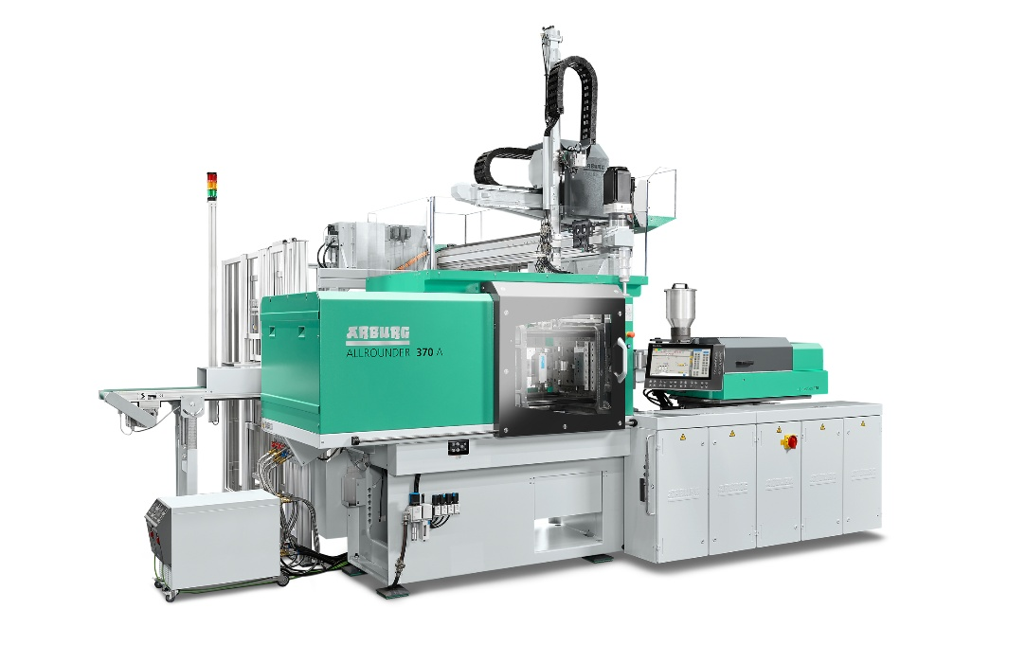

An electric Allrounder 370 A with Multilift Select 8 is used to process “paper pearls”, an alternative material with over 50 per cent fibre content.

Photo: ARBURG

137879

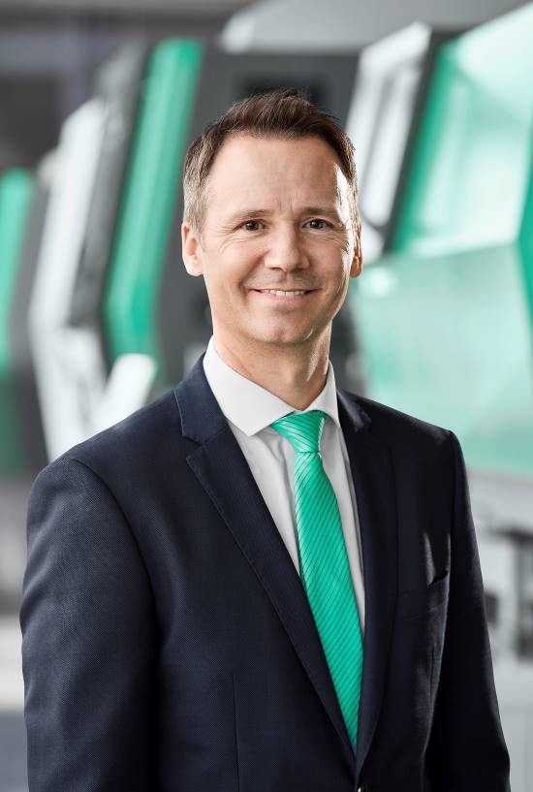

Marcel Spadini, Managing Director of the Swiss Arburg subsidiary

Photo: ARBURG
Photo download:
https://media.arburg.com/web/76e1ff53c559990c/swiss-plastics-2026/

Press release
File: Press preview Swiss Plastics2026_en.docx
Characters: 2,680
Words: 394

This and other press releases are also available for download on our website at www.arburg.com/de/presse/ (www.arburg.com/en/presse/).

Contact
ARBURG GmbH + Co KG
Press Office
Susanne Palm
Dr Bettina Keck
P.O. Box 1109
72286 Lossburg
Tel.: +49 7446 33-3463
Tel.: +49 7446 33-3259
presse_service@arburg.com

About Arburg
Founded in 1923, the German family-owned company is one of the world's leading manufacturers of injection moulding machines. AMKmotion, a manufacturer of electric drive technology, also belongs to the Arburg family.
The portfolio for plastics processing encompasses Allrounder injection moulding machines, robot systems as well as customer- and industry-specific turnkey solutions. It also includes digital products and services. Arburg is a pioneer in the plastics industry when it comes to energy and production efficiency, digitalisation and sustainability. Arburg machines are used to manufacture plastic products for the mobility, packaging, electronics, medical, construction and equipment engineering and leisure industries, for example.
The company headquarters are located in Lossburg, Germany. In addition, Arburg has own organisations in 27 countries at 37 locations and is represented in over 100 countries together with trading partners. Of a total of roughly 3,450 employees, about 2,850 work in Germany, with another 600 employees based in Arburg's organisations around the world.
Arburg is certified to ISO 9001 (Quality), ISO 14001 (Environment), ISO 27001 (Information Security), ISO 29993 (Education and Training) and ISO 50001 (Energy).
Further information: www.arburg.com, www.amk-motion.com.

