Arburg at the Chinaplas 2025
Customised for Asia: Allrounder E Golden Electric Evo and Flexlift robotic system

- Local-to-local: Arburg presents interesting technologies for the Asian market at Chinaplas
- Focus: mobility, medicine and automation
- General contractor: Arburg provides customers with everything from a single source

Lossburg, 11.02.2025
At Chinaplas from 15 to 18 April 2025 in Shenzhen, China, Arburg will be presenting interesting technologies for the Asian market. At stand F41 in hall 12, two Allrounder E Golden Electric Evo machines will demonstrate reliable LSR processing and the efficient production of medical bulk items. A turnkey system centred around an Allrounder rotary table machine will produce connector components fully automatically for the mobility sector, which is growing in China. Special exhibition areas for arburgSOLUTIONworld, including the topics of automation, digitalisation and service, round off the trade fair presentation.

"Chinaplas is the most important platform in Asia for presenting our local-to-local strategy. With the Allrounders Golden Electric Evo and the Flexlift Robot system we are showcasing products that are specifically interesting to our customers in China and Asia at an attractive price-performance ratio and short delivery times. In addition, there are local automation solutions that we implement in Pinghu with local partners," explains Zhao Tong, Managing Director of the Arburg organisations in China. "As a technology and system partner, we offer everything from a single source and also provide our customers with comprehensive support in the turnkey business, in digitalisation and with our services."

Electrical machines for LSR and medicine
The two Chinplas exhibits from the Golden Electric Evo series impressively demonstrate the performance of these electric, very precise Allrounder injection moulding machines. Compared to standard hydraulic machines, dry cycle times are reduced by up to two seconds. In addition, the energy requirement can be reduced by up to 50 per cent.
An Allrounder 470 E Golden Electric Evo with a clamping force of 1,000 kN uses a 160-cavity cold runner mould from Fangyi to produce sealing elements weighing 0.06 grams each from liquid silicone (LSR) from Wacker - burr-free and with an injection precision of 0.01 millimetres. These LSR injection-moulded parts are used to protect the individual wires in automotive connectors against the penetration of liquid media.
An Allrounder 570 E Golden Electric Evo with a clamping force of 2,000 kN will demonstrate the production-efficient manufacture of prefillable syringe barrels from the glass substitute material COP (Cyclic Olefin Polymer). COP is transparent and has similar barrier properties to glass, but is virtually unbreakable and more cost-efficient to produce. The exhibit is equipped with an 8-cavity mould from Unistar. A Flexlift 10 linear robotic system gently removes the moulded parts from the mould and places them on a conveyor belt.
(for more see press release Allrounder Golden Electric Evo)

Turnkey system overmoulds inserts fully automatically
Electromobility and the automotive industry in general are becoming increasingly important in China. A sophisticated turnkey system for this industry will be on show at Chinaplas 2025. The centrepiece is an Allrounder 1600 T rotary table machine with a clamping force of 2,000 kN, which sequentially overmoulds metal inserts into high-voltage modules for automotive connectors. A small six-axis robot feeds the inserts into the system via a transfer platform and also stacks the finished moulded parts. A second, large six-axis robot places the metal inserts in one half of Concraft's injection mould. After overmoulding with glass fibre-reinforced PBT, it transfers the pre-moulded parts to the second half of the mould, where the finished module is produced by overmoulding again.

Comprehensive: automation, digitalisation, service
Arburg has decades of expertise in injection moulding, automation and digitalisation and offers a wide range of services that enable customers to manufacture their products efficiently, quickly and to a high standard of quality. The arburgSOLUTIONworld exhibition area brings together consulting expertise on all these topics. The Arburg experts will also answer individual questions and present, for example, the Arburg host computer system ALS, the arburgXworld customer portal and the range of spare parts and calibration services. The Flexlift will also be in focus. This modular linear robotic system can be customised precisely to the respective requirements - e.g. with application-specific drives, valve sets and variable control cabinet positioning.
(for further information see Flexlift press release)

Pictures

470E Golden Electric Evo Flexlift

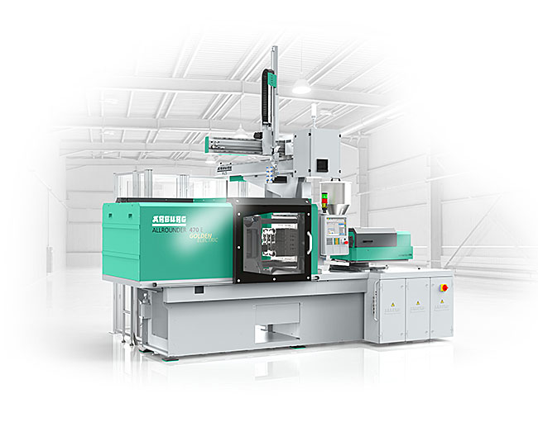

At Chinaplas 2025, Arburg will be presenting two Allrounders Golden Electric Evo and the Flexlift Robot system, which are specifically tailored to customers in China and Asia.

165421

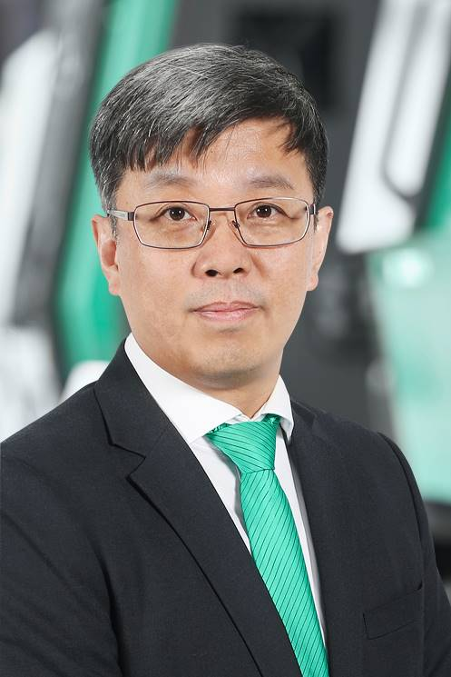

Zhao Tong, Managing Director Arburg China.

Photos: ARBURG
Photo Download:
https://media.arburg.com/web/af9133aa5941eada/chinaplas-2025-press-preview/

Press Release
File: ARBURG press preview Chinaplas 2025_en.docx
Character: 4,352
Words: 651

You can also download this and other press releases from our website at www.arburg.com/de/presse/ (www.arburg.com/en/presse/)

Contact us
ARBURG GmbH + Co KG
Press office
Susanne Palm
Dr Bettina Keck
PO Box 1109
72286 Lossburg
Phone: +49 7446 33-3463
Phone: +49 7446 33-3259
presse_service@arburg.com

About Arburg
Founded in 1923, the German family-owned company is one of the world's leading machine manufacturers for plastics processing. The ARBURG family also includes AMKmotion and ARBURGadditive including innovatiQ.
The portfolio includes injection moulding machines, 3D printers for industrial additive manufacturing, robotic systems and customer- and industry-specific turnkey solutions. It also includes digital products and services.
ARBURG is a pioneer in the plastics industry when it comes to energy and production efficiency, digitalisation and sustainability. ARBURG machines are used to manufacture plastic products for sectors such as mobility, packaging, electronics, medicine, construction, apparatus engineering and leisure.
The company headquarters are located in Lossburg, Germany. In addition, ARBURG has its own organisations in 27 countries at 37 locations and is represented in over 100 countries together with trading partners. Of the total workforce of around 3,700, around 3,100 are employed in Germany and around 600 in the ARBURG organisations worldwide.
ARBURG is certified in accordance with ISO 9001 (quality), ISO 14001 (environment), ISO 27001 (information security), ISO 29993 (training) and ISO 50001 (energy).
Further information: www.arburg.com, www.amk-motion.com and www.arburg.com/arburgadditive.

