Arburg at rapid+tct 2025
Wide range of AM applications: from knee implants to robotic grippers

- High temperature: Freeformer 750-3X also processes materials such as Ultem and PAEK
- High performance: medical and aerospace components including multi-material combinations
- Highly interesting: switches for night trains, cartilage replacement for the knee and grippers "on demand"

Lossburg, 28/01/2025
From 8 to 10 April 2025, ARBURGadditive will be presenting its portfolio for additive manufacturing at stand no. 2308 in Detroit, USA. The centrepiece will be a Freeformer 750-3X in a high-temperature version, which can process Ultem 9085 and PAEK as original granulate, for example. In addition, numerous components will demonstrate the wide range of applications, including 3D-printed light switches as spare parts for the Austrian Federal Railways (ÖBB), TPU-based knee implants as cartilage replacements and multi-material grippers for robotic systems.

"At rapid+tct 2025, we will be presenting innovative application examples from our customers and development partners in addition to the machine exhibit," says Martin Neff, Director Sales at ARBURGadditive. "In addition, a wide range of materials that can be processed with our industrial 3D printers will be on display at our exhibition stand and will be continuously expanded. The possibility of using cost-intensive materials several times in the Arburg Plastic Freeforming (APC) and to return them to the material cycle is also interesting and sustainable."

Freeformer 750-3X in high-temperature version
At rapid + tct 2025, a high-temperature version of the Freeformer 750-3X will be presented, which can additively manufacture sophisticated functional components from a wide range of different plastic granulates. The build chamber can be tempered to 200 degrees Celsius and plasticising takes place at up to 450 degrees Celsius. The high-end machine has three discharge units so that even complex geometries and functional multi-material combinations with support material can be realised. This industrial 3D printer can be used to additively manufacture and customise larger functional components or small series quickly and flexibly using the APF process.
(for more see press release Freeformer 750-3X)

Wide range of materials
Plastic granules with specific approvals and certifications for applications in the medical, electronics, mobility and aviation sectors, for example, can also be processed. These include Ultem 9085, LMPAEK and PEEK. Another new addition to the APF material portfolio is Grilamid TR 90, an amorphous PA12 material approved for food and drinking water, which ARBURGadditive has made "3D printable" in cooperation with Ems Chemie. In addition, break-away support structures made from Ultem 9085, for example, can be shredded and reused several times in the form of flakes.

Spare parts and operating resources "on demand"
A major advantage of additive manufacturing is the ability to produce spare parts where and when they are needed. As a practical example, light switches made of flame-retardant PC/ABS compound are shown, which the Austrian Federal Railways (ÖBB) has produced as required for its night trains using a Freeformer. The Freeformer is also suitable for the fast and cost-effective production of operating equipment and end-of-arm tools (EOAT). The production of plant pots at Osko shows how 3D printing and automated injection moulding processes complement each other perfectly: The injection-moulded pots are handled gently using special packaging automation with 3D-printed grippers that are precisely adapted to the product. The sturdy black gripper centrepiece made of fibre-reinforced plastic is two to three times lighter and significantly more cost-effective than aluminium. The four white gripper rings in a hard/soft combination were produced using the APF process. The soft gripper part is "inflated" with compressed air, thereby fixing the moulded part for removal from the mould.

Innovative solutions for medical technology
The Freeformer is also particularly suitable for use in cleanrooms and innovative applications in medical technology. Typical products are resorbable implants, breast prostheses or medical devices and aids. At rapid + tct 2025, examples of components that will be presented include nose and ear prostheses made from sterilisable TPE (TM5 Med). A new application idea is the "iKnee" - a patient-specific implant based on medical TPU that can be inserted into the knee as a minimally invasive cartilage replacement. A customer realises hollow medical valve bodies on the inside with a Freeformer 750-3X, which produces these components in an airtight and resilient multi-material combination of PP and TPE.

Seamless traceability and documentation
An indispensable prerequisite for the use of additively manufactured functional components in safety-relevant areas is a reproducible and reliable AM process. For patient-specific implants or safety-relevant components in aeroplanes, for example, it is imperative that the production parameters for each individual component can be fully documented and traced. Arburg offers the "ProcessLog" customer portal app for this purpose. This allows a wide range of process and build order data from APF components to be clearly visualised and documented. This ensures transparency, high part quality and can significantly reduce rejects and error rates.

Pictures

183833

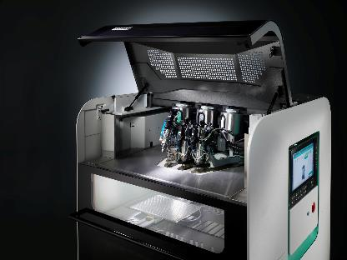

With the 750-3X high-temperature Freeformer with three discharge units, the installation space can be tempered to 200 degrees Celsius and the original granulate is plasticised at up to 450 degrees Celsius.

iKnee DSC5567

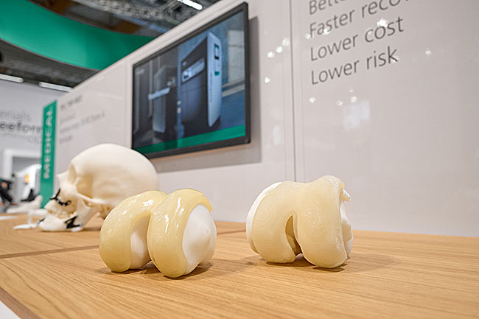

The Freeformer is also suitable for new application ideas in medical technology. These include the "iKnee" - a patient-specific implant based on medical TPU that can be inserted into the knee as a minimally invasive cartilage replacement.

Gripper DSC8299
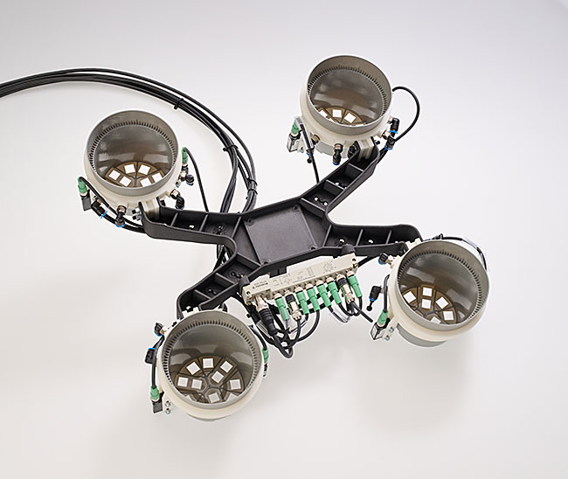
Fast, cost-effective and lightweight: robotic grippers, e.g. for the gentle removal of injection-moulded plant pots, can be additively manufactured "on demand".

ARBURG 178070 Freeformer ProcessLog_en.jpg
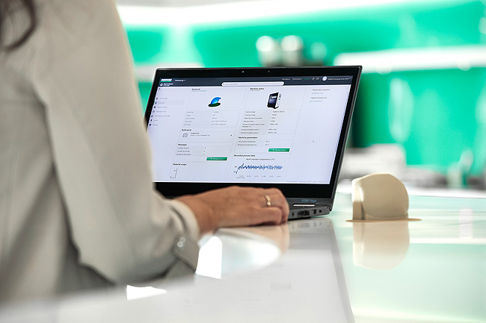

"ProcessLog": With the "arburgXworld" customer portal app developed especially for the Freeformer, a wide range of process and build order data for APF components can be clearly displayed and documented.

Photos: ARBURG
Photo Download:
https://media.arburg.com/web/5d34e45f594d7651/rapid-tct-2025-press-preview-/

Press Release
File: ARBURG press preview rapid + tct 2025_en_GB.docx
Character: 5,021
Words: 743

You can also download this and other press releases from our website at www.arburg.com/de/presse/ (www.arburg.com/en/presse/)

Contact us
ARBURG GmbH + Co KG
Press office
Susanne Palm
Dr Bettina Keck
PO Box 1109
72286 Lossburg
Phone: +49 7446 33-3463
Phone: +49 7446 33-3259
presse_service@arburg.com

About Arburg
Founded in 1923, the German family-owned company is one of the world's leading machine manufacturers for plastics processing. The ARBURG family also includes AMKmotion and ARBURGadditive including innovatiQ.
The portfolio includes injection moulding machines, 3D printers for industrial additive manufacturing, robotic systems and customer- and industry-specific turnkey solutions. It also includes digital products and services.
ARBURG is a pioneer in the plastics industry when it comes to energy and production efficiency, digitalisation and sustainability. ARBURG machines are used to manufacture plastic products for the mobility, packaging, electronics, medical, construction and apparatus engineering and leisure sectors, for example.
The company headquarters are located in Lossburg, Germany. In addition, ARBURG has its own organisations in 27 countries at 37 locations and is represented in over 100 countries together with trading partners. Of the total workforce of around 3,700, around 3,100 are employed in Germany and around 600 in the ARBURG organisations worldwide.
ARBURG is certified in accordance with ISO 9001 (quality), ISO 14001 (environment), ISO 27001 (information security), ISO 29993 (training) and ISO 50001 (energy).
Further information: www.arburg.com, www.amk-motion.com and www.arburg.com/arburgadditive.

