Arburg exhibit at K 2025
Allrounder 720 A: Efficient injection compressing moulding of IML thin-wall cups

- Powerful: Electric Allrounder 720 A “Ultimate” manufactures high-quality packaging product
- Efficient: Injection compressing moulding saves up to 20 percent in materials and improves energy balance
- Precise: Tool sensors and pilot function in control system monitor and control injection moulding process

Lossburg, 18.09.2025
Arburg (Stand 13A13) will be demonstrating how injection moulding in conjunction with in-mould labelling (IML) can be used to manufacture packaging products in a remarkably reliable and energy-efficient manner, using up to 20 per cent less material. At K 2025, a thin-walled round cup with a tamper-evident closure will be produced for the first time – featuring geometry that cannot be achieved in thermoforming. A high-performance electric Allrounder 720 A “Ultimate” has been specifically optimised for this application in terms of performance, energy efficiency and precision.

The electric Allrounder 720 A “Ultimate” with a clamping force of 3,200 kN and a size 1300 injection unit can achieve remarkably high injection volumes and injection speeds of up to 400 millimetres per second. In the application being exhibited, great importance was attached to a material-saving component design and energy efficiency.

Injection compressing moulding saves material and reduces clamping force
Injection compressing moulding offers several advantages at once and is more resource-efficient than classic injection moulding: It allows significantly thinner wall thicknesses to be achieved; less injection pressure is required and tool temperatures of 20 instead of 12 degrees Celsius can be used. Improvements to this process have yielded energy savings of up to 30 per cent, accompanied by a significant reduction in component weight.
In contrast to thermoforming, complex geometries can also be created. Thanks to the optimum design of the machine and peripherals, Arburg's application and process experts have succeeded in reducing the clamping force required for the exhibit at K 2025 by around 20 per cent from 2,900 to 2,300 kN. Together with savings in relation to machine size and purchase cost, footprint, wear and connected load.

Four thin-walled IML cups in just 3.5 seconds
The electric Allrounder 720 A “Ultimate” uses a 4-cavity mould from Brink to produce IML cups weighing 12.4 grams, each holding 400 millilitres and featuring a tamper-evident closure. The wall thickness measures just 0.37 millimetres and the cycle time is around 3.95 seconds. The high injection speed required are provided by precise servo motors from the Arburg sister company AMKmotion. A side-entry robot from Brink is also integrated into the production cell. This inserts the labels then goes on to remove the finished cups before stacking them on a conveyor belt. The special Next Cycle label can be separated completely from the cup during the recycling process, enabling the PP product to be recycled by type after use.

Process reliability to high part quality
For process monitoring, the tool is equipped with three displacement and embossing sensors. These are positioned in the main plane, in the embossing plane and on the needle gate nozzle. This makes it possible to fine-tune the chronological sequence of the stamping process from injection to tool closing to control of the needle-type shut-off nozzle. Smart assistance and pilot functions in the Gestica, such as the “aXw Control ScrewPilot” compensate for deviations in the filling process. This ensures stable mould filling, process reliability and consistently high component quality.

Images

720A_IML cups_196678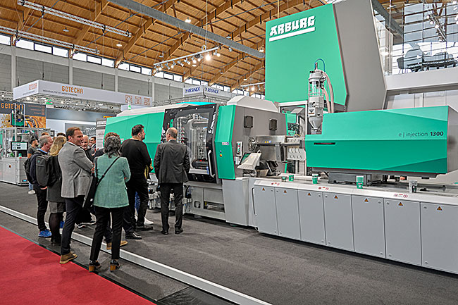
An electric Allrounder 720 A “Ultimate” has demonstrated energy- and resource-saving injection moulding at trade fairs. At K 2025, it will be producing thin-walled IML cups with high-quality closures for the first time.

IML-Cups_DSC4830
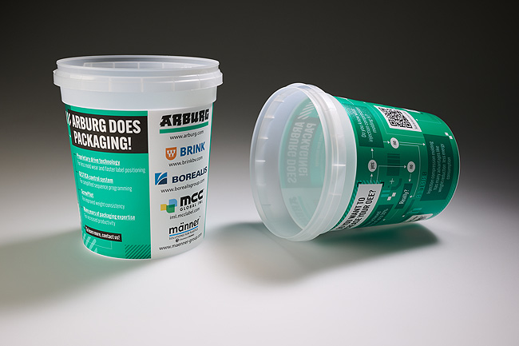
The recyclable IML round cups made of PP mono-material have a wall thickness measuring just 0.37 millimetres.

Photos: ARBURG

Photo Download:
https://media.arburg.com/web/1895b1f992e080fe/iml-packaging-k2025/

Press release
File: ARBURG press release Allrounder 720A K2025_en_GB.docx
Sign: 3,237
Words: 497

These and other press releases can also be downloaded from our website at www.arburg.com/de/presse/ (www.arburg.com/en/presse/)

Contact
ARBURG GmbH + Co KG
Press
Susanne Palm
Dr. Bettina Keck
P.O. Box 1109
72286 Lossburg
Phone: +49 7446 33-3463
Phone: +49 7446 33-3259
presse_service@arburg.com

About Arburg
Founded in 1923, the German family-owned company is one of the world’s leading manufacturers of injection moulding machines. The Arburg family also includes AMKmotion, a manufacturer of electric drive technology.
The Arburg portfolio for plastics processing includes Allrounder injection moulding machines, robotic systems as well as customer- and industry-specific turnkey solutions. In addition, there are digital products and services. In the plastics industry, Arburg is a pioneer in the areas of energy and production efficiency, digitalisation and sustainability. Arburg machines are used to manufacture plastic products for the mobility, packaging, electronics, medical, construction and apparatus construction and leisure sectors to name just a few examples.
The company headquarters are located in Lossburg, Germany. In addition, Arburg has its own organisations in 27 countries at 37 locations and is represented in over 100 countries together with trading partners. Of the total of around 3,450 employees, roughly 2,850 are employed in Germany and about 600 in the Arburg organisations worldwide.
Arburg is certified in accordance with ISO 9001 (Quality), ISO 14001 (Environment), ISO 27001 (Information Security), ISO 29993 (Training) and ISO 50001 (Energy).
Further information: www.arburg.com, www.amk-motion.com.

