Electric machines for Asia
Local to local: Asia Allrounder series
Golden Electric Evo

- Electric: Entry-level machines for the Asian market
- Focus: "Made by Arburg" – cost effective and
quickly available
- Efficient: Up to 50 per cent less energy consumption

Lossburg/Shanghai 11/02/2025
The Golden Electric Evo series, which has been available since 2024, is fully tailored to Asia. The electric Allrounders combine the "Made by Arburg" quality seal known throughout the global market with unbeatable value for money and short delivery times, making the purchase of an Arburg machine easy, quick and cost effective for Asian customers. It is also suitable for LSR applications and can be automated with a Flexlift linear robotic system, which is also specially designed for Asia.

Arburg set the initial course for its "local-to-local" activities back in 2020, with the opening of the Arburg Technology Factory (ATF) in Pinghu. Initially, activities focused on adapting Allrounder machines to customer-specific requirements and implementing turnkey systems in cooperation with local suppliers of moulds and peripheral equipment.

Tailored for customers in Asia
This was followed in 2023 by the Flexlift linear robotic system and 2024 the Allrounder Golden Electric Evo. Both product series are specifically tailored to the requirements of customers in Asia and are also exclusively available there. Assembly in the ATF ensures quick availability of the entry-level electric machines. The portfolio includes the sizes 370, 470, 520 and 570, which cover clamping forces ranging from 600 to 2,000 kN. The injection units range from size 100 to size 800, for shot weights of up to around 430 grams of PS.

Precision, fast and energy efficiency
The Allrounder Golden Electric Evo is extremely precise, thanks to its high-quality injection units. The servo-electric drives for "inject", "dose" and "open and close mould" deliver fast acceleration, high speeds, and simultaneous movements, all of which add up to short cycle times. Compared to standard hydraulic machines, the dry cycle times are up to two seconds shorter. What's more, the energy requirement can be reduced by up to 50 per cent with the toggle-type clamping unit, the high efficiency of the servo-electric drive and recovery of braking energy.

Image

Allrounder 470E Golden Electric Evo perspective

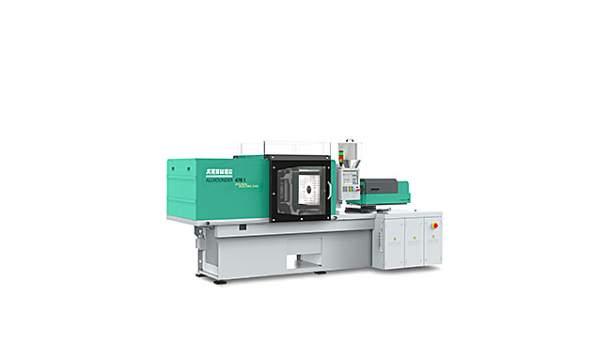

The Allrounder Golden Electric Evo series is specifically tailored to the requirements of customers in Asia, and are also exclusively available there.

Photo: Arburg
Photo download:
https://media.arburg.com/web/70ac1ab84ab39d8d/allrounder-golden-electric-evo/

Press release
File: ARBURG press release Allrounder Golden Electric Evo_en_GB.docx
Characters: 2,010
Words: 314

This and other press releases are available for download from our website at www.arburg.com/de/presse/ (www.arburg.com/en/press/)

Contact
Arburg GmbH + Co KG
Press office
Susanne Palm
Dr. Bettina Keck
Postfach 1109
72286 Lossburg, Germany
Tel.: +49 7446 33-3463
Tel.: +49 7446 33-3259
presse_service@arburg.com

About Arburg
Founded in 1923, the German family-owned company is one of the world's leading machine manufacturers for plastics processing. The ARBURG family also includes AMKmotion and ARBURGadditive including innovatiQ.
The portfolio includes injection moulding machines, 3D printers for industrial additive manufacturing, robotic systems and customer- and industry-specific turnkey solutions. It also includes digital products and services.
ARBURG is a pioneer in the plastics industry when it comes to energy and production efficiency, digitalisation and sustainability. ARBURG machines are used to manufacture plastic products for sectors such as mobility, packaging, electronics, medicine, construction, apparatus engineering and leisure.
The company headquarters are located in Lossburg, Germany. In addition, ARBURG has its own organisations in 27 countries at 37 locations and is represented in over 100 countries together with trading partners. Of the total workforce of around 3,700, around 3,100 are employed in Germany and around 600 in the ARBURG organisations worldwide.
ARBURG is certified in accordance with ISO 9001 (quality), ISO 14001 (environment), ISO 27001 (information security), ISO 29993 (training) and ISO 50001 (energy).
Further information: www.arburg.com, www.amk-motion.com and www.arburg.com/arburgadditive.

