Arburg at the K 2025
Premiere off to a flying start: Allrounder Trend - the new global standard

- Completely new: Electric “Trend” performance level expands portfolio for standard applications
- Easy as pie: Cost-effective entry, quick delivery, simple operation and easy maintenance
- Highly flexible: Turnkey-capable and can be automated with all Arburg robotic systems

Lossburg, 07.10.2025
The world premiere of the Allrounder Trend heralds an exciting new era. Arburg is expanding its portfolio of proven high-end technology solutions with completely newly developed electric machines for standard applications. The Allrounder Trend have been designed specifically to meet current market requirements: They are quick to set up, particularly easy to operate and maintain and they produce injection moulded parts extremely reliably and energy-efficiently. No less than three Trend machines will be presented at K 2025. These will produce electronic connectors, demonstrate automated LSR production and will process recyclates reliably.

“We have completely redeveloped the Allrounder Trend - from the all-electric drive train, energy-efficient clamping and high-performance injection unit to the dynamic electric ejector and the new Gestica lite control variant. This ensures repeatable and reliable part production,” summarises Guido Frohnhaus, Managing Director Technology & Engineering. “The machine technology is very easy to master, even without specialist personnel, and enables quick and easy entry into injection moulding of standard components”. Tobias Baur, Managing Director Sales and After Sales, lists further advantages: “Our new Trend performance level offers high cost efficiency coupled with proven Arburg quality and globally standardised service. We wish to reach existing customers worldwide as well as completely new target groups who do not yet have an Allrounder in their injection moulding production facilities”. The new electric Trend machines can be ordered from K 2025 and will be available worldwide from spring 2026.

Simple and cost-efficient production of moulded parts
The Allrounder Trend is available at short notice to enable injection moulding companies to act flexibly and manufacture competitively despite frequently changing orders in increasingly fast-moving markets. The time from order to delivery ex works is usually only around four weeks. Trend machines offer low investment and operating costs and are characterised by a fast return on investment (ROI) with a low total cost of ownership (TCO). The purchase therefore pays off even with short machine running times. This also makes Arburg interesting for completely new markets in which high-quality moulded parts have to be produced efficiently and precisely under intense cost pressure. The particularly slim design ensures a compact footprint and space-optimised production, resulting in increased output per square metre.

Set up quickly and easily and work productively
Thanks to intuitive controls and “smart” assistance functions, even inexperienced employees can be onboarded quickly. The easily accessible large mould installation space and cleverly arranged interfaces for electronics, pneumatics and cooling water close to the mould ensure convenient setup and start-up. Peripheral devices can be connected effortlessly using “Plug & Work” and the cylinder module can be replaced quickly if required. This enables the machine to go into production rapidly, saving resources and time. Arburg offers new training concepts in the form of e-learning and remote training to familiarise personnel with the machine.

Simple and intuitive operation
The Trend machines are equipped with the new Gestica lite control variant. This features an intuitive user interface with a clear dashboard, making operation very easy, even for non-specialists. Here too, the key word is “easy”: the user interface provides everything at a glance that is needed for operation. This includes information about the job, the current process and direct access to the most important parameters - all intelligently and actively supported by assistance functions. From the dashboard, you can use the touch function to jump directly to the detailed parameter pages for the clamping and injection unit.
The status centre, which displays all alarms, the help centre with practical online support and a digital pinboard for production-related personal notes provide additional benefits. In addition, there is a simplified search and fast troubleshooting function involving assisted workflows with visual solution trees and simplified navigation.

Simple and convenient maintenance
Arburg has also placed great emphasis on ease of maintenance and low maintenance requirements. For better accessibility and convenient set-up, the safety gate has been significantly enlarged and the sliding guard on the injection unit can be opened wide in two stages. The maintenance points on the injection and clamping unit, e.g. for grease lubrication, are easily to access without the need for special tools.
If you wish to do your own machine maintenance, you can access digital support, including installation instructions, directly on the control unit: The “aXw Control MaintenanceAssist” explains the tasks to be performed step by step in a series of video tutorials. For maintenance by Arburg's technical support team, a global service network and standardised worldwide maintenance contracts with customisable services can be accessed.

Easily expand and automate with options
Options can also be retrofitted if required. For example, up to two serial core pulls and freely configurable I/O interfaces. The control cabinet is equipped with numerous slots. For entry into digitalisation, the machines are prepared for an IIoT gateway, e.g. to be able to connect them to the arburgXworld customer portal or the Arburg host computer system ALS.
For automated moulded part production, the Allrounder Trend can be equipped with robotic systems from Arburg, such as the linear Multilift Select 4, and suitable compact protection and can also be integrated into complex turnkey systems. In general, all robotic systems from Arburg can be used and fully integrated into the machine control system.

Simply rely on quality “Made by Arburg”
Anyone who opts for a machine “Made by Arburg” receives reliable quality and more than 75 years of expertise in plastics processing. Initially only for the markets in Asia, assembly will be increasingly carried out on a “local to local” basis in the future, also using local components.
The Allrounder Trend is relevant for all industries, such as technical injection moulding and electronics. However, they are not high-speed machines and are not suitable for all special processes. Their performance has been specifically optimised for standard applications. At market launch, there are four sizes in the clamping force range from 500 to 2,000 kN and with electric injection units in sizes 100 to 800. The injection speed is between 200 and 500 millimetres per second. And the naming is also new: in the new system, the clamping force follows the product name Allrounder. The Allrounder 1000 e Trend, for example, has a clamping force of 1,000 kN; the “e” stands for electric and “Trend” for the performance level in the standard machine segment.
(more regarding Allrounder Trend see interactive website: trend.arburg.com/en/)

K exhibits: Electronics, automation, LSR and recyclate
With three electric Trend machines, Arburg will be demonstrating the production of connectors, an automated simple LSR application and the processing of recyclate at K 2025:
- An Allrounder 1000 e Trend produces electronic connectors. The servo-electric ejection synchronised with the mould movement ensures precision and reproducible dropping of the moulded parts.
- A turnkey system based around an Allrounder 1800 e Trend produces LSR diaphragm valves fully automatically with a 64-cavity mould. A Multilift Select 16 linear robotic system is used for depositing, separated according to cavities.
- Another Allrounder 1000 e Trend takes centre stage at the arburgGREENworld pavilion and demonstrates an example of upcycling: Equipped with the “aXw Control RecylatePilot” pilot function in the Gestica lite, it reliably processes recyclate from used fishing nets into model dolphins.

Pictures

ALLROUNDER 1800 e TREND_359

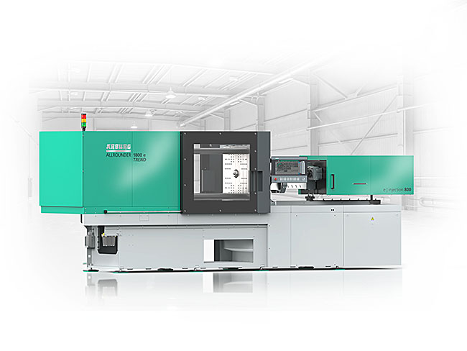

World premiere at the K 2025: The electric Allrounder Trend can be set up particularly quickly and easily and is specifically designed for the efficient production of standard injection moulded parts.

ALLROUNDER 1800e TREND automation_397

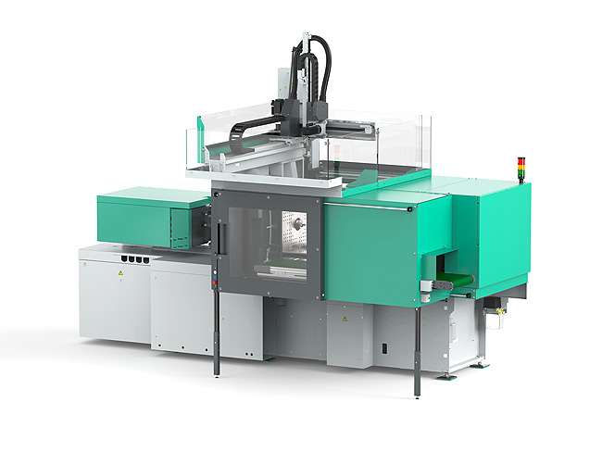

The Allrounder Trend can be equipped with robotic systems and compact protection from Arburg for automated moulded part production.

Photo: Arburg
Photo Download:
https://media.arburg.com/web/bab914d4c577373e/press-release-allrounder-trend-2025/

press release
File: Press release Product Allrounder TREND 2025_en_GB.docx
Characters: 7,863
Words: 1,177

You can also download this and other press releases from our website at www.arburg.com/de/presse/ (www.arburg.com/en/presse/)

Please contact
Arburg GmbH + Co KG
Press Office
Susanne Palm
Dr Bettina Keck
P.O. Box 1109
72286 Lossburg, Germany
Phone: +49 7446 33-3463
Phone: +49 7446 33-3259
presse_service@arburg.com

About Arburg
Founded in 1923, the German family-owned company is one of the world's leading manufacturers of injection moulding machines. AMKmotion, a manufacturer of electric drive technology, also belongs to the Arburg family.
The portfolio for plastics processing encompasses Allrounder injection moulding machines, robot systems as well as customer- and industry-specific turnkey solutions. It also includes digital products and services. Arburg is a pioneer in the plastics industry when it comes to energy and production efficiency, digitalisation and sustainability. Arburg machines are used to manufacture plastic products for the mobility, packaging, electronics, medical, construction and equipment engineering and leisure industries, for example.
The company headquarters are located in Lossburg, Germany. In addition, Arburg has own organisations in 27 countries at 37 locations and is represented in over 100 countries together with trading partners. Of a total of roughly 3,450 employees, about 2,850 work in Germany, with another 600 employees based in Arburg's organisations around the world.
Arburg is certified to ISO 9001 (Quality), ISO 14001 (Environment), ISO 27001 (Information Security), ISO 29993 (Education and Training) and ISO 50001 (Energy).
Further information: www.arburg.com, www.amk-motion.com.

