Arburg awarded by Harting in 2025
Harting Americas recognizes Arburg Inc. with award for Supplier Excellence

- Excellent: Award presented during Harting’s 2025 Annual Supplier Day on August 12th in Chicago
- Inaugural: Americas suppliers event covering Harting’s operations in USA, Mexico and Brazil
- Reliable: Arburg always there for Harting when needed

Lossburg/Rocky Hill, 15/09/2025
As part of the first annual Supplier Day held by Harting Americas on August 12th 2025 at their Chicago-area Americas Headquarters, Arburg received an award for Supplier Excellence. The event covered Harting operations in USA, Mexico and Brazil (Americas). Arburg as well as over a dozen other suppliers were invited. The suppliers that attended ranged from raw material, components, wires to equipment suppliers.

The aim of the award is to recognise outstanding suppliers in the areas of quality, sustainability, logistics and innovation, and to further strengthen cooperation based on partnership. All award winners are characterised by close, long-term cooperation with Harting Americas and a shared commitment to quality and innovation.
In his delivery of the award, Florian Stuetzel, COO at Harting Americas, emphasized: “Arburg was there when needed with quick unbureaucratic reaction during an emergency situation. The company helped Harting to get new moulds into production that otherwise would not have made schedule.”

Harting Americas: Arburg customer for more than five years
Harting is an Arburg customer in the Americas for over five years. The award was presented at Harting headquarters for the Americas in Elgin, Illinois, where also Arburg has a Technology Center (ATC). Especially, the cooperation is labelled by a close working relationship with the local team at this ATC.
Regarding the cooperation with Harting, Martin Baumann, President & CEO at Arburg Inc. in Rocky Hill, Connecticut/USA, states the following: “We are very happy with getting this award. This shows that Arburg in the Americas is very well positioned not only in the technical, but also in the service sector. Indeed, we are a proud supplier of injection moulding technology to Harting. The close relationship will continue, as we are quoting new systems at the moment. We are supporting Harting’s regional growth with our machine and turnkey solutions.”

Photo

Harting award Supplier Excellence US 2025_IMG_6776

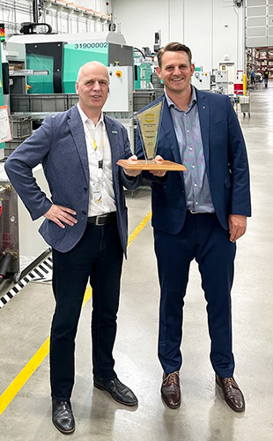

Florian Stuetzel (right), COO at Harting Americas, hands over the award for Supplier Excellence to Arburg’s Martin Baumann, President & CEO Arburg Inc.

Photo: ARBURG

Photo Download:
https://media.arburg.com/web/642f4b06488021ee/harting-award-supplier-excellence-2025/

Press release
File: ARBURG press release Harting Supplier Award 2025_en_GB.docxx
Characters: 1,962
Words: 303

This and other press releases are available for download from our website at www.arburg.com/de/presse/ (www.arburg.com/en/press/)

Contact
ARBURG GmbH + Co KG
Press office
Susanne Palm
Dr Bettina Keck
Postfach 1109
72286 Lossburg
Tel.: +49 (0)7446 33-3463
Tel.: +49 (0)7446 33-3259
presse_service@arburg.com

About Arburg
Founded in 1923, the German family-owned company is one of the world's leading manufacturers of injection moulding machines. AMKmotion, a manufacturer of electric drive technology, also belongs to the Arburg family.
The portfolio for plastics processing encompasses Allrounder injection moulding machines, robot systems as well as customer- and industry-specific turnkey solutions. It also includes digital products and services. Arburg is a pioneer in the plastics industry when it comes to energy and production efficiency, digitalisation and sustainability. Arburg machines are used to manufacture plastic products for the mobility, packaging, electronics, medical, construction and equipment engineering and leisure industries, for example.
The company headquarters are located in Lossburg, Germany. In addition, Arburg has own organisations in 27 countries at 37 locations and is represented in over 100 countries together with trading partners. Of a total of roughly 3,450 employees, about 2,850 work in Germany, with another 600 employees based in Arburg's organisations around the world.
Arburg is certified to ISO 9001 (Quality), ISO 14001 (Environment), ISO 27001 (Information Security), ISO 29993 (Education and Training) and ISO 50001 (Energy).
Further information: www.arburg.com, www.amk-motion.com.

