Arburg renews ISO 27001 certificate
Information security management system successfully recertified

- ISO 27001 certification renewed after 2023
- Comprehensive documentation of IT security and data protection in the company
- ARBURG underpins pioneering position for digitalisation in the industry

Lossburg, 01.10.2025
Understandably enough, the first step towards Arburg's certification in accordance with the globally recognised DIN ISO/IEC 27001 standard in March 2023 was an extensive and time-consuming process. But that was only the first step. The implementation of an effective information security management system (ISMS) in the Global IT & Digital Services division was followed by an ongoing process of updates and adaptation to satisfy the stringent requirements of information security and the security procedures that underpin them. This was an important development for Arburg as well as for its global customers and cooperation partners, one that was finalised with the presentation of the recertification certificate in September.

As an internationally recognised framework, ISO 27001 creates the safety barriers for information security, comprising procedures, guidelines and directives. This is exactly what more and more customers, partners and suppliers around the world are increasingly calling for and, in some cases, are actually demanding. Steffen Kroner, Managing Director Finance, Controlling, IT, Human Resource Management, is delighted with the successful recertification, “as it shows that IT security is a top priority for us and that we are constantly working on making this area more efficient, and that this is being done by a comprehensively qualified team of experts. Our information security procedures are not only reliably documented, but we are also constantly working to improve them in order to continuously strengthen our IT resilience”.

Global security is essential
IT security and data protection are of central importance throughout the company, both at the Lossburg headquarters and at the 35 locations in 25 countries. Above all, it is important to reliably prevent unauthorised access, which risks the outflow of sensitive data. Recertification takes place at regular intervals, accompanied by an annual detailed risk assessment of all IT services, the analysis of which is incorporated into the company's own opportunity management protocol. Internal audits, management assessments and monitoring audits by TÜV Süd are also conducted.

Vigilant for the future
The company is unrelenting in its efforts to maintain and further expand IT security at the highest level. Stephan Reich, Vice President Global IT & Digital Services, comments: “At times like these, we face new challenges every day arising from increasing complexity of cyber threats, particularly through the use of GenAI and the spread of identity theft and ransomware. As a company, we must constantly anticipate and implement the latest countermeasures in order to ward off these threats effectively. In addition to the ongoing training of our employees, the alignment of IT in accordance with ISO 27001 is also an important step in ensuring that we are always 'up to date' in the field of IT security”. This comprehensive expertise flows directly into digital products such as the arburgXworld customer portal and the ALS host computer system to ensure maximum security for customers when using Arburg solutions.

Picture

ISO 27001 Certificate 2025_DSC4768

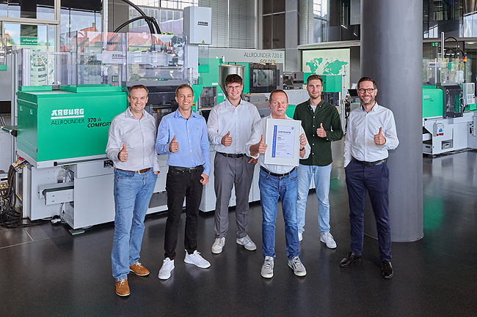

Arburg successfully recertified to ISO 27001: Steffen Kroner (right), Managing Director Finance, Controlling, IT, Human Resources Management and Stephan Reich (left), Vice President Global IT & Digital Services with his certification team Björn Burkhardt, Tobias Hahn, Rolf Steinwandt and Lukas Broghammer (from left).

Photo: ARBURG

Photo download:
https://media.arburg.com/web/62305d2bd7720283/iso-27001-certificate-2025/

press release
File: ARBURG press release certification ISO 27001_en_GB.docx
Characters: 3,104
Words: 470

You can also download this and other press releases from our website at www.arburg.com/de/presse/ (www.arburg.com/en/presse/)

Contact
ARBURG GmbH + Co KG
Press Office
Susanne Palm
Dr Bettina Keck
P.O. Box 1109
72286 Lossburg
Phone: +49 7446 33-3463
Phone: +49 7446 33-3259
presse_service@arburg.com

About Arburg
Founded in 1923, the German family-owned company is one of the world's leading manufacturers of injection moulding machines. The Arburg family also includes AMKmotion, manufacturer of electric drive technology.
The Arburg portfolio for plastics processing includes Allrounder injection moulding machines, robotic systems and customer- and industry-specific turnkey solutions. It also includes digital products and services. Arburg is a pioneer in the plastics industry when it comes to energy and production efficiency, digitalisation and sustainability. Arburg machines are used to manufacture plastic products for the mobility, packaging, electronics, medical, construction and apparatus engineering and leisure industries, for example.
The company headquarters are located in Lossburg, Germany. In addition, Arburg has its own organisations in 27 countries at 37 locations and is represented in over 100 countries together with trading partners. Of the total workforce of around 3,450, around 2,850 are employed in Germany and around 600 in the Arburg organisations worldwide.
Arburg is certified to ISO 9001 (quality), ISO 14001 (environment), ISO 27001 (information security), ISO 29993 (training) and ISO 50001 (energy).
Further information: www.arburg.com, www.amk-motion.com.

