Arburg at Chinaplas 2026
Everything for the Asian market

- Local-to-local: Arburg showcases technologies specifically relevant to the regional market at Chinaplas
- Highlight: Asian premiere of the electric Allrounder Trend
- Solution partner Arburg : Machine technology, service, automation and digitalisation from a single source

Lossburg, 09/02/2026
From 21 to 24 April 2026, Arburg will be exhibiting at Chinaplas in Shanghai, China (Hall 4.1, Stand D42). One highlight will be the new Allrounder Trend electric machine concept, which will celebrate its Asian premiere at Chinaplas 2026. Arburg will also be presenting an exciting rotary table machine and its wide range of automation services – once again with a focus on “local-to-local”.

“Chinaplas is the most important platform for presenting our local-to-local strategy to Asian customers. Which is why we are no longer located in the German Pavilion and are instead alongside other local machine manufacturers in Hall 4.1”, explains Zhao Tong, Managing Director of the Arburg organisations in China. “With the new Trend standard machines, we are not only addressing existing customers, but also companies for whom our portfolio has not been a contender until now”.

New: Allrounder Trend machine concept
Important criteria for the success of the electric Allrounder Trend are that it can be set up particularly quickly, it is intuitive to operate and is easy to maintain. Other benefits are its short delivery lead times and its attractive pricing. The Allrounder Trend is particularly interesting for Asian injection moulders, especially in the mobility and electronics industries. Another new feature is the Gestica lite control system with a modern dashboard. Here too, the focus is on simple operation and a clear user interface.
At market launch, there are four sizes in clamping force, rangeing from 500 to 2,000 kN and with electric injection units in sizes 100 to 800. The injection speed is 200, 350 and 500 millimetres per second.
Two Trend exhibits for standard applications will be on display at the Arburg stand: An Allrounder 1000 e Trend with a clamping force of 1,000 kN that produces PCB connectors from LCP. The second Allrounder 1000 e Trend, equipped with a Flexlift 10+2 robotic system, produces gears from POM. The Flexlift is only available in Asia. The linear robot system can be equipped with application-specific drives, valve sets and variable control cabinet positioning, for example.

Customer-specific production cells for Asia
At the Arburg Technology Factory (ATF) in Pinghu, Allrounders are completed with automation from local partners and customer-specific production cells are installed. Arburg now also assembles the Allrounder Trend for China and the Asian market here. “Process reliability and component quality will continue to gain in importance, and more and more robots and complex production cells will be used,” Zhao Tong is convinced. “With our portfolio, know-how and our Arburg Technology Factory, we are ideally positioned for this”.

Allrounder 1600 T overmoulds inserts fully automatically
An example of a turnkey system specially designed to meet the needs of regional customers will be on display at Chinaplas 2026: an Allrounder 1600 T with a clamping force of 2,000 kN that overmoulds inserts fully automatically. The rotary table machine manufactures high-voltage modules for automotive connectors, to name just one example. A small six-axis robot feeds the metal inserts via a transfer platform and stacks the finished injection-moulded parts. Another six-axis robot places the inserts in the injection mould and, after overmoulding with glass fibre-reinforced PBT, transfers the pre-moulded parts to the mould, where the finished module is created by another overmoulding process.

Arburg: Solution partner for digitalisation and service
As a technology leader and systems specialist, Arburg does more than supply injection moulding machines and turnkey systems from a single source. It also supports its customers in digitalisation and with comprehensive services. The trade fair will also showcase how plastic parts can be produced efficiently, quickly and to a high standard of quality thanks to innovative digital pilots and assistants of the Gestica control system. One example is the “aXw Control FillAssist” for filling simulation directly on the control system. Furthermore, experts will be on hand at to answer individual questions about Arburg host computer system, the dedicated MES system, the arburgXworld customer portal and the range of spare parts.

Image

Zhao Tong_DSC7105

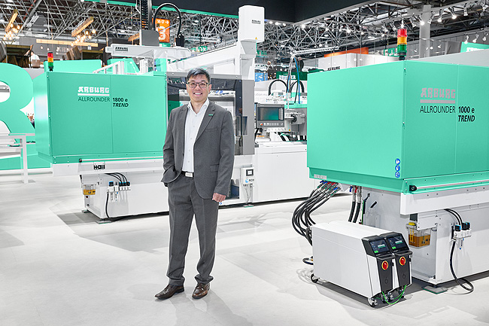

Zhao Tong, Managing Director of the Arburg organisations in China, with the new Trend electric Allrounders, which are celebrating their Asian premiere at Chinaplas 2026.

Photo: ARBURG
Photo download:
https://media.arburg.com/web/fe460f23cd594183/chinaplas-2026-press-preview/

Press release
File: ARBURG press preview Chinaplas 2026_en_GB.docx
Characters: 4,215
Words: 652

This and other press releases are also available for download on our website at www.arburg.com/de/presse/ (www.arburg.com/en/presse/).

Contact
ARBURG GmbH + Co KG
Press Office
Susanne Palm
Dr Bettina Keck
P.O. Box 1109
72286 Lossburg, Germany
Tel.: +49 7446 33-3463
Tel.: +49 7446 33-3259
presse_service@arburg.com

About Arburg
Founded in 1923, the German family-owned company is one of the world's leading manufacturers of injection moulding machines. The Arburg family also includes AMKmotion, a manufacturer of electric drive technology.
The Arburg portfolio for plastics processing includes Allrounder injection moulding machines, robotic systems and customer- and industry-specific turnkey solutions. It also offers digital products and services. Arburg is a pioneer in the plastics industry in the areas of energy and production efficiency, digitalisation and sustainability. Arburg machines are used to manufacture plastic products for industries such as mobility, packaging, electronics, medicine, construction and apparatus engineering, and leisure.
The company headquarters are located in Lossburg, Germany. Arburg also has its own organisations in 27 countries at 37 locations and is represented in over 100 countries together with trading partners. Of the total workforce of around 3,400, around 2,800 are employed in Germany and around 600 in Arburg organisations worldwide.
Arburg is certified according to ISO 9001 (quality), ISO 14001 (environment), ISO 27001 (information security), ISO 29993 (training) and ISO 50001 (energy).
Further information: www.arburg.com, www.amk-motion.com.

