Arburg at the Fakuma 2026
Allrounder 475 V: Small footprint, high clamping force

- Space-saving: Vertical Allrounder 475 V with 1.000 kN clamping force
- Efficient: Arburg servo hydraulic system (ASH) reduces energy consumption by up to 60 per cent
- Flexible automation: Turnkey system for overmoulding of wireless car keys

Lossburg, 17/09/2026
The vertical Allrounder 475 V with a clamping force of 1,000 kN looks predestined for both manual and automated overmoulding of inserts. It showcases high energy efficiency, a small footprint and an attractive price-performance ratio. At Fakuma 2026, Arburg (hall A3, stand 3101) will be using a wireless car key demonstrator to show how this flexible vertical machine can be used to produce products with high-quality designs and finishes for the mobility sector.

The new vertical machine is specifically designed for standard applications, for example for the growth sector of e-mobility as well as for electronics and medical technology. These include the manual or automated overmoulding of cables, contacts and infusion accessories. The also new “Gestica lite” control system ensures particularly simple and intuitive operation.

Efficient way to get a high-quality wireless key cover
The demonstrator at Fakuma 2026 is the cover of a wirelss control key, featuring a design based on the “Generic Keyfob” from company Huf, a global supplier and development partner specialising in vehicle access and authorisation systems for car manufacturers. The material used is a post-industrial recyclate (PIR) based on PC/ABS. A high-quality surface is created using the new PLF technology (Protective Layer Finish) for In-Mould Decoration (IMD) from partner Leonhard Kurz in combination with a structured mould insert. This technology does not use conventional transfer systems, but rather a thin PET carrier which remains permanently attached to the component. The decoration is protected behind this layer, which serves both as a protective layer and a carrier. The wafer-thin PET film, including the decoration system, is fed into the mould from the outside via a feed unit. There, the decorative film is applied to the plastic surface by means of in-mould lamination. The mould is supplied by Kurz’s subsidiary Schöfer; the standardised components by Meusburger; the mould insert design, including the Arburg logo, by Reichle; and the hot-runner technology by Witosa. The cover is punched out rectangularly in the mould, and the remaining film is rolled up in the installation space of the vertical machine. The product can be recycled. The PET layer ensures high resistance to abrasion, impact and everyday wear and tear, thereby helping to extend the product’s lifespan. Different films featuring a variety of designs and colours that can be used flexibly for product variants.

Vertical machine can be automated in a flexible manner
If required, the vertical machine can be automated flexibly, for example with a six-axis robot or a linear Multilift robotic system. Arburg can fulfil almost any customer requirement, including simple sprue removal, difficult component handling or customised automation for complex production cells including upstream or downstream process steps.
A Kuka six-axis robot is used for the complete part handling. It first removes the moulded part from the mould and feeds it to a laser station, where it is labelled with a code. The robot then transfers the part to a milling station and, with the gripper, guides it along the milling path to remove excess film and generate the final contour. In a subsequent cleaning station, the wireless key cover is deburred before finally getting placed on a conveyor belt by the six-axis robot and ejected from the production cell.
The fully automated application is also a successful practical example of the R-Cycle initiative. Data relating to recycling such as the material composition can be retrieved via a code on the component. Such digital product passports lay the groundwork for data-based material flows and a closed plastics cycle.

Small footprint and 60 per cent reduced energy consumption
The Allrounder 475 V, with a clamping force of 1,000 kN, has been available since the spring 2026. The new vertical machine is characterised by high energy efficiency, a small installation area and an attractive price-performance ratio. Despite its compact footprint, the Allrounder 475 V offers extra space also for larger moulds. The standard installation height is 250 millimetres with the option of extending it by 100 or 200 millimetres. The table height is 900. For energy-efficient operation, the Allrounder 475 V is equipped as standard with the Arburg servo hydraulics system (ASH). This minimises idling losses and reduces the specific energy requirement by up to 60 percent compared to conventional hydraulic machines.

Pictures

Allrounder 475V K2025 DE_DSC6744

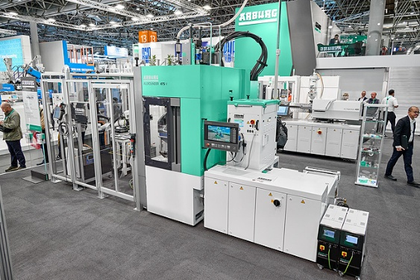

A production cell centred around a vertical Allrounder 475 V produces high-quality key fob covers from PC/ABS recyclate using In-Mould Decoration (IMD).

475V Keyfob DSC6334
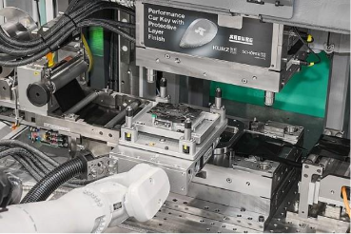

In the mould of the vertical Allrounder 475 V, the decorative film is overmoulded with PC/ABS recyclate.

Allrounder 475V_407

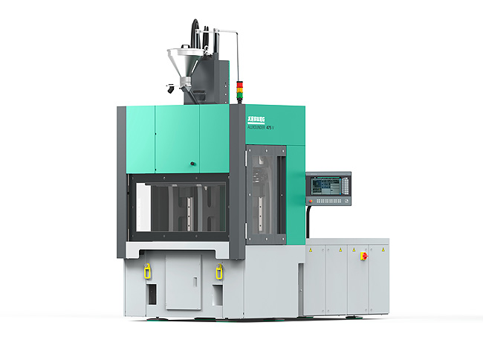

The new Allrounder 475 V with a clamping force of 1.000 kN is an energy-efficient, space-saving, cost-effective and versatile for overmoulding of inserts.

Photo: Arburg

Photo Download:
https://media.arburg.com/web/945382004dd858cb/allrounder-475v-press-release/

press release
File: Pressemitteilung Allrounder 475V Fakuma 2026_en_GB.docx
Characters: 4,495
Words: 701

This and other press releases are available for download from our website at www.arburg.com/de/presse/ (www.arburg.com/en/press/)

Contact
ARBURG GmbH + Co KG
Press office
Susanne Palm
Dr Bettina Keck
Postfach 1109
72286 Lossburg, Germany
Tel.: +49 (0)7446 33-3463
Tel.: +49 (0)7446 33-3259
presse_service@arburg.com

About Arburg
Founded in 1923, this German family-owned company is one of the world’s leading manufacturers of injection moulding machines. The Arburg family also includes AMKmotion, a manufacturer of electric drive technology.
Arburg’s portfolio for plastics processing comprises Allrounder injection moulding machines, robotic systems and customer- and industry-specific turnkey solutions. It also includes digital products and services. In the plastics industry, Arburg is a pioneer in the areas of energy and production efficiency, digitalisation and sustainability. Arburg machines are used to manufacture plastic products for sectors such as mobility, packaging, electronics, medicine, construction and equipment manufacturing, as well as leisure.
The company’s headquarters are located in Lossburg, Germany. Furthermore, Arburg has its own organisations in 27 countries at 37 locations and is represented in over 100 countries through its distribution partners. Of the total workforce of around 3,400 employees, approximately 2,800 are based in Germany and around 600 in Arburg’s global organisations.
Arburg is certified to ISO 9001 (Quality), ISO 14001 (Environment), ISO 27001 (Information Security), ISO 29993 (Training) and ISO 50001 (Energy).
Further information: www.arburg.com, www.amk-motion.com.

