Arburg at Fakuma 2026
Allrounder Trend – a broad application range in standard injection moulding

- Cost-effective and automatable: New Allrounder Trend standard electric machines
- Quick and easy: Set up, operation and production
- Efficient and high-quality: Automotive connectors and LSR seals

Lossburg, 03/09/2026
At Fakuma 2026, Arburg (Hall A3, Stand 3101) will be exhibiting its wide application range of electric Allrounder Trend machines for injection moulding in the standard sector. One exhibit will be producing connector components for the automotive industry. A second Allrounder Trend machine will be procesing LSR to produce ‘Secure Seal’ closures. Both of these machines are automated with Multilift Select linear robotic systems. These demonstrations will also show how easy it is to operate the new Gestica lite control system.

The electric Allrounder Trend machines are suitable for standard applications across all industries and can be supplied worldwide at short notice. They can be set up particularly quickly, are intuitive to operate and easy to maintain, and impress with their high energy efficiency and low capital and running costs. They also offer proven Arburg quality and a globally standardised level of support. The machines pay for themselves even in short running times through their combination of a rapid return on investment (ROI) and a consistently low total cost of ownership (TCO).

Fast standard machine for technical injection moulding
The Allrounder Trend is available in four sizes with clamping forces ranging from 500 to 2,000 kN. The injection speeds are 200, 350 and 500 millimetres per second. At Fakuma 2026, an Allrounder 1000 e Trend with a clamping force of 1,000 kN, an maximum injection speed of 500 millimetres per second and a 16-cavity mould from Rosenberger will demonstrate the automated production of technical parts for the automotive sector. In a cycle time of around eight seconds, 16 connector components are produced from PA 12 filled with 30 per cent glass fibre. A Multilift Select 8 removes the moulded parts and, via a tube system, sets them down, segregated by mould cavity.

Fully automated production of LSR closures
For automated injection moulding production, the new standard machines can be equipped with any of Arburg’s robotic systems and the appropriate compact safety enclosure. Each configuration is fully integrated into the machine controller and can be combined to create complex turnkey systems. At Fakuma 2026, a production cell centred around an Allrounder 1800 e Trend with a clamping force of 1,800 kN, compact guards and a 64-cavity mould from ACH Solution will be producing around 9,200 ‘Secure Seal’ LSR closures per hour fully automatically. These mass-produced items are used for needles and syringes in the medical sector. A Multilift Select 16 linear robotic system sets down the finished parts separated by mould cavities as well as into a drawer system for quality assurance.

Simple and clear: Gestica lite
All Trend machines are equipped with the new Gestica lite control system, which features a robust industrial panel. The intuitive user interface, with its clearly layout dashboard, makes operation a simple task, even for relatively inexperienced personnel: The home screen provides everything at a glance that the operator needs to get a job done. Gestica lite adopts the logic and operational philosophy familiar from other Arburg control systems, supplementing these with ‘smart’ functions and active support. Using the touch function, you can jump directly to the detailed parameter screen pages for the clamping and injection units. Further added value is provided by the Status Centre, which displays all alarms, by the Help Centre with practical online support, and by a digital noticeboard for personal notes related to production. Further new features are simplified navigation and search with AI functionality. At Fakuma 2026, visitors will also be able to learn about the comprehensive features of Gestica lite with the help of simulators. One of the innovative features being unveiled for the first time is the ‘aXw Control FirstShotAssist’. This enables a quick production start-up thanks to the automatic calculation of the data set based on STL data directly on the machine.

Images

ALLROUNDER 1000e TREND 290e

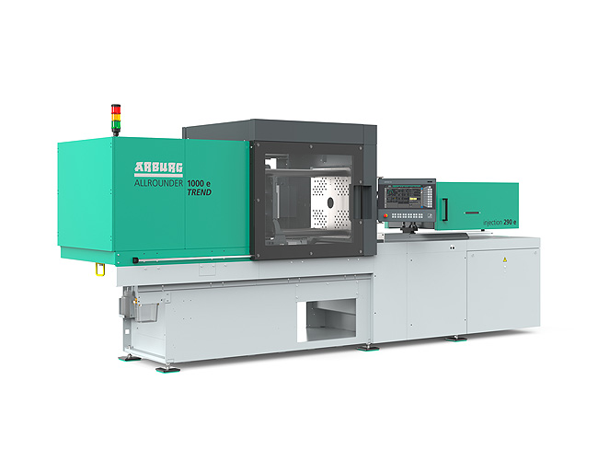

The new Allrounder Trend machines have a specific configuration that meets current market needs: they are available at short notice, can be set up quickly, are particularly easy to operate and maintain, and are characterised by high energy efficiency as well as low investment and operating costs.

ALLROUNDER 1800 e TREND_397

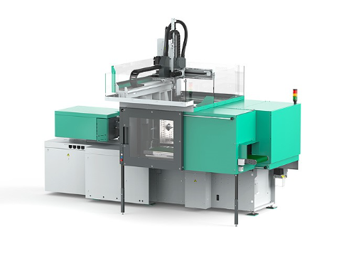

The new standard from Arburg: at Fakuma 2026, an electric Allrounder 1800 e Trend, fitted with a compact guard and a Multilift Select 16 robot system, will be used to produce LSR closures automatically.

Photos: ARBURG
Photo download:
https://media.arburg.com/web/c36041253c707c04/allrounder-trend-2026-article/

Press release
File: Pressemitteilung Allrounder Trend Fakuma 2026_en_GB.docx
Characters: 3,971
Words: 626

This and other press releases are available for download from our website at www.arburg.com/de/presse/ (www.arburg.com/en/press/)

Contact
ARBURG GmbH + Co KG
Press office
Susanne Palm
Dr Bettina Keck
Postfach 1109
72286 Lossburg, Germany
Tel.: +49 (0)7446 33-3463
Tel.: +49 (0)7446 33-3259
presse_service@arburg.com

About Arburg
Founded in 1923, the German family-owned company is one of the world's leading manufacturers of injection moulding machines. AMKmotion, a manufacturer of electric drive technology, also belongs to the Arburg family.
The portfolio for plastics processing encompasses Allrounder injection moulding machines, robot systems as well as customer- and industry-specific turnkey solutions. It also includes digital products and services. Arburg is a pioneer in the plastics industry when it comes to energy and production efficiency, digitalisation and sustainability. Arburg machines are used to manufacture plastic products for the mobility, packaging, electronics, medical, construction and equipment engineering and leisure industries, for example.
The company headquarters are located in Lossburg, Germany. In addition, Arburg has own organisations in 27 countries at 37 locations and is represented in over 100 countries together with trading partners. Of a total of roughly 3,400 employees, about 2,800 work in Germany, with another 600 employees based in Arburg's organisations around the world.
Arburg is certified to ISO 9001 (Quality), ISO 14001 (Environment), ISO 27001 (Information Security), ISO 29993 (Education and Training) and ISO 50001 (Energy).
Further information: www.arburg.com, www.amk-motion.com.

