Arburg at Fakuma 2026
‘Mold your future’ – great career opportunities at Arburg!

- Putting their heart and soul into it: 60 apprentices will be joining the exhibition team on Career Friday
- Informative: Guided tours of the large exhibition stand in Hall A3, focusing on Smartest Factory
- With a firm eye on the future: Arburg offers a wide range of apprenticeship and degree programmes

Lossburg, 02/10/2026
For Fakuma’s ‘Mold your dreams, mold your future’ Career Friday on 16 October 2026, over 60 apprentices and trainers will be joining the Arburg trade fair team in Friedrichshafen to showcase this innovative family-run company’s wide range of career opportunities to talented young people. They can look forward to being taken on special guided tours of the stand focusing on the key theme of the ‘Smartest Factory’ and to a Prize Draw. In addition, Professor Andreas Fath, the ‘swimming professor’ and Arburg brand ambassador, will be in attendance.

“‘Mould your future’ is not just our motto for Career Friday at Fakuma – an event that we wholeheartedly endorse – but is one that applies to Arburg in general. As an industry pioneer and innovative family-run business, we are actively shaping the future of plastics processing”, explains Training Manager Michael Vieth. “We are always on the lookout for motivated school pupils, students and young professionals who are interested in innovative technologies, mechanical engineering and future-oriented topics relating to digitalisation”.

‘Swimming Professor’ and Prize Draw
As part of the campaign, Arburg will also be offering an exciting programme of events at its exhibition stand. Among those taking part is brand ambassador Professor Andreas Fath from German Furtwangen University, who – as part of his commitment to clean waters and the fight against microplastics, and in his role as the ‘swimming professor’ – has swum the entire length of major rivers such as the Elbe and the Danube. He will be on hand to answer questions and can explain how plastics and sustainability can be reconciled.
Visitors to the stand can also try out a virtual welding machine using VR glasses, equipment used on training courses. Anyone wishing to look directly from Friedrichshafen to the company’s headquarters in Lossburg can set up a pair of 3D glasses, attach them to their smartphone and embark on a virtual 360-degree tour of the Arburg Training Center. Young visitors to the stand can also take part in a Prize Draw, with three sets of two tickets to the amusement park ‘Europapark Rust’ up for grabs. Everyone will also receive an attractive giveaway.

Unique Arburg training – it’s worth applying
Arburg offers a unique, triple-quality-certified training programme. Over the past more than 75 years, the company has prepared more than 2,400 young people for the world of work. Applications can be submitted online via www.arburg.com/info/ausbildung at any time. Of course, a team of trainers and careers professionals will also be on hand in Friedrichshafen. Here interested visitors can easily apply for an apprenticeship, a degree course or a direct career entry directly at the Fakuma Careers Friday.

Stand tours focusing on digitalisation
Arburg’s trade fair presence is entirely centred on the theme of ‘Smartest Factory’. As part of guided tours of the stand led by Arburg’s apprentices, participants at Career Friday can see for themselves that Arburg has a wealth of resources to draw on when it comes to digitalisation: These cover everything, from innovative injection moulding technologies – including smart assistants and AI-supported features – through to efficient automation and turnkey systems, right up to the digital networking of the entire production process. The apprentices will explain how all these elements mesh together perfectly and interact along the value chain, as well as which apprenticeship programmes and degree courses Arburg can offer.

Image

Trainees Mold the Future_01211

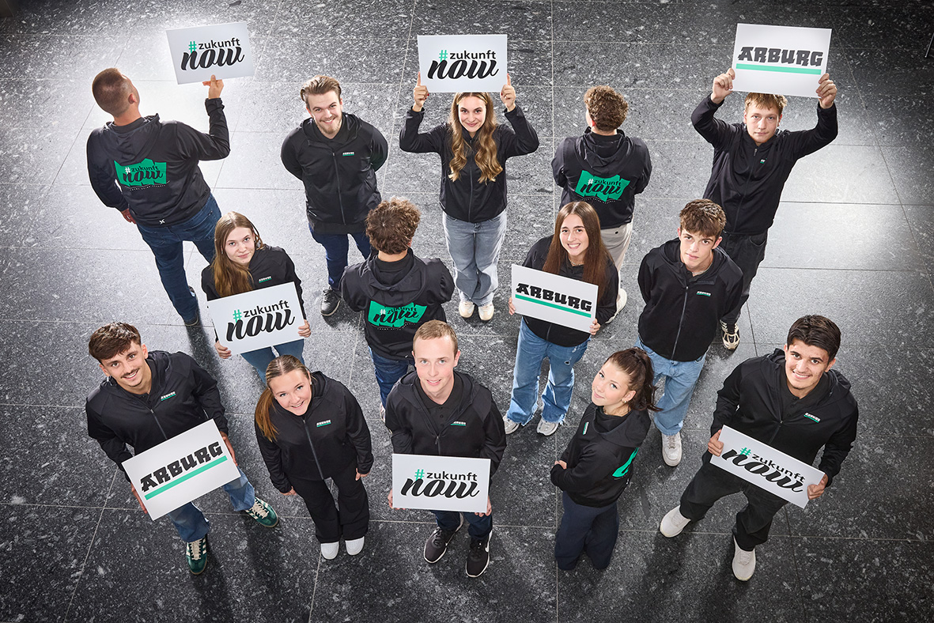

Following the successful campaign at Fakuma 2026, this year around 60 Arburg apprentices will be showcasing the fantastic prospects Arburg offers in terms of apprenticeships and DHBW degree programmes at the ‘mold your future’ Career Friday in Friedrichshafen.

Photo: Arburg

Photo download:
https://media.arburg.com/web/ea4d8a018dc936f3/career-day-fakuma-2026/

Press release
File: Press release – Fakuma 2026 Career Day_en.docx
Characters: 3,530
Words: 553

You can also download this and other press releases from our website at www.Arburg.com/de/presse/ (www.Arburg.com/en/presse/)

Contact
Arburg GmbH + Co KG
Press Office
Susanne Palm
Dr Bettina Keck
PO Box 1109
72286 Loßburg, Germany
Tel.: +49 7446 33-3463
Tel.: +49 7446 33-3259
presse_service@Arburg.com

About Arburg
Founded in 1923, this German family-owned company is one of the world’s leading manufacturers of injection moulding machines. The Arburg family also includes AMKmotion, a manufacturer of electric drive technology.
Arburg’s portfolio for plastics processing comprises Allrounder injection moulding machines, robotic systems and customer- and industry-specific turnkey solutions. It also includes digital products and services. Within the plastics industry, Arburg is a pioneer in the areas of energy and production efficiency, digitalisation and sustainability. Arburg machines are used to manufacture plastic products for sectors such as mobility, packaging, electronics, healthcare, construction, plant engineering and leisure.
The company’s headquarters are in Loßburg, Germany. In addition, Arburg has its own organisations in 27 countries at 37 locations and, together with its distribution partners, is represented in over 100 countries. Of the total workforce of around 3,300, approximately 2,700 are employed in Germany and around 600 in Arburg’s organisations worldwide.
Arburg is certified to ISO 9001 (quality), ISO 14001 (environment), ISO 27001 (information security), ISO 29993 (training) and ISO 50001 (energy).
Further information: www.arburg.com, www.amk-motion.com.

