Arburg at Allpack 2026
Highlight: Allrounder Trend

- Premiere: Allrounder Trend on display in Indonesia for the first time
- Packaging: Electric standard machine produces screw caps
- Attractive: Cost-effective, fast entry, simple operation and easy maintenance

Lossburg, 09/09/2026
From 20 to 23 October 2026, Arburg will be exhibiting at the Allpack trade fair in Jakarta for the veery first time. Indonesia is an important market for the packaging, food, beverage and pharmaceutical sectors. The highlight at Stand AP037 in Hall A1 will be the premiere of the new electric standard machines Allrounder Trend in Indonesia. The machine on display will be showcasing the production screw caps made from HDPE for the packaging industry.

“At Allpack, we shall be presenting the new electric Allrounder Trend to our customers in person. These machines offer an excellent price/performance ratio combined with Arburg’s high quality”, emphasises Haryadi Mulyono, Branch Manager of Arburg Indonesia. “We will demonstrate how these standard machines can be used to manufacture packaging products in high quantities efficiently and sustainably. While also showing our customers how they can increase their productivity and reduce their energy requirement using Arburg’s complete solutions. Automation and digitalisation are playing an increasingly important role in this regard”.

Exhibit produces 24 screw caps every seven seconds
To showcase energy-efficient and cost-effective large-scale production, an electric Allrounder Trend 1800 e fitted with a 24-cavity mould will be producing screw caps for the packaging and pharmaceutical industries.
These electric Allrounder Trend machines are suitable for standard applications across all industries and are available for delivery worldwide at short notice. They can be set up particularly quickly, they are intuitive to operate and easy to maintain, and they offer the advantage of high energy efficiency and low investment and operating costs. Furthermore, they offer Arburg’s proven quality and a globally standardised service.
There are currently four machine sizes available, with clamping forces ranging from 500 to 2,000 kN. All Trend machines are equipped with the new Gestica lite control system. This features an intuitive user interface and a clearly laid out dashboard.
For automated injection moulding production, the Allrounder Trend can be equipped with all Arburg robotic systems and the appropriate compact protective guards. These are fully integrated into the machine controller and incorporated into complex turnkey systems.

Boosting efficiency with digital products and services
When it comes to digitalisation, Arburg also supports its customers with bundled expertise, produces and services for smart producktion. At Allpack 2026, Arburg will be presenting its own Manufacturing Execution System (the ALS) and the arburgXworld customer portal. Via the MES, for instance, all information relating to orders, production progress, changeover times and maintenance can be accessed and archived.
Using the tools in arburgXworld, users can configure Allrounders, retrieve information on machines or order spare parts around the clock. The AI-powered “Ask Arburg” app is also particularly helpful; it contains a wealth of easily accessible injection moulding expertise and can answer specific questions about all Arburg products and processes relating to injection moulding. It can also help with troubleshooting.

Arburg Indonesia’s expert team
Arburg has been present in Indonesia since the year 1993, and with a wholly-owned subsidiary since 2006. The Arburg team offers a comprehensive range of services, expert advice and rapid on-site Service. True to the brand promise “Wir sind da.”, the local employees ensure that Indonesian customers receive fast, reliable and comprehensive support in all matters whenever required. This includes expert advice on machine and process technology, mould design, machine comparisons and a comprehensive pre- and after-sales service.

Images

1800e TREND_359

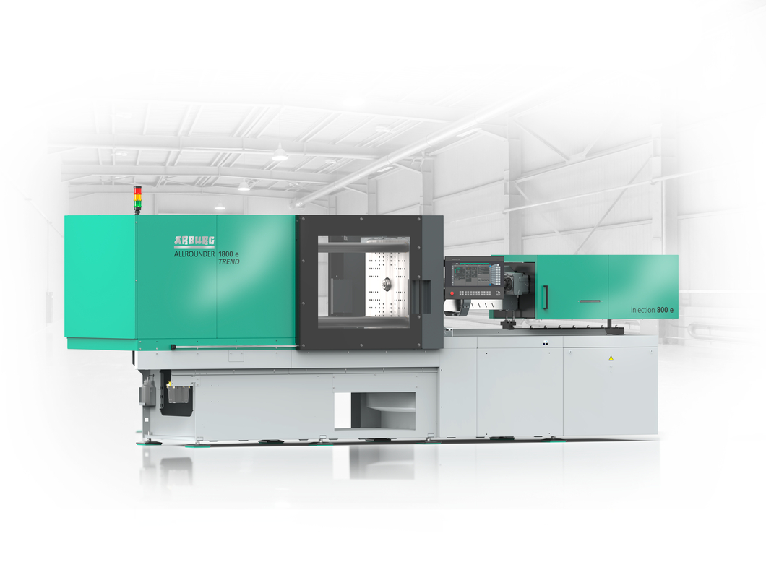

The new electric Allrounder Trend standard machines will make their Indonesian debut at Allpack 2026.

Photos: ARBURG

Photo download:
https://media.arburg.com/web/c36041253c707c04/allrounder-trend-2026-article/

Press release
File: Allpack 2026 press preview_en.docx
Characters: 3,737
Words: 548

You can also download this and other press releases from our website at www.arburg.com/de/presse/ (www.arburg.com/en/presse/)

Contact
ARBURG GmbH + Co KG
Press Office
Susanne Palm
Dr Bettina Keck
PO Box 1109
72286 Lossburg
Tel.: +49 7446 33-3463
Tel.: +49 7446 33-3259
presse_service@ARBURG.com

About ARBURG
Founded in 1923, this German family-owned company is one of the world’s leading manufacturers of injection moulding machines. The ARBURG family also includes AMKmotion, a manufacturer of electric drive systems.
Arburg’s portfolio for plastics processing comprises Allrounder injection moulding machines, robotic systems and customer- and industry-specific turnkey solutions. It also includes digital products and services. Within the plastics industry, Arburg is a pioneer in the areas of energy and production efficiency, digitalisation and sustainability. Arburg machines are used to manufacture plastic products for industries such as Mobility, Packaging, Electronics, Medical, Construction and equipment engineering, and Leisure.
The company’s headquarters are in Lossburg, Germany. Furthermore, ARBURG has its own organisations in 27 countries at 37 locations and, together with its distribution partners, has a representation in over 100 countries. Of the total workforce of around 3,400 employees, approximately 2,800 are based in Germany and around 600 work in ARBURG’s organisations worldwide.
ARBURG is certified to ISO 9001 (quality), ISO 14001 (environment), ISO 27001 (information security), ISO 29993 (training) and ISO 50001 (energy).
Further information: www.arburg.com, www.amk-motion.com.

