Arburg at Interplast 2026
Highlight: Allrounder Trend

- Premiere: Allrounder Trend officially launched in Brazil and South America
- Standard electric machine produces 48 screw caps in nine seconds
- Interplast brings together decision-makers from Brazil and South America

Lossburg, 25/06/2026
Arburg will be attending at the Interplast trade fair from 25 to 28 August 2026 in Joinville, Santa Catarina (Brazil) at stand B15. The highlight will be the official premiere of the new Allrounder Trend in Brazil. The
is electric standard machine is ideally suited to the markets in Brazil and South America. On display will be an Allrounder 1800 e Trend, which will be producing 48 PP screw caps live.

“The trade fair’s focus on sustainability, circular economy, advanced manufacturing and innovation also aligns with our objectives”, says Alfredo Fuentes, Managing Director of Arburg Ltda. in São Paulo, regarding the significance of Interplast. “Our absolute highlight is the new Allrounder Trend, which offers excellent value for money. Having said that, Arburg also has a lot to offer in terms of automation, digitalisation, energy efficiency and sustainable manufacturing.

Exhibit produces 48 screw caps in nine seconds
As an example of energy- and cost-efficient high-volume production, an electric Allrounder 1800 e Trend with a clamping force of 1,800 kN will be producing PP screw caps for the packaging and pharmaceutical industries. The specific outcome takes the form of 48 moulded parts each weighing 1.4 grams, produced with a cycle time of nine seconds. Real-time monitoring and control of key process parameters are the key to achieving optimum process stability and reproducibility. This application meets the current demand for higher productivity, resource conservation and high process reliability in modern manufacturing environments.

Electric Allrounder Trend: Efficient and cost-effective
The electric Allrounder Trend machines are suitable for standard applications across all industries and delivery lead times are short, to any destination in the world. These machines are remarkably quick to set up, they are intuitive to operate and easy to maintain. Their low investment and operating costs are impressive. Their high energy efficiency class 8+ (Euromap 60.1) boosts their profitability on a daily basis in injection moulding plants. At market launch, there will be four sizes with clamping forces ranging from 500 to 2,000 kN. All Trend machines are equipped with the new Gestica lite control system. This features an intuitive user interface and a well laid out dashboard.
For automated injection moulding production, it is possible to equip the Allrounder Trend machines with all Arburg robot systems and suitable compact protection, fully integrated into the machine control system and also incorporated into complex turnkey systems. Furthermore, they can be connected to a higher-level MES such as the Arburg host computer system (ALS).

Interplast: Platform for Brazilian injection moulding industry
Alfredo Fuentes is looking forward to Interplast for several reasons: “This event plays a crucial role for the plastics industry in Brazil and South America, because it provides a platform for technology demonstrations, knowledge exchange and the assessment of market suitability for new products. We look forward to in-depth discussions with customers and partners and are keen to see how trade fair visitors react to our new electric trend standard machines”.

Images

1800e TREND_359

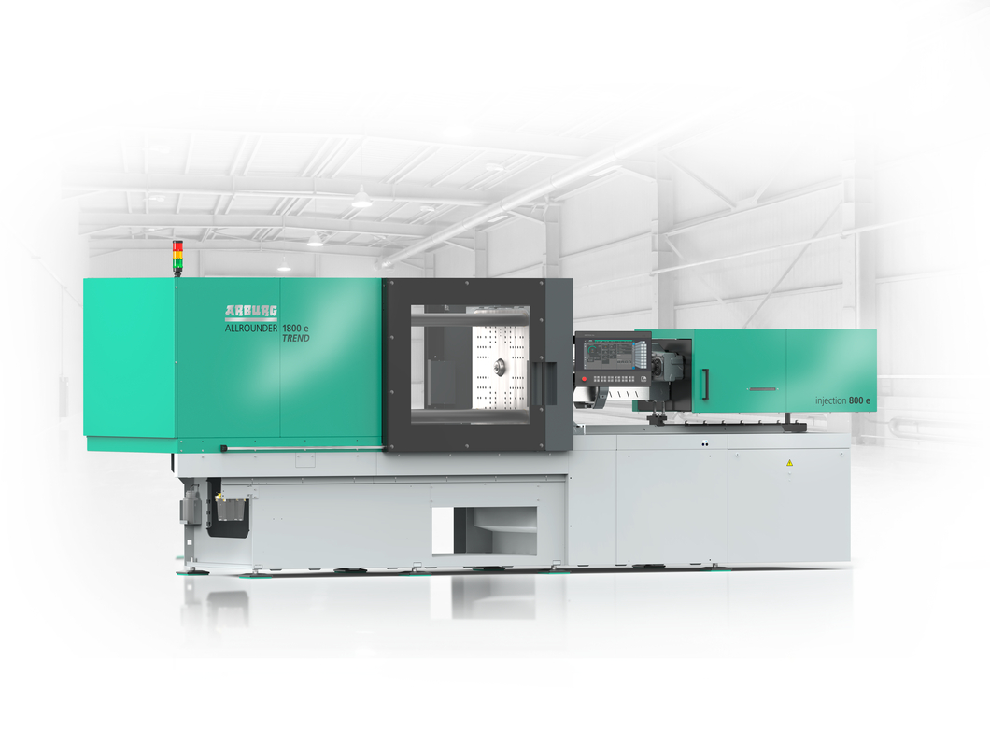

At Interplast 2026 in Brazil, the new Allrounder Trend standard electric machines will make their debut in Brazil and South America.

Photo: ARBURG

Alfredo Fuentes_255

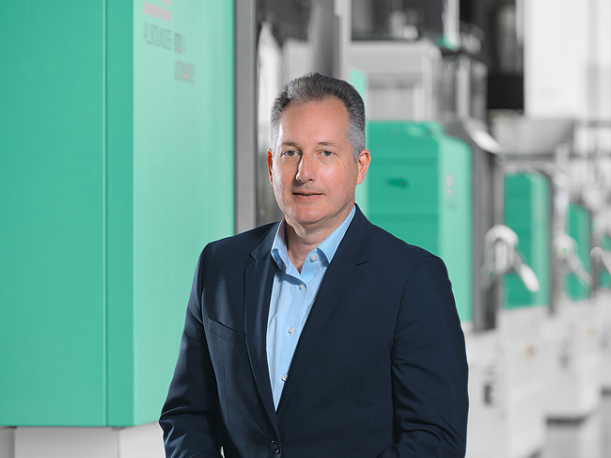

Alfredo Fuentes, Managing Director Arburg Ltda. in São Paulo, Brazil.

Photos: ARBURG

Foto Download:
https://media.arburg.com/web/cabae77d4dfe7f72/interplast-2026-press-preview/

Press release
File: Pressevorbericht Interplast 2026_en_GB.docx
Characters: 3,189
Words: 487

You can also download this and other press releases from our website at www.arburg.com/de/presse/ (www.arburg.com/en/presse/)

Contact
ARBURG GmbH + Co KG
Press Office
Susanne Palm
Dr Bettina Keck
PO Box 1109
72286 Loßburg
Tel.: +49 7446 33-3463
Tel.: +49 7446 33-3259
presse_service@arburg.com

About Arburg
Founded in 1923, this German family-owned company is one of the world’s leading manufacturers of injection moulding machines. The Arburg family also includes AMKmotion, a manufacturer of electric drive technology.
Arburg’s portfolio for plastics processing comprises Allrounder injection moulding machines, robotic systems and customer- and industry-specific turnkey solutions. It also includes digital products and services. In the plastics industry, Arburg is a pioneer in the areas of energy and production efficiency, digitalisation and sustainability. Arburg machines are used to manufacture plastic products for sectors such as mobility, packaging, electronics, medicine, construction and equipment manufacturing, as well as leisure.
The company’s headquarters are located in Lossburg, Germany. Furthermore, Arburg has its own organisations in 27 countries at 37 locations and is represented in over 100 countries through its distribution partners. Of the total workforce of around 3,400 employees, approximately 2,800 are based in Germany and around 600 in Arburg’s global organisations.
Arburg is certified to ISO 9001 (Quality), ISO 14001 (Environment), ISO 27001 (Information Security), ISO 29993 (Training) and ISO 50001 (Energy).
Further information: www.arburg.com, www.amk-motion.com.

