Arburg at MSV 2026
Allrounder Trend makes its debut in the Czech Republic

- Highlight: New Allrounder Trend standard electric machine at the trade fair in Brno
- Attractive: Cost-effective, quick to get started, easy to operate and maintain
- Further focus: Digital products and services

Lossburg, 01/09/2026
The MSV trade fair will be held in Brno from 6 to 9 October 2026. Arburg will be presenting its electric standard machines in the Czech Republic for the first time at its stand 31 in Hall G1. On display will be an Allrounder 1000 e Trend with a Multilift 4 linear robot system. This will be producing a garden shovel as a giveaway. Digital products and services such as Arburg’s own MES (ALS) and the arburgXworld customer portal round off the exhibition presentation.

“The electric Allrounder Trend machines are ideally suited to our customers in the Czech Republic, enabling them to get started quickly and cost-effectively in the injection moulding of standard components. They combine everything that sets Arburg apart: They have short delivery times, they are energy-efficient, compact, quick to set up, intuitive to operate and easy to maintain”, emphasises Dr Daniel Orel, Managing Director of Arburg spol. s r.o. in Brno, the Czech Republic.
“These new standard machines impress with their low investment and operating costs – in other words, high cost-efficiency – which they combine with proven Arburg quality. And when it comes to digitalisation and automation, we offer everything our customers are looking for. At our Arburg Technology Center in Brno, our experts can also implement bespoke turnkey systems in a practical and customised manner”.

Allrounder Trend: A new standard in injection moulding
The electric Allrounder Trend machines are configured for standard applications across all industries. They are currently available in four sizes with clamping forces ranging from 500 to 2,000 kN. All Trend machines are equipped with the new Gestica lite control system. This features an intuitive user interface and a clearly laid-out dashboard.
At the MSV, an Allrounder 1000 e Trend with a clamping force of 1,000 kN will be on display, demonstrating the production of garden shovels – a popular giveaway with trade fair visitors. A linear robotic system Multilift Select 4 removes the moulded part from the single-cavity mould and sets it down on a conveyor belt.

Arburg – long-term partner for end-to-end solutions
Arburg is a long-term partner that offers injection moulding engineers tailor-made, comprehensive end-to-end solutions which extend far beyond mere machine technology. In addition to automation and peripheral equipment, these solutions also include comprehensive pre- and after-sales support.
In the ‘Digitalisation’ sector, the spotlight at MSV 2026 will be on Arburg’s own Manufacturing Execution System (the ALS) and the arburgXworld customer portal. The Arburg MES helps users to increase machine availability, to reduce the scrap rate and to boost production efficiency. Using the features integrated into arburgXworld, users can, for example, configure Allrounder machines with the aid of AI. They can also retrieve information about machines or order spare parts. Visitors to the stand will be able to find out more about these digital products across a number of screens. Assistance and pilot functions for the Gestica control system will also be presented. The experts on the exhibition team will be there to explain how smart, efficient and sustainable plastic parts production can be achieved with reduced total cost of ownership (TCO), accompanied at the same time by further improvements in part quality.

Images

ALLROUNDER 1000e TREND 290e

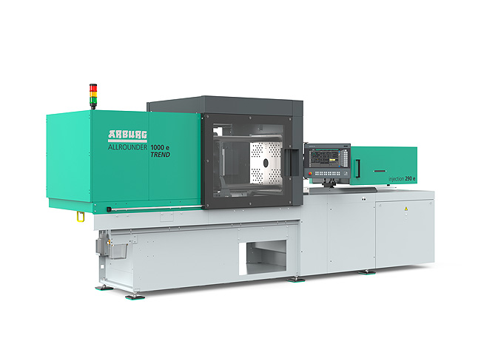

The new Allrounder Trend machines are specifically designed to meet current market needs: They can be set up quickly, they are remarkably easy to operate and maintain and are defined by low investment and operating costs.

ALLROUNDER 1800 e TREND_397

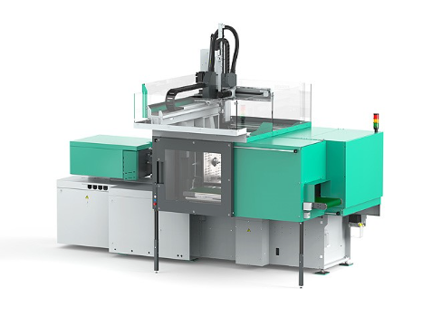

If required, the Allrounder Trend machines can be equipped with Arburg robotic systems.

Photos: ARBURG
Photo download:
https://media.arburg.com/web/c36041253c707c04/allrounder-trend-2026-article/

Press release
File: ARBURG press preview MSV 2026_en.docx
Characters: 3,344
Words: 521

You can also download this and other press releases from our website at www.arburg.com/de/presse/ (www.arburg.com/en/presse/)

Contact
ARBURG GmbH + Co KG
Press Office
Susanne Palm
Dr Bettina Keck
PO Box 1109
72286 Lossburg
Tel.: +49 7446 33-3463
Tel.: +49 7446 33-3259
presse_service@ARBURG.com

About ARBURG
Founded in 1923, this German family-owned company is one of the world’s leading manufacturers of injection moulding machines. The ARBURG family also includes AMKmotion, a manufacturer of electric drive systems.
Arburg’s portfolio for plastics processing comprises Allrounder injection moulding machines, robotic systems and customer- and industry-specific turnkey solutions. It also includes digital products and services. Within the plastics industry, Arburg is a pioneer in the areas of energy and production efficiency, digitalisation and sustainability. Arburg machines are used to manufacture plastic products for industries such as Mobility, Packaging, Electronics, Medical, Construction and equipment engineering, and Leisure.
The company’s headquarters are in Lossburg, Germany. Furthermore, ARBURG has its own organisations in 27 countries at 37 locations and, together with its distribution partners, has a representation in over 100 countries. Of the total workforce of around 3,400 employees, approximately 2,800 are based in Germany and around 600 work in ARBURG’s organisations worldwide.
ARBURG is certified to ISO 9001 (quality), ISO 14001 (environment), ISO 27001 (information security), ISO 29993 (training) and ISO 50001 (energy).
Further information: www.arburg.com, www.amk-motion.com.

