ARBURG at Plast 2026
Four innovative exhibits in Milan

- Highly interesting: Four exhibits showcase a broad product portfolio and process expertise
- Highlight: New electric Allrounder Trend produces the ‘Donut-ella’ design product
- Outstanding: Italy is a key injection moulding market for Arburg

Lossburg, 31/03/2026
At the Plast trade fair in Milan, from 9 to 12 June 2026, Arburg (Hall 22, Stand C101 – D118) will be showcasing no fewer than four innovative exhibits. A highlight is the new electric Allrounder Trend standard machine. Process expertise and the broad product portfolio will be demonstrated by an Allrounder More 2000 producing two-component parts, a hybrid Allrounder 470 H processing solid silicone rubber, and a fully automated vertical Allrounder 375 V overmoulding inserts. In addition, there will be a full-spectrum display of digital products and services.

As Plast takes place every three years, it is an important barometer for Italy’s plastics industry. “This leading trade fair highlights the latest technological trends and promotes the exchange of know-how and contacts”, confirms Cesare Pedone, Sales Director at Arburg Italy. “We will demonstrate our technological expertise, especially with our new Allrounder Trend, thereby addressing the specific needs of our market. For us, Plast 2026 is an important opportunity to further strengthen Arburg’s presence in Italy”.

Highlight: New Allrounder Trend standard machine
With the Allrounder Trend, Arburg is expanding its portfolio of proven high-end technology solutions to include completely newly developed electric machines for standard applications. These machines are designed specifically to meet current market needs: They can be set up quickly, they are remarkably easy to operate and maintain, and they produce moulded parts at exceptional levels of reliability and energy efficiency. They offer low investment and operating costs and are characterised by a fast return on investment (ROI) combined with a low total cost of ownership (TCO).
At launch, four machine sizes with clamping forces ranging from 500 to 2,000 kN will be available. All are equipped with the new Gestica lite control system. This features an intuitive user interface with a clearly laid out dashboard, making operation a breeze even for non-specialists. In Milan, visitors can experience first-hand how innovation, design culture and industrial manufacturing go hand in hand.
At Plast 2026, an automated electric Allrounder 1000e Trend will be producing the innovative ‘Donut-ella’ product – a three-part USB cable winder – as a promotional giveaway. In December 2025, this injection-moulded part, shaped rather like a doughnut, won the Pleiades design competition (Plastic European Innovation Award for Design and Sustainability) organised by the Italian IUAV University of Venice. To bring the product idea to life, the partner Uniform supplied the 1+1+1-cavity family mould while Ewikon supplied the hot runner. A Multilift Select 8 linear robotic system sets the three individual parts down on a conveyor belt and assembles the top and middle sections. The bottom section is added manually after the cable has been inserted.

Innovative solutions and comprehensive expertise
With three further machine exhibits, Arburg is showcasing additional innovative solutions and comprehensive expertise in the injection moulding process right across the value chain:
- A technically sophisticated turnkey solution is on display based around an Allrounder More 2000. This two-component machine produces two-colour dominoes using a complex 32-cavity hot runner mould from Polarform and Hasco. These moulded parts are then assembled and packaged ‘hand in hand’ by a Multilift V 30 linear robotic system and a collaborative cobot to form a complete game set. The result is a ready-to-use giveaway for trade fair visitors.
- The continuous processing of solid silicone rubber (HTV) into cable ties is demonstrated by a hybrid Allrounder 470 H. It produces moulded parts are produced using a 2+2-cavity tool in a cycle time of around 30 seconds. The machine is equipped with a silicone package and a customised injection unit. ACH Turnmix metering technology ensures a continuous, bubble-free material feed.
- A vertical Allrounder 375 V with a rotary table and an 8-cavity mould produces rollers for pneumatic and hydraulic pistons in a cycle time of around 35 seconds. A fully automatic system featuring a six-axis robot operates the feeding and removal of inserts as well as quality control. This ensures consistent cycle times and process reliability.

Provider of complete solutions
As a provider of complete solutions, Arburg can also offer its customers numerous digital products and features. These include its own MES (ALS), the arburgXworld customer portal and the Gestica control system with its smart pilot and assistance functions. The Gestica lite variant also features an intuitive interface with a clear dashboard that is easy to use even for non-specialists and it provides everything needed for daily work at a glance.
Cesare Pedone describes Arburg’s comprehensive support in Italy in the following terms: “Our customers can experience the latest innovations first-hand here in Milan. Our experts also provide support through high-quality technical service, rapid response times, on-site process optimisation, automation, and comprehensive Service and training”.

Images

ALLROUNDER 1000e TREND 290e_003

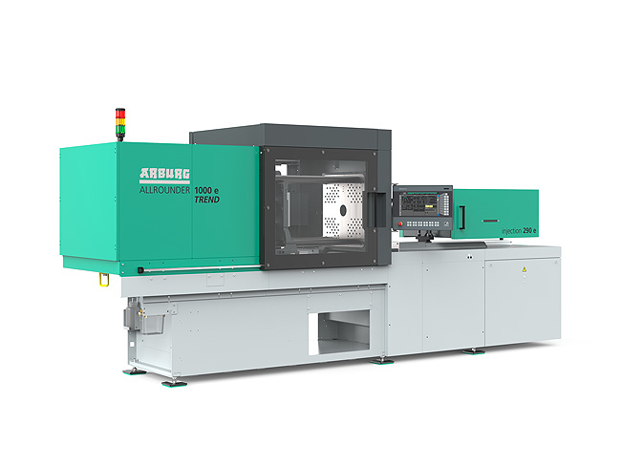

The new Allrounder Trend machines are specifically configured to meet current market needs: They are available at short notice, can be set up quickly, they are particularly easy to operate and maintain, and their investment and operating costs are low.

Donut-ella D1A3667

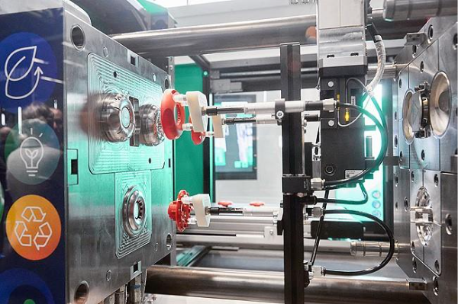

A new electric Allrounder 1000 e Trend standard machine will be producing the ‘Donut-ella’ design product – a USB cable winder – at Plast 2026.

Photo: ARBURG
Photo download:
https://media.arburg.com/web/502d602f0efcbd5b/plast-2026-press-preview/

Press release
File: Pressevorbericht Plast 2026_en_GB.docx
Characters: 5,192
Words: 767
s
This and other press releases are also available for download on our website at www.arburg.com/de/presse/ (www.arburg.com/en/presse/).

Contact
ARBURG GmbH + Co KG
Press Office
Susanne Palm
Dr Bettina Keck
P.O. Box 1109
72286 Lossburg, Germany
Tel.: +49 7446 33-3463
Tel.: +49 7446 33-3259
presse_service@arburg.com

About Arburg
Founded in 1923, the German family-owned company is one of the world's leading manufacturers of injection moulding machines. AMKmotion, a manufacturer of electric drive technology, also belongs to the Arburg family.
The portfolio for plastics processing encompasses Allrounder injection moulding machines, robot systems as well as customer- and industry-specific turnkey solutions. It also includes digital products and services. Arburg is a pioneer in the plastics industry when it comes to energy and production efficiency, digitalisation and sustainability. Arburg machines are used to manufacture plastic products for the mobility, packaging, electronics, medical, construction and equipment engineering and leisure industries, for example.
The company headquarters are located in Lossburg, Germany. In addition, Arburg has own organisations in 27 countries at 37 locations and is represented in over 100 countries together with trading partners. Of a total of roughly 3,400 employees, about 2,800 work in Germany, with another 600 employees based in Arburg's organisations around the world.
Arburg is certified to ISO 9001 (Quality), ISO 14001 (Environment), ISO 27001 (Information Security), ISO 29993 (Education and Training) and ISO 50001 (Energy).
Further information: www.arburg.com, www.amk-motion.com.

